**Lifestyle**

**The sustainable student**

**Living**

**Learning**

A POEM ABOUT TEXTBOOKS

Don’t buy textbooks, you’ll probably need 1 word in 3

Make friends so you can borrow theirs.

If making friends is unsuccessful, borrow it from the library,

So at the very least you get your degree,

Or find the martyr who bought a copy, then put it online for free

Orange is nobodies colour. Stop accessorising with Sainsbury’s carrier bags and start accepting those bumble totes outside the library. Or, invest in the bag business venture of an overly confident art student.

DO YOU own clothes that don’t represent you anymore because University is a journey of self -discovery?

Shed your old self on Ebay and Depop, and invest in second hand collectables.

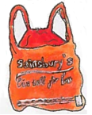

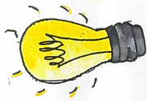

REASONS TO SWITCH YOUR LIGHTS OFF:

-Mice don’t need light to find your food

-Textbooks are best enjoyed in the dark…where they can’t be seen

-To see if carrots really do help you see in the dark

-(Serious energy saver)

[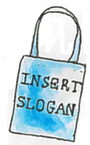](http://www.shrubcoop.org/)

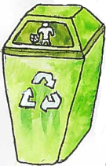

Swap the disposable containers for the indispensable feeling. Give no forks and you’ll live a more sustainable knife. Plastic is less than fantastic and for those occasions where you can’t resist-RECYLE.

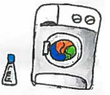

If your landlord convinced you a tumble dryer was worth the inflated rent, do what any self-respecting student would do and DON’T USE THEM.

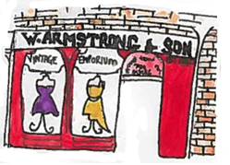

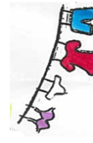

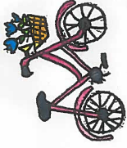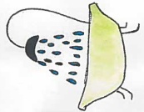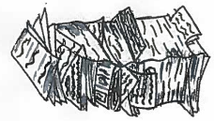

See if your friendships really are more than skin deep. Go makeup free once in a while and cut down on shower times.

Nobody wants to come face to face with their overdraft. Go paperless with bills and statements, and whilst we’re at it, get last year’s flatmates’ mail redirected so Sharon can actually attend her own graduation.

To the fresher that got McDonald Road. For the older student that decided on an hour long commute out of choice. Have quads to show for your misfortune or stupidity and take a second-hand bike instead of the bus.