Reusing existing recordings from Media Hopper Replay

17/03/2020 - latest updates are highlighted

An easy way to reuse a lecture from a previous year is to simply copy it between courses within Echo360.
IS have produced a short video illustrating the process: https://media.ed.ac.uk/media/0_23and0kh
Here are the instructions written out:
- Log in to last year’s Learn course and click through to Media Hopper Replay

- Find the lecture that you want to copy. Click on the green Replay icon to open the menu of actions, and choose Create copy.
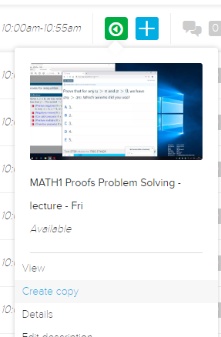

- Click “OK” to make the copy.
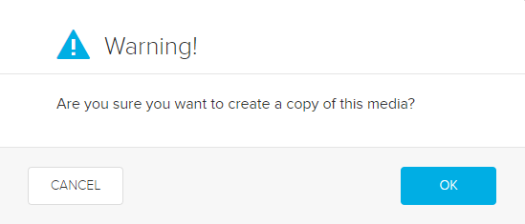
- You should then see confirmation in the bottom right corner of the screen:
- You can now follow the steps to publish content to this year’s course:

http://www.docs.is.ed.ac.uk/skills/documents/Lecture%20Recording/Guides/3879.pdf

In brief:

- Click through to Media Hopper Replay
- Click on the “echo” icon at the top of the page:
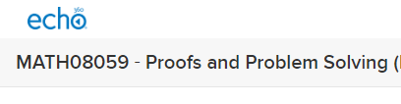
- Click My content in the left-hand menu, and click on the recording that you want to use (the copy that you just made should appear here).
- When it opens, click the Add to a class button.
- In the dialog that appears, choose the course and other settings to publish the content.

Full guidance on using Media Hopper Replay:
https://www.ed.ac.uk/information-services/learning-technology/media-hopper-replay/help-and-support/staff-help-and-support/staff

