Guide to using Piazza as an instructor
  - 17 March 2020
Piazza is an online platform that facilitates interaction among students and instructors.
You can use Piazza to:
- answer students’ questions once for all students to see;
- post videos and other resources;
- conduct polls to get a sense of where students stand.
Students can also offer answers to help others, and you can endorse good answers.
This guide aims to support you to do all of the above.
There is a demo page available. This is read-only and all student data has been removed. It will help to let you see what Piazza looks like: https://piazza.com/class/k57xsesjj80m3

1. Setting up Piazza for your course
If you do not already have a Piazza page for your course then please ask the Course Secretary to set one up for you.
You should also add a link to the Piazza page for the course to the course’s page on Learn.

2. Answering student questions
The left-hand panel shows a list of all the student questions. Click on one to see the detail, including any existing answer provided by other students:
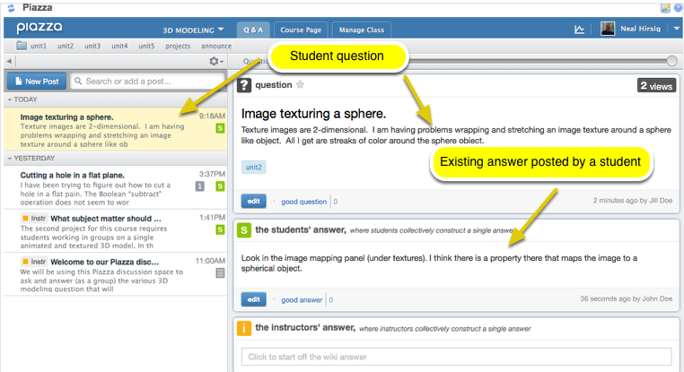
There are three ways for you to respond to a student question, which are outlined below.
When answering questions, you can include mathematics using LaTeX code. Note that to get inline expressions, you have to use double $s, e.g. “Since $$\sin x$$ is odd, $$\int_{-\pi}^{\pi}\sin x\,dx=0$$.” would produce:
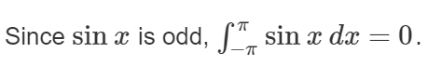

2.1 Join in the student wiki-like student answers
In the student's answer box, click Edit.
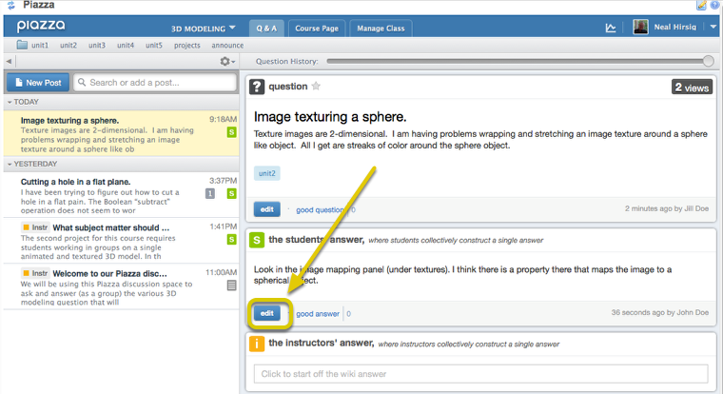
This displays the Piazza Text Editor. Enter your response, then click Submit.
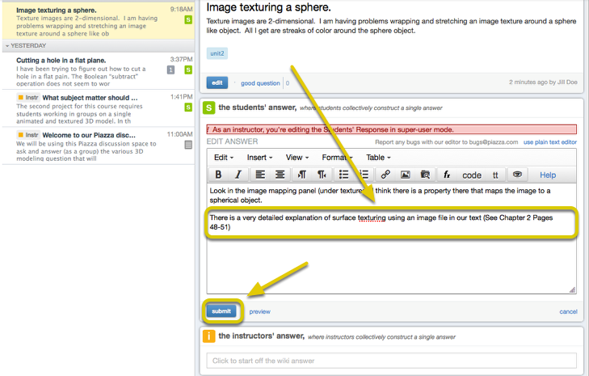
To the students, this will display as part of the "student's answer" panel and others can add to the answer.
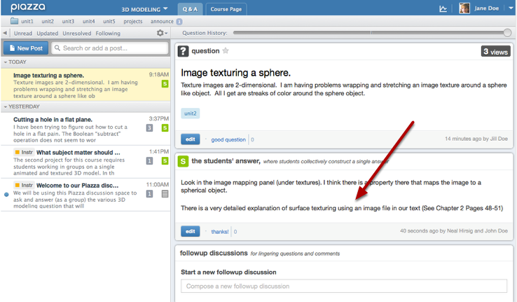

2.2 Create a separate "Instructor Answer"
Click on the student question, then click in the "Instructor's Answer" box:
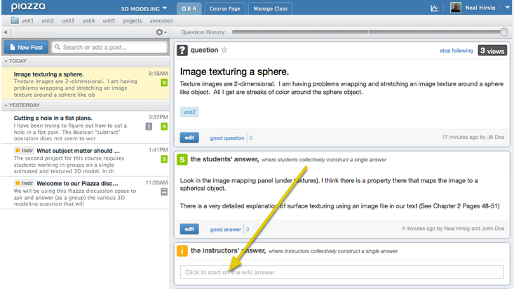
This displays the Piazza Text Editor. Enter your instructor's answer, then click Submit.
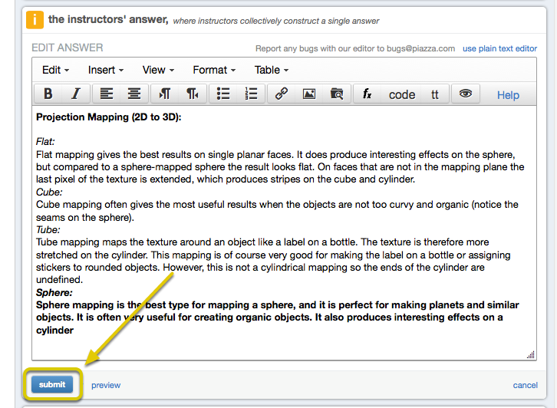
To the students, this will display as the Instructor's answer. Students cannot edit this panel.

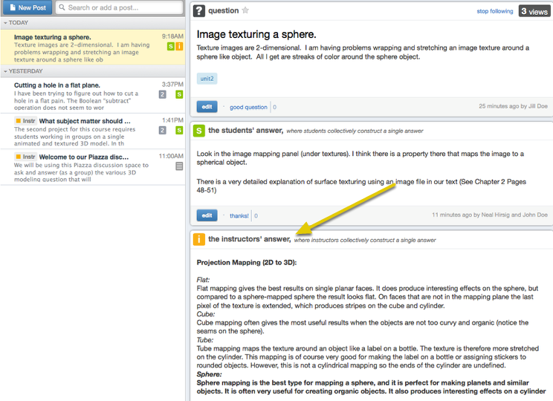
Note that if there are multiple instructors monitoring Piazza, you might find that a colleague is responding to a question at the same time as you. This will be indicated by a message below the text editor:
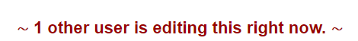
If someone else edits the instructor answer before you submit your own text, then you will be warned about the conflict – your text will be shown on the left and the new version on the right, so you can decide how to merge the changes.

2.3 Endorse an existing student answer - Click on the student question
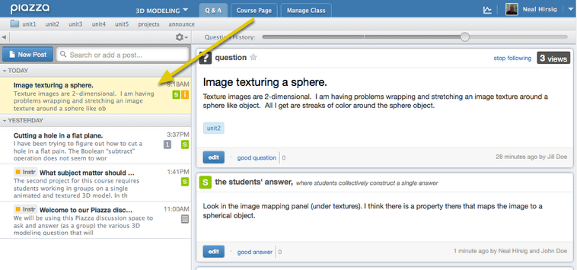
In the student's answer box, click "Good Answer".
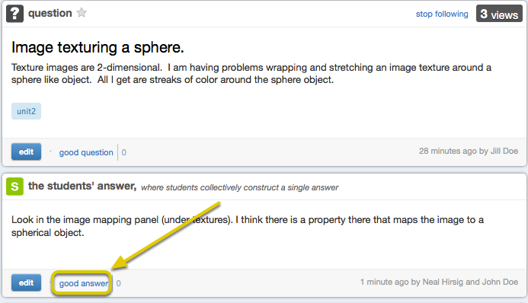
Note: You may have to use the Question History slider (above the question) to isolate a specific student answer.
To the students, this will display as a student answer that is endorsed by the instructor.
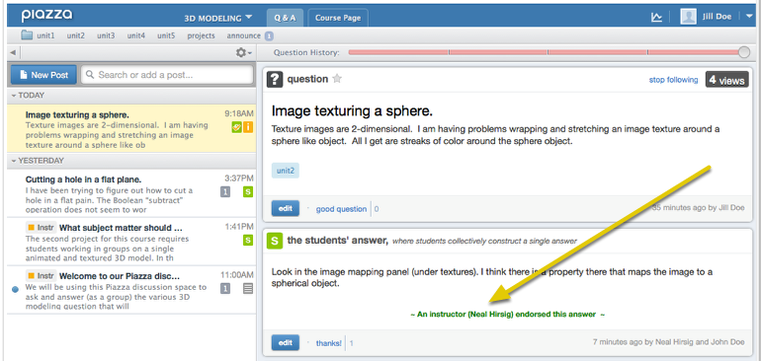

3. Posting videos and other resources

Creating and uploading videos
You may wish to consider add short teaching videos using screen capture to go over any difficult teaching points in discussions. See the Guidance on creating screencasts: https://edin.ac/39XeVUj

Add a screencast saved on Media Hopper Create
Go to your media in Media Hopper Create https://media.ed.ac.uk/my-media
- Click on the video that you want to share.
- On the video page, select Actions > Publish:
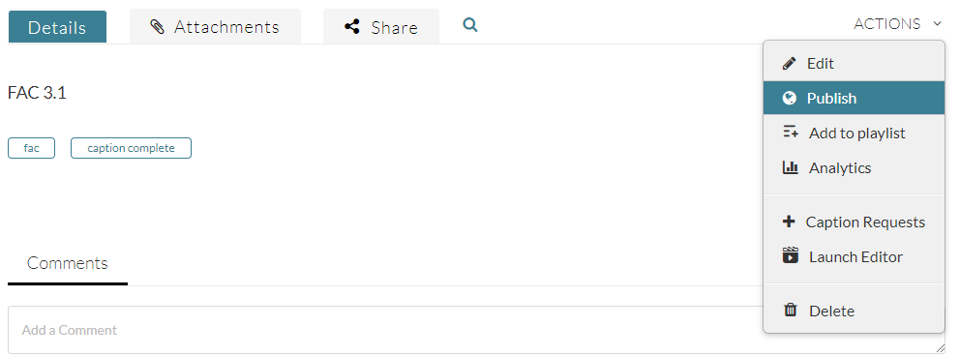
- Make sure the permission is set to Unlisted or Published so that others will be able to view the video, and click Save:
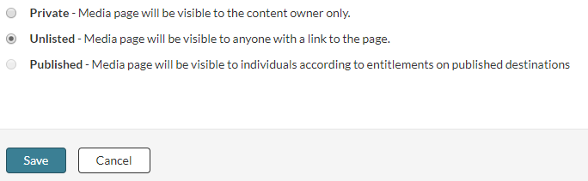
- Now click on the Share tab:
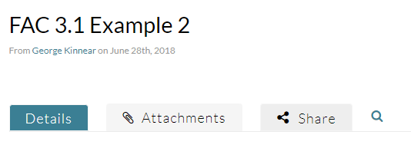
- Copy the link that appears:
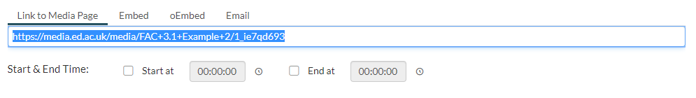
- You can then paste this link into your Piazza post.

Add other videos
Piazza supports direct Embedding of YouTube video – this is not recommended since some students may not be able to access YouTube.

Scanning and uploading and written notes
It may be more convenient to upload a page of handwritten notes to address a particular question. Handwritten notes can be easily converted to PDF (with multiple pages if necessary) using the mobile apps Adobe Scan or Microsoft Office Lens (both available free of charge for iOS and Android).
You can attach files to a Piazza post:
https://support.piazza.com/support/solutions/articles/48000616696-instructors-attach-a-file-to-a-post

4. Conducting polls
You may wish to gauge understanding or encourage participation by posting a poll.
https://tuftsedtech.screenstepslive.com/s/18992/m/73355/l/810751-how-do-instructors-and-students-post-a-poll

5. Encouraging students to help each other
Students may feel isolated so please try to encourage them to seek help using Piazza.
Please encourage students to communicate about course matters using Piazza rather than individual email. This allows other students to see common questions (and answers) and to help each other. It will also help to avoid single points of failure.
Separate guidance for students on using Piazza will be available soon but you might encourage them to upload photos of working if they are stuck with something.
You can set “timer delays” on questions so that students have an opportunity to help each other before you get involved:
https://support.piazza.com/support/solutions/articles/48000616732-instructors-set-timer-delays

