Producing video content for teaching mathematics online
Last updated Thu 19 March 2020. Changes from previous version highlighted yellow.

This guide describes how to use the University’s Media Hopper Create tool, to produce video clips showing your screen with a voiceover. IS have produced a short video clip showing the general process here: https://media.ed.ac.uk/media/1_5stbj87u
Tip: There is no need to make a recording that is the usual length of a lecture. A few shorter, focussed videos may be easier for students to digest and will upload faster.
The remainder of this guide walks through the steps used to create this example video:
https://edin.ac/2INsjP8
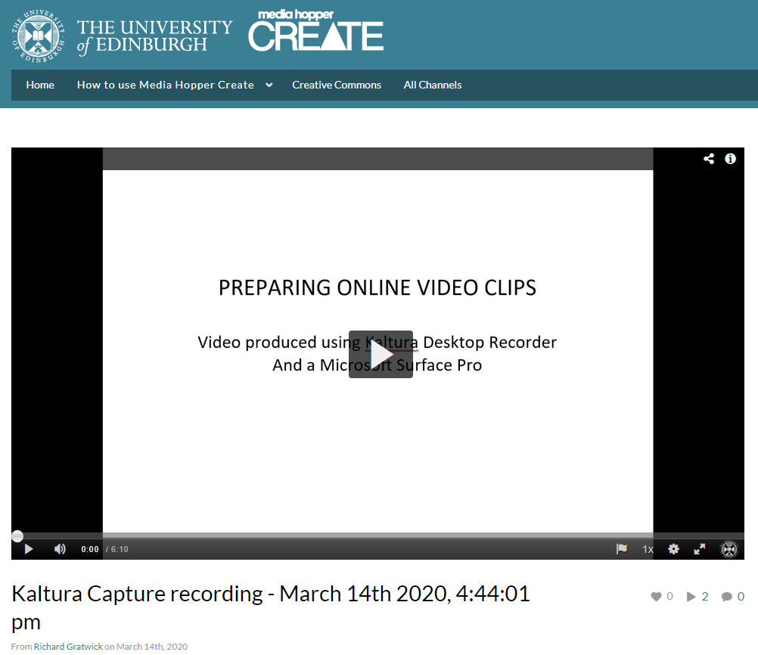

Download Kaltura Desktop Recorder from Media Hopper Create.
Following these steps ensures that your recordings are automatically available in your Media Hopper Create “My Media” library. This makes them very easy to make available to students, particularly through Learn (see below).
- Go to the Media Hopper Create website. Navigate to Guest -> Login. This will take you to the EASE login page, where you should log in with your usual credentials.

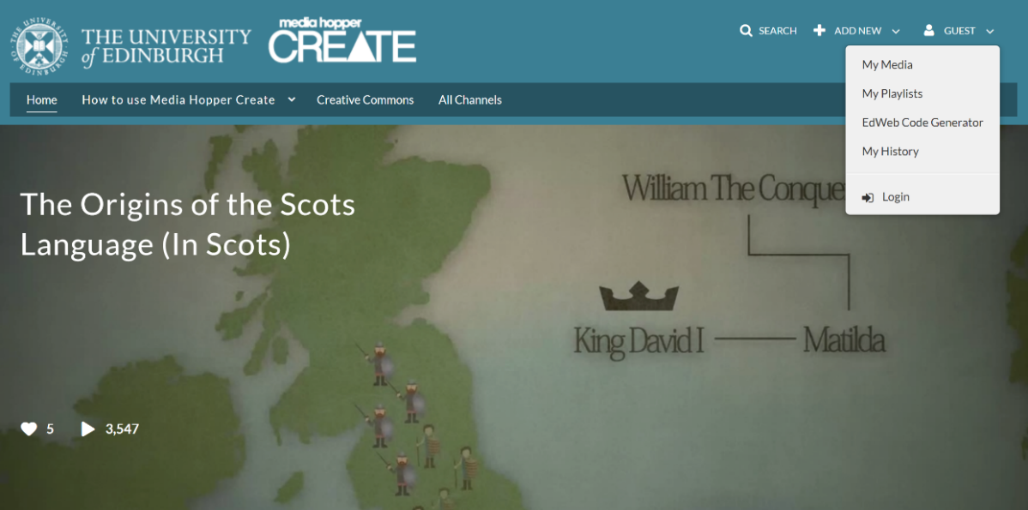

- Once back on the Media Hopper Create page, navigate to Add New -> Launch Desktop Recorder.

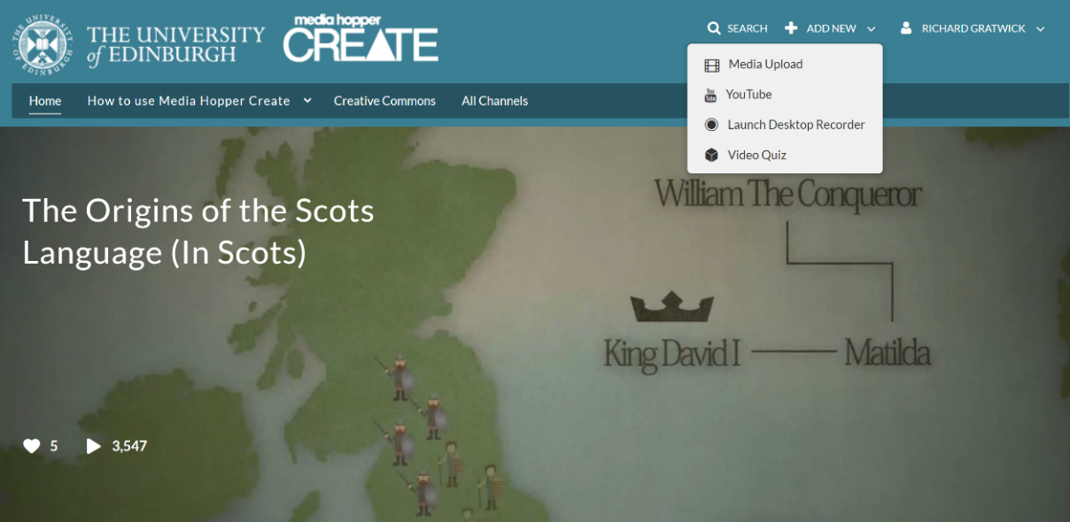

- This will take you to a page from which you can download Kaltura Desktop Recorder. Follow the usual instructions for installing it on your device.
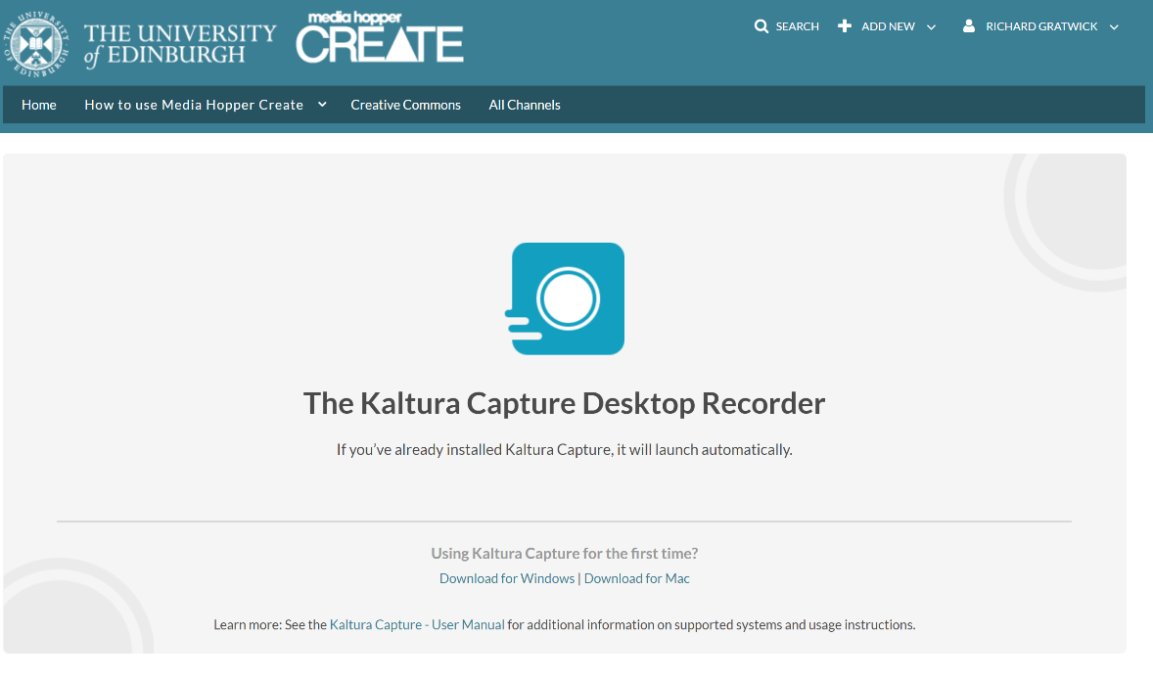

Record a video using Kaltura Desktop Recorder
You are now equipped to record media on your device. We will consider recording audio and (part of) the screen. The most common way of giving students access to recordings is through Learn, so we shall consider the easiest way of doing that.
- Open whatever application or document you want to use as the basis of the recording, and prepare any material you wish to include in your recording. See the video for examples: we will use Microsoft OneNote, and simply open a blank page in that to write on. It is good to have some initial material present before you begin, to avoid your recording appearing as a blank rectangle of white when not being played. The example video begins with the background below, and an Adobe Acrobat file opened but minimized.
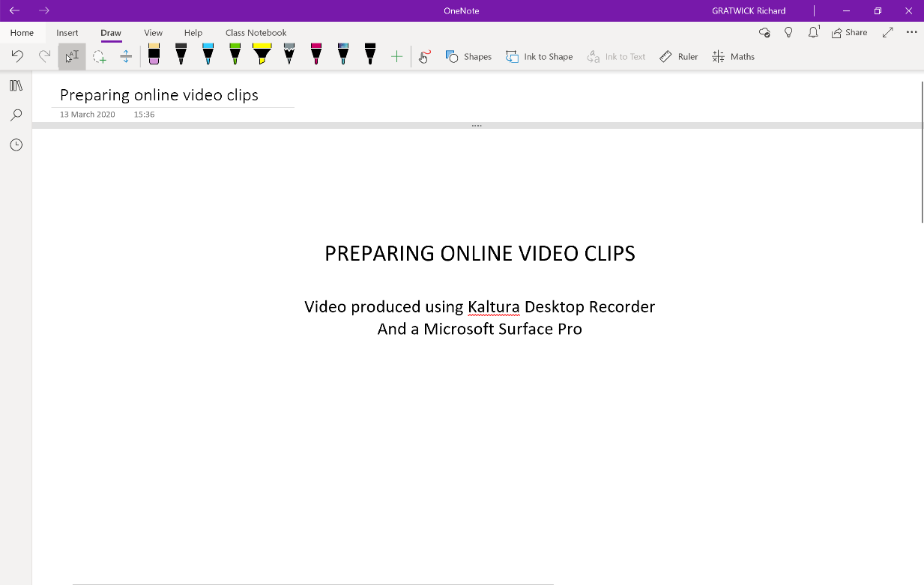
- Navigate to the Learn page on which you want to include your recording, and then to Build Content->Media Hopper Create Media.

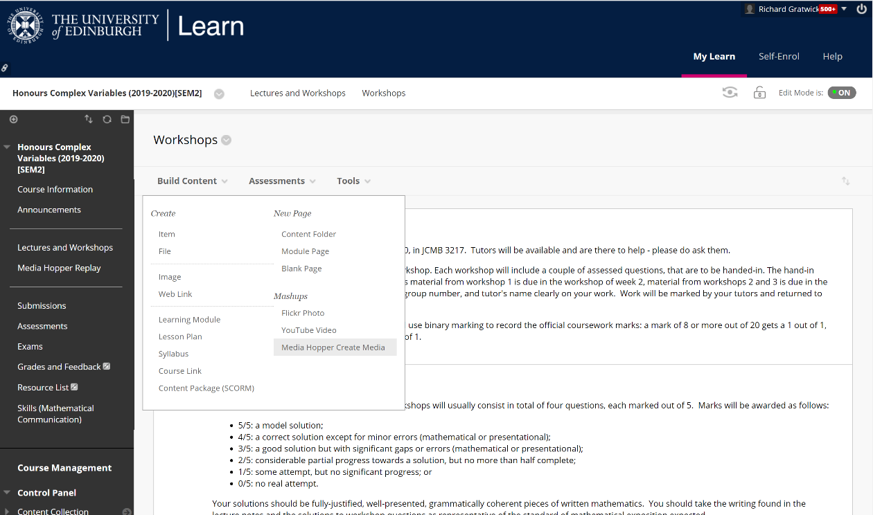

- This will display all content currently in your My Media library (it might take a few seconds). If you have already made the recording you want to include (e.g. by opening Kaltura Desktop Recorder independently, saving the recording, and uploading it to Media Hopper Create) then it should appear here, in which case skip ahead to item 18. In the screenshot below we see a couple of the videos that I made for the Fundamentals of Algebra and Calculus course, which were the last recordings I uploaded to Media Hopper Create. Navigate to Add New-> Launch Desktop Recorder.

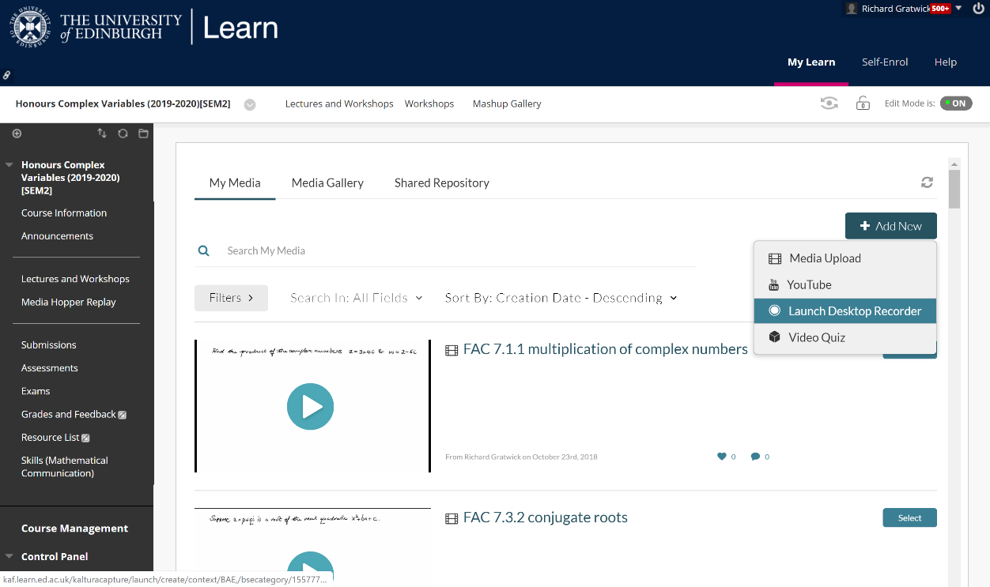

- Kaltura Desktop Recorder should open. It’s worth reorganizing your windows at this point so that Kaltura displays over the background to your video. To make the example recording, we minimized the browser, restored OneNote (fullscreen makes life easiest), and brought Kaltura to the front again. (Kaltura should go straight to the interface for producing a new recording, if not simply select New Recording.)
- Select whichever inputs you want to record by toggling Screen/Camera/Audio (as appropriate) as available or not. Inputs that will be captured will be blue, inputs not being captured will be grey and will be struck-through. We want to capture audio and (part of) the screen. So we ensure Camera is unavailable but Screen and Audio are available. If multiple sources are available for one input, the drop-down list will indicate this (if e.g. you have two screens). In particular we are given the choice of selecting to capture the full screen or to select an area of the screen.

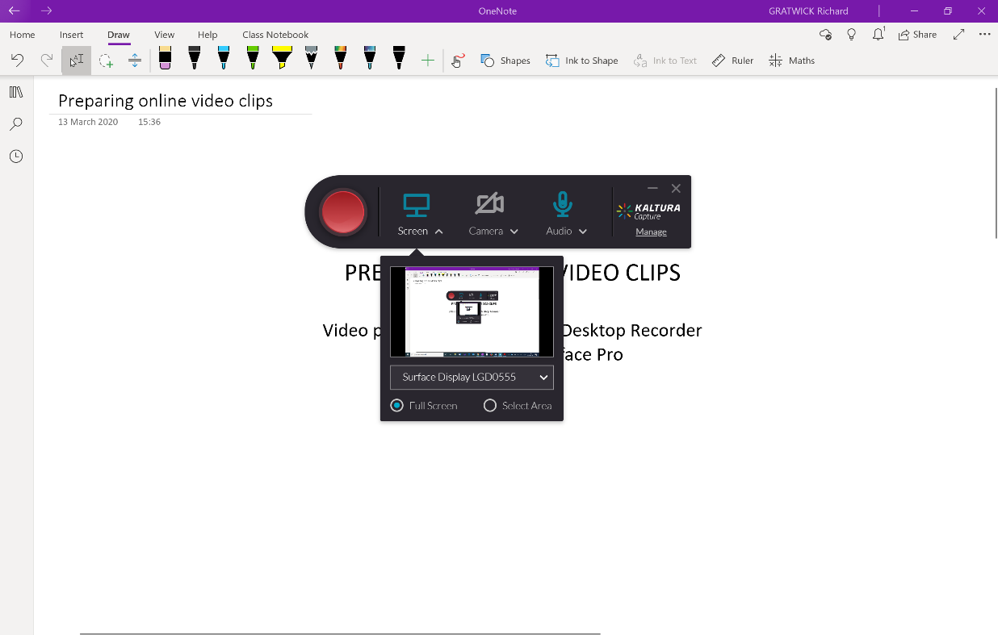

- We select “Select Area”. This overlays the screen with a grey rectangle which indicates the area that can be captured. The dimensions of this can be changed (we use 1600x1200, although a minor bug seems to demand we first select a different setting then revert to this one to correctly establish this) and the area can be dragged around the screen. This will be a physical area of the screen: anything displayed, dragged, or scrolled through that area will be captured. If you are going to use multiple windows in your recording (e.g. we move from OneNote to Adobe Acrobat) you should check now what will be displayed in each window in the area captured. Getting this right now will save awkward moments in the video repositioning windows or dragging objects around. Once you are happy that the area of the screen you want to capture is the size and position you want, select “Confirm”.

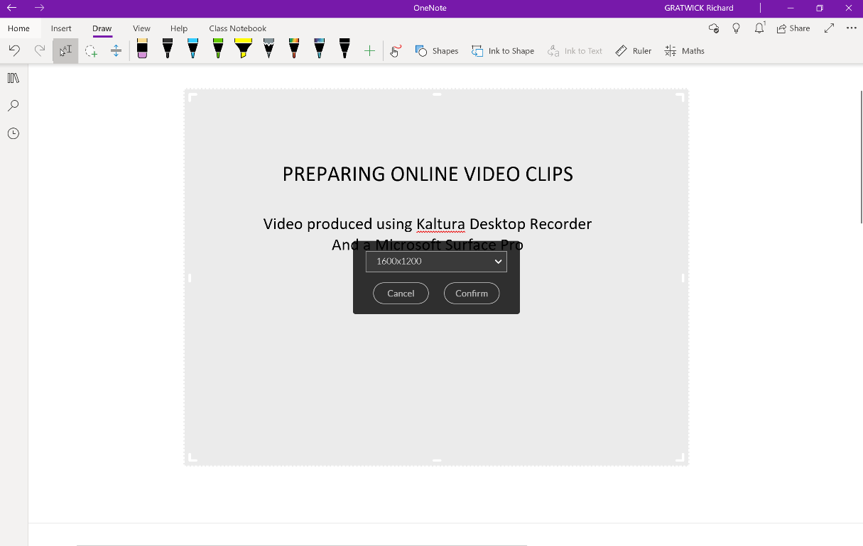

- The area should now be indicated with a hard red border. Select the red button to begin your recording. It will give you a brief countdown. Then make your recording! See the video for an example.
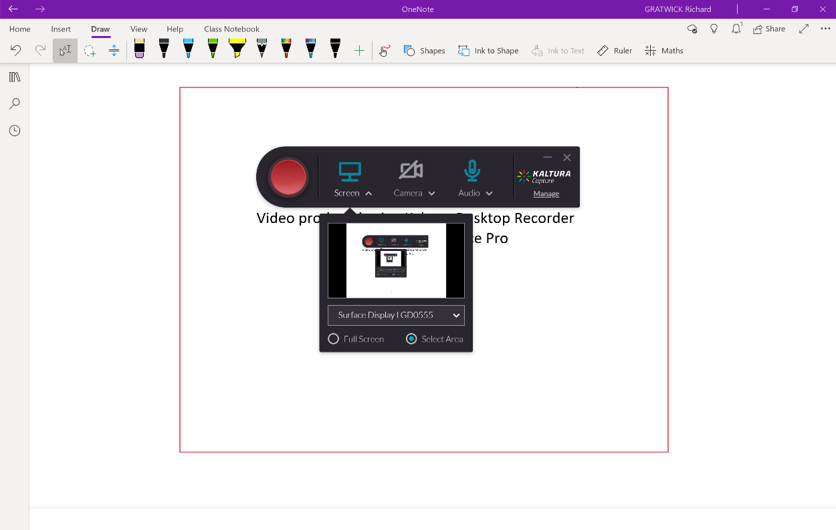
- While you are recording, Kaltura will display a small panel in the bottom right of your screen, with options to (left-right) end, pause, cancel, and (on the far right) annotate the video.

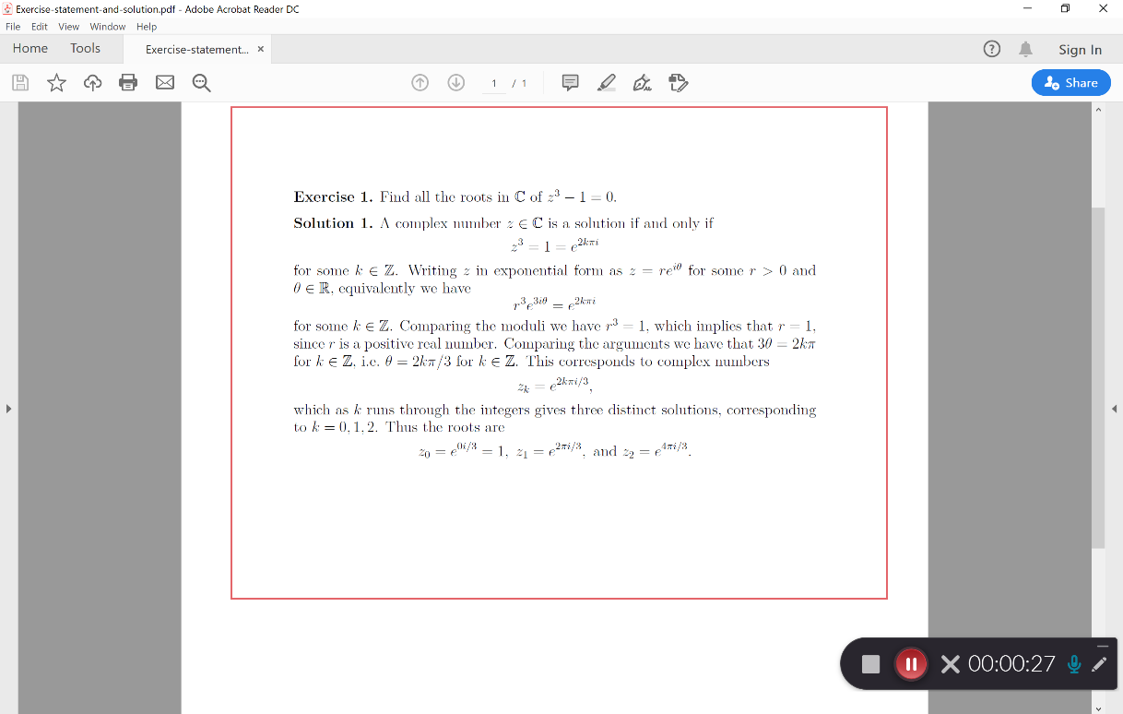

A small panel will appear with various options if you select to make annotations. The option used in the example video are below.

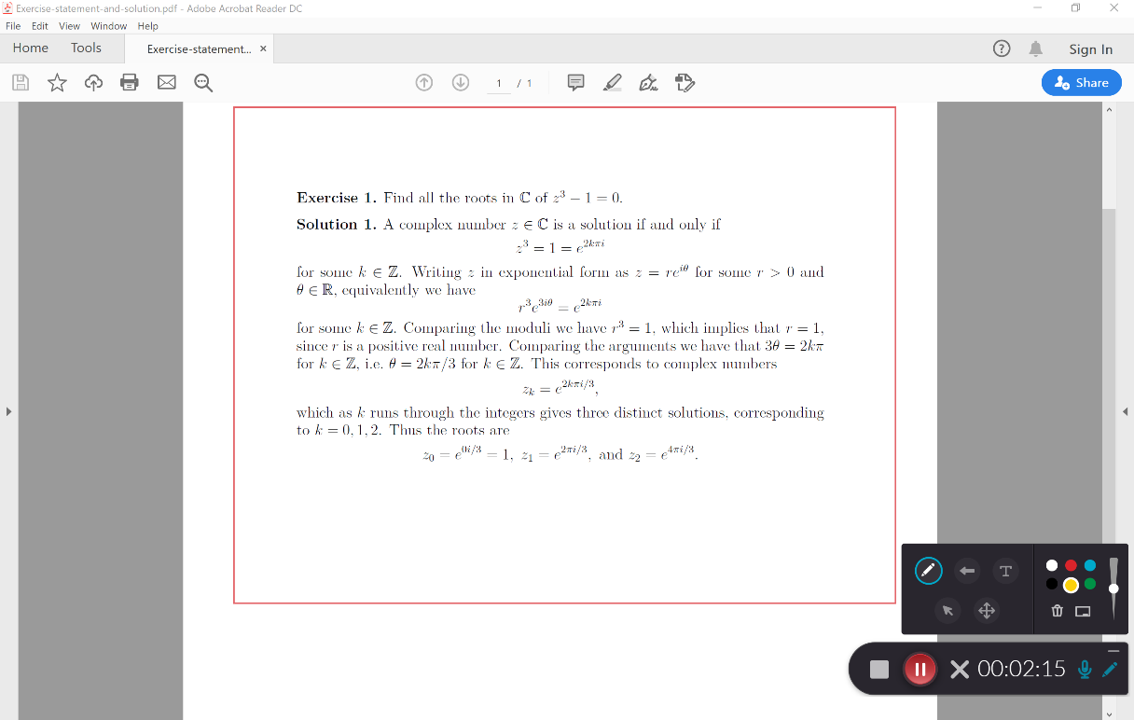

- Once you are done, select the left-hand square end recording button.

- Kaltura will display a screen with a preview of your recording and fields for the Title, Description, and Tags. Preview the recording to check you are happy with it, and that everything was captured that you want, and nothing more. This last point is particularly relevant if you are moving between windows – be sure not to record, however briefly, anything you do not want students to see (emails etc.).
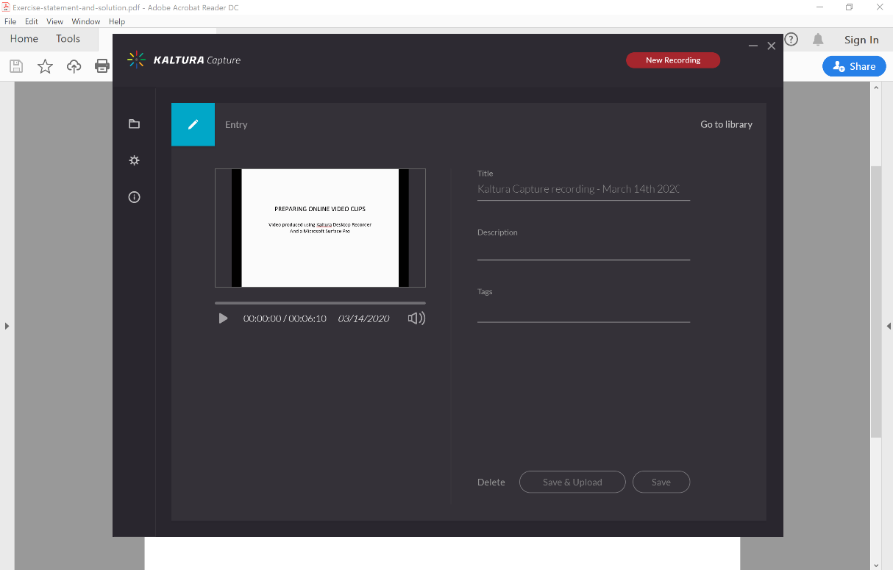
- Select Save and Upload. Kaltura then saves the recording and uploads it to Media Hopper Create as a private item, visible only to you (n.b. not yet to Learn – do not worry about anything becoming available yet).

.
- This will take a few minutes, depending on the length of the recording.

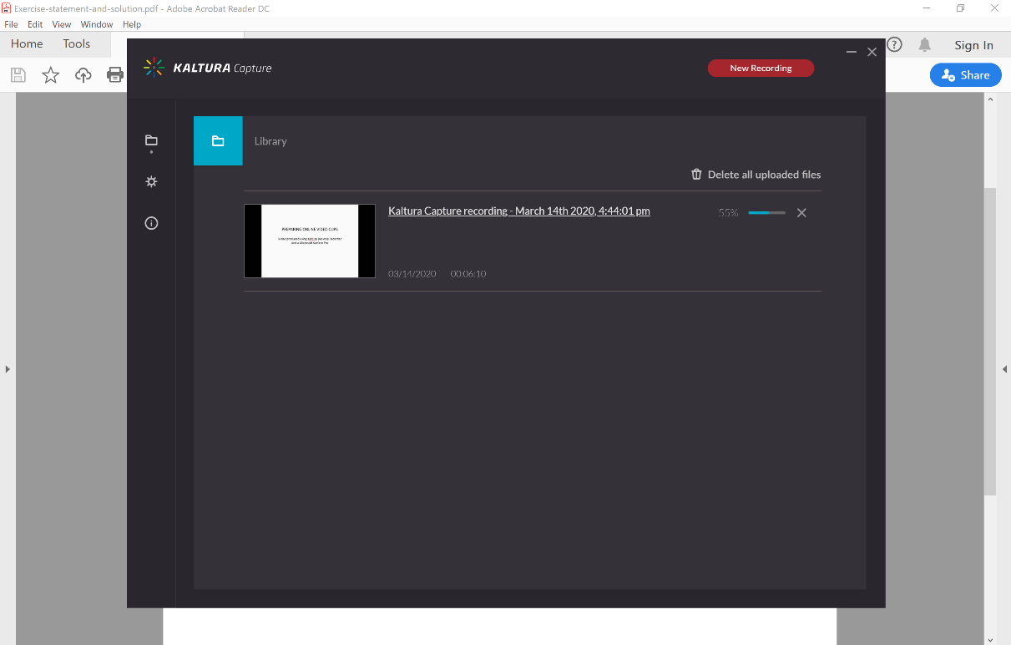

- Kaltura should notify you once the recording is uploaded. You will then see your recording in your Kaltura library.

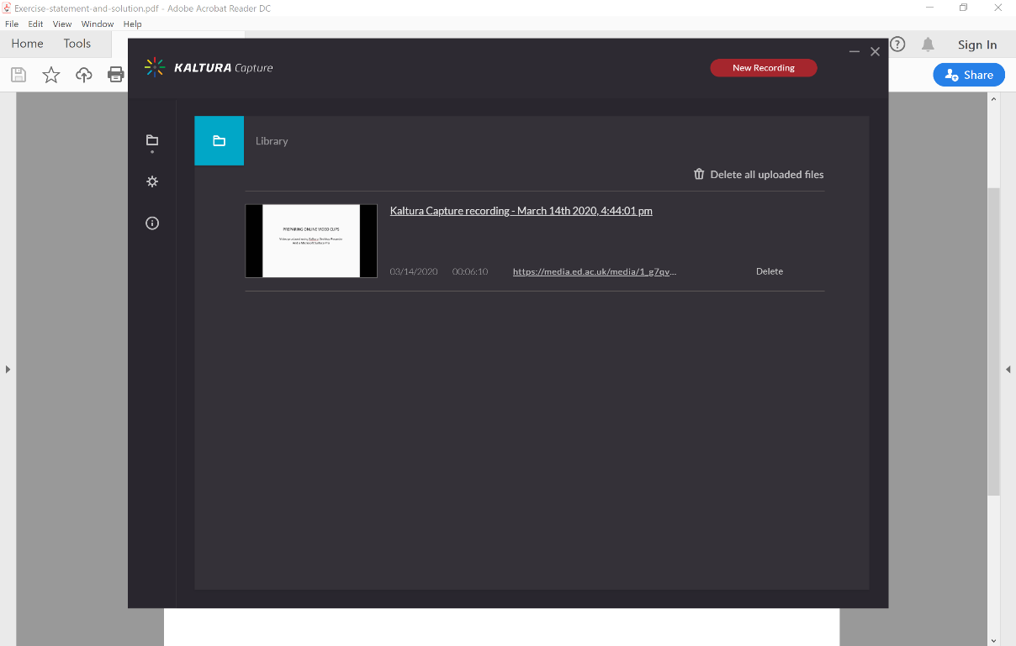

- Return now to you browser, which was last displaying the Kaltura Capture Desktop Recorder Page. Select Back.
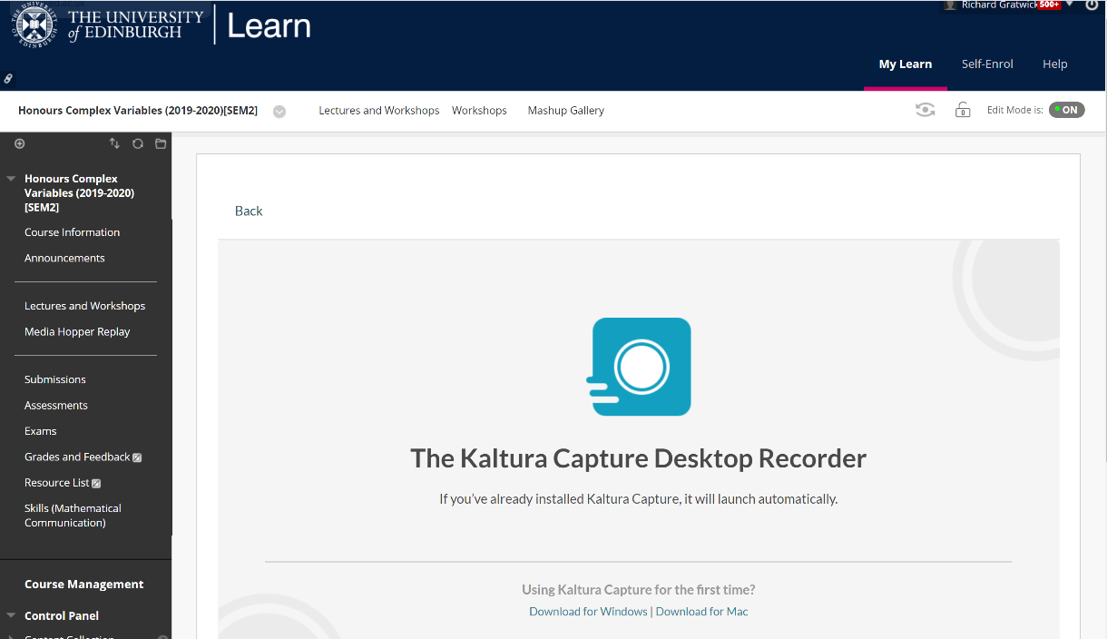
- This returns you to your list of content in your My Media Library. Your new recording should be at the top. Even once it has uploaded, it might still be processing – this is indicated by revolving cogs in the preview panel. Once it has finished it will display the usual preview of the opening of the recording. Click Select.

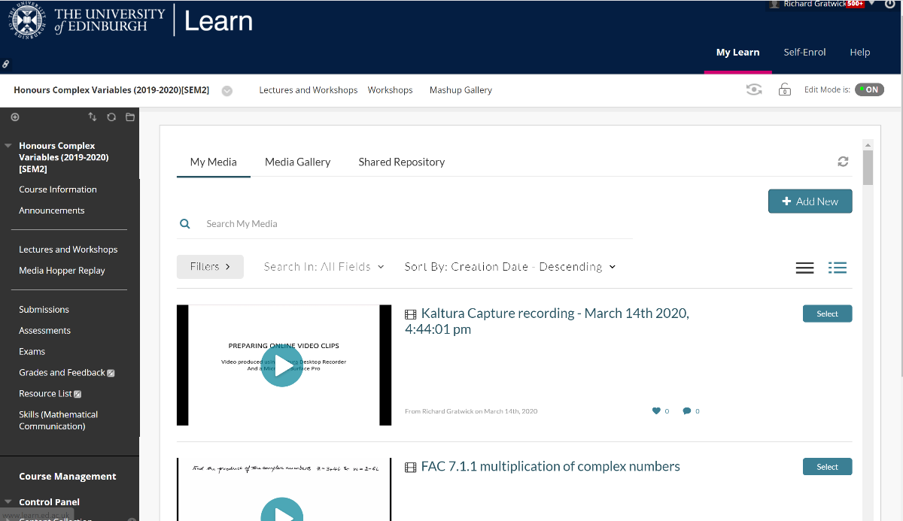

- Choose “No thanks” to “Would you like to submit this media as assignment?” You are now taken to the usual Learn Item creation page, which you should complete as usual with a title, description, and availability options at the bottom. Then click Submit.

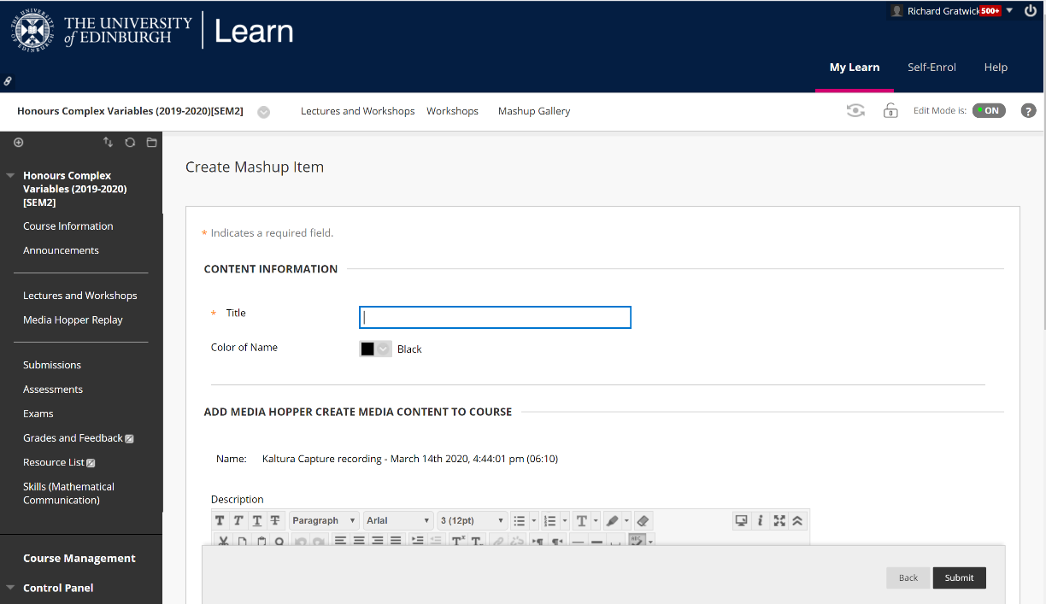

- Your recording is now available on your Learn page!
