Matilda Bird Study plan
14th October 2020
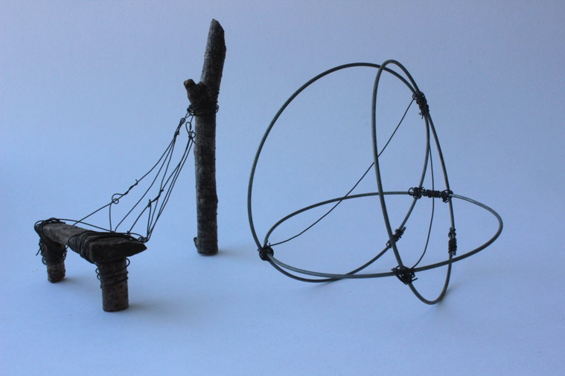

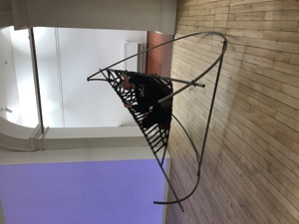
1)start by trying to identify two or three works that you have made over the last year and that you conceder could give you good starting points.

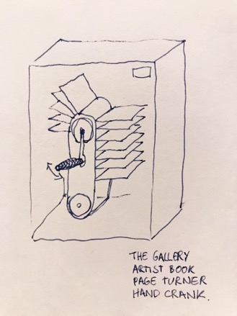
- my series of chair models were really helpful in evolving my initial ideas and sketches through their materiality. Also, They were defiantly the most effective means of showing people what I was thinking about creating. Which is invaluable when needing to work alongside technicians to actualise the work. So I think model making is a great means for me to evolve and develop ideas around a subject.

- My finished chair was greatly rewarding as it was the first time I’ve worked at this scale and I loved that the audience was able to interact with it and it could offer them an experience. I also love that it’s a functional piece.
- Artist books elective was a great idea generator for me, enjoyed investigating pop up and making my own pop up swing series so I feel continuing with book investigations could help me further researching toward larger pieces.i plan of doing several wild camps this semester and thought that making a small book of sorts for each trip could be a great way to document them and contain research.
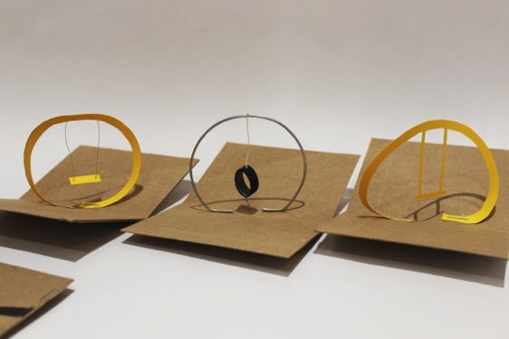
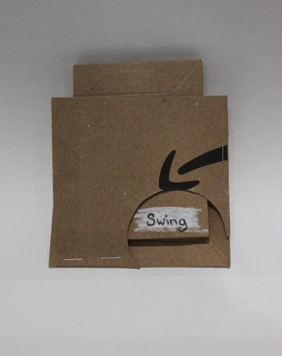
2)is it possible to extend where these works have taken you (e.g. through looking at materials,scale,context.,detail…)?

- I defiantly feel making small scale pieces helps me prepare and work out larger ones so I think I need to continue that process and also maybe hone in on my technique and finishing quality and if executed well the pieces can stand for themselves as not all pieces will be actualised.
- Small scale also makes playing with new materials quicker and easier?

3) what adjustments will you need to make when considering your current working environment? Make a list of five ways you can do this

- WORK SMALL for storage reasons
- do more photography doesn’t take up room,no waste products and is a great way to document.
- a more selectful means of material, again space, cant hord loads of odd ‘possible’ bits hanging around my room
-re-using materials and recycling projects that have been unsucseesful
-plan trips- mainly because my ecological concerns can hold me back from actually producing work for fear of being wasteful. I feel that being in the land will inspire me and provide me with far reaching sources of inspiration and subject. Also potential settings and locations for work to be made/presented.

4)what primary and secondary research do you need to undertake? This could include places you need to visit or objects you need to draw or photography, text you need to read, artists you want to look at, material research you’d like to do. Make a list of ten research ideas.

1.chair research-previous designs and materials
2.clay experiments
3.wild camping trips throughout Scotland
4.exsperimental photography in the landscapes
5.drawings of chairs
6.Richard long
7.Andy Goldsworthy
8.using waste materials for example old inner tubes and tiers (things that you can recycle and that cant break down)
9.regenerating materials- using my paper waste to make new paper turn that into sketch book ect ect
10.learning traditional craft methods.
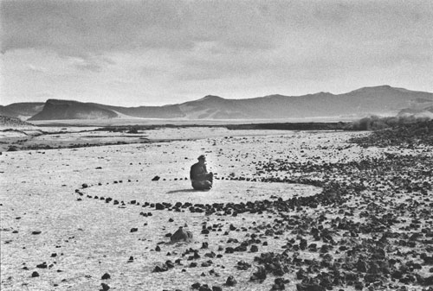
Photo of sculpture by Richard Long.
5)short term goals
-to get into nature and gain a sense of direction for my work, starting points for investigations
-to start generating ideas through sketches and photographs
-work towards progressing my model making skills particularly in clay as I’m fairly new to it and it’s a material I can see myself using comfortably from home with a range of possibility’s.

6)long term goals
-a clear set of personal guidelines of which my work sits within, and a meaning to my work.
Quieten down my struggle between beauty and ethics
-to establish a large database of research into natural and waste materials
-to have a series of work that ties together nicely
-to have greater practical skills for making for example confidence with machinery for work working, a basic understanding of joinery and traditional making methods

