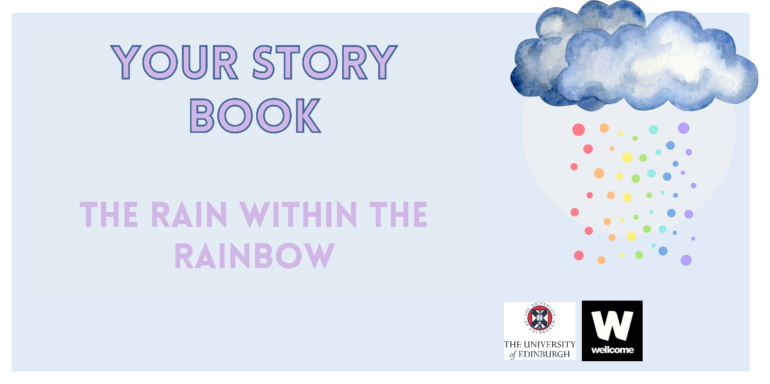

Hello and thank you for your interest in the Rain within the Rainbow – we are really looking forward to learning more about you. This Story Book can be completed as a stand-alone activity (which you can return to us via email or in the post), or it can be used to prepare to take part in a conversational interview with a researcher from our team.

How to use the Story Book
This Story Book can be used digitally or you can print it out and write on it. We encourage you to use the Story Book however it is helpful to you: you can add photos, bits of important paperwork, anything you would like to share with us. You can draw, write, and scribble on it, copy and paste digital objects, add bits in or rip bits out - it’s your booklet and we want it to be useful to you.
If you would like to share your completed booklet with us, you can email it to us, or if you have completed a paper copy, you can take photos of the parts you would like to share and send them to us. If you would prefer to share the full paper copy you can bring it with you to your interview (if in person) or you can post us the paper copy back. If you want us to include your Story Book in the research, you will need to fill out the release form (on page 4-5) to give us ‘official’ permission to do so.

Address for posting your Story Book (if you want):
Hazel Marzetti,
Doorway 6, Old Medical School,
Teviot Place, Edinburgh, EH8 9AG
Please be aware that posting documents comes with risks. We cannot guarantee the safety of documents whilst in the postal service.

If you would like to use the Story Book as part of an interview
The Story Book mirrors the questions that you will be asked in the interview, so you know what we’ll ask your about and there shouldn’t be any big surprises. If you would like to, you can use the Story Book to prepare for the interview and think about what you would like to tell us, or use it to jog your own memory during the interview. If you choose to do this, you can share this booklet with us before, during or after your interview – but you are also welcome not to share it, and use it instead as a personal reflection tool.

Before you get started
Before taking part in this project, you may wish to reflect on whether taking part at this time, is the right decision for you. We encourage you to discuss taking part with anyone you would find it helpful to talk it over with (we will keep your participation confidential, but you do not have to). We (inspired by our friends at the National Suicide Prevention Alliance) have also put together a list of questions that it might be useful to think over before taking part in the research which you can find here [insert hyperlink to reflection questions document].

Get in touch
Please remember that if you have any questions or would like to talk about what taking part in this research is like, you can get in touch by email RainWithinTheRainbow@ed.ac.uk or by phone 07425535848

Consent form for sharing your workbook

This form records what you would like the research team to do with the parts of your workbook that you have shared with us. You have three options, please only pick one option.

Name (this does not have to be your real name):

Please choose an alternative name that we will refer to you with in outputs from this research – if you leave this blank, we are happy to choose a name for you):

Pronouns:

Email address (optional if you would like us to update you on the research or contact you for an interview):

Date:

I am happy for the parts of my workbooks that I have shared with the research team to be anonymously included in analysis, reports, publications, resources, presentations, archives, and events.

I am happy for the parts of my workbook that I have shared with the research team to be included in analysis. I do not want the pages from my workbook to be shared or reproduced, but they can be described in reports, publications, resources, presentations, archives, and events.

I have shared parts of my workbook with the research team, so that I can refer to it during my interview, but I do not want my workbook to be used in analysis for this research.

Please note that if you include photographs in this Story Book, you must make sure that anyone in those photographs has given permission, or alternatively please cover their faces so we will not recognise them.

Consent Form for taking part

You must make a mark in the boxes on the right-hand side of the table below to indicate your consent to take part.

I confirm that I have read and understood the Participant Information Sheet (Version 1.1 dated 02 10 2025) for the above study.

I have been given the opportunity to consider the information provided, ask questions and have had these questions answered to my satisfaction.

I understand that my participation is voluntary and that I can withdraw from the study at any time without giving a reason and without my medical care or legal rights being affected.

I understand that my anonymised data will be stored for a minimum of 10 years and may be used in future ethically approved research.

By marking this box (right) I agree to take part in the above study.

Optional: I would like the research team to get in touch (via the email address I have provided above) to invite me to interview.

Optional: I would like the research team to keep in touch via my email address (above), to share the research findings and other research opportunities.

Section 1: Getting to know you

Please use this section of the book to introduce yourself, and tell us anything you would like us to know about you, your story and your history - sharing as much or as little as you feel comfortable with.
This does not need to relate to your experiences of suicidal distress – but can include anything that you would like someone to understand about you, your past, and your hopes for the future, before telling them about your experiences of suicide.
Reminder: please do not feel you have to do this activity. It is designed to get you thinking about anything you would like to share, but if there isn’t anything, that is fine by us.
Throughout this booklet, you’ll notice a series of timelines, pathways, grid systems, and outlines, as well as blank spaces, which you can use across the four sections of this story book. You do not need to use them, but we wanted to provide plenty of options. Use what works for you, feel free to delete anything that doesn’t and add in something different, it’s your booklet!

Question 1: What do you think is important for us to know about you before learning about your experiences of suicide?

You can include whatever is important to you in your answer, but we know that some people find prompt questions helpful and so we have included some here:
- Which parts of your identities, experiences or characteristics do you think have been important to you or do you think it would be important for others to understand about you?
- What has life been like for you?
Thinking about your life to date (from childhood to now)
- Which people and relationships have been important to you?
- Which places (online or offline) have been important to you?
- What have been your most important moments or events? (this could include births, marriages, deaths, life events with your partner/s, trips, achievements at school or work, social events)
- What was going on around you in the outside world? Were there any big changes that were important or influential to you?
- How was ‘coming out’ for you (to yourself or to others in your life)?

Question 1: What do you think is important for us to know about you before learning about your experiences of suicide?



Section 2: Understanding your experiences of suicide
The second part of this Story Book will focus on your experiences of suicide, including suicidal thoughts, feelings or attempts.
We know that reflecting on these experiences can be emotional, and may be distressing, please remember to take regular breaks and to pay attention to how you’re feeling. If you’re finding working on the reflective activities difficult, please do not continue to work on them, and consider reaching out to a trusted person to share how you’re feeling; we have also included some links to LGBTQ+, mental health and suicide prevention listening services at the back of this booklet who are there to help.
If helpful, add to what you’ve written or drawn already using a different coloured pen (and remember to tell us what the colours mean to you!).

Question 2: What would you like to tell us about your experiences of suicide?

You can include whatever is important for you to tell us about your experience of suicidal thoughts, feelings or attempts, but some things you might want to think about are:
- What would you like to tell us about your experiences of suicide?

- What is your first memory of suicide?

- Have there been other times when you have had experiences of suicide?

- Have there been any differences you noticed in your experiences of suicide over time (for example, differences in the length of times you experienced suicidal feelings, differences in feelings or emotions or the intensity of them)?

- What do you feel was going on for you, or around you, that made living feel hard at those times?

- Are there any places or locations that you particularly associate with your experiences of suicide?

- Do you think your experiences as an LGBTQ+ person affected your experiences of suicide? If so, in what ways?

Question 2: What would you like to tell us about your experiences of suicide?



Section 3: living with, through and beyond suicidal distress
In this section we are interested in learning more about what has helped you to cope with suicidal thoughts and feelings, and survive. We know that everyone has different experiences of suicide, and that some people taking part in this research may be discussing feelings they live alongside every day, whilst others may be thinking about experiences of suicide that happened a long time ago.

Question 3: what helped or would help life to feel more liveable?
You may want to add your answers into your previous responses, but if you would prefer to start a fresh, we have included additional pages here. To remind you, please feel free to write, draw, and add in any documents and images that you would like to share.
Please only engage with the questions that feel relevant to your experiences and helpful to answer.
- Who or what helped you to cope at times when you felt suicidal?

- What does or did supportiveness look and/or feel like for you?

- Who or what has helped you to manage living alongside suicidal feelings, or to experience a sense of recovery?

- Are there any places (digital or physical) that you found helpful, hopeful or soothing at times when you were feeling suicidal? What are or were they like?

- What has helped you to feel hope for the future? What makes life liveable for you?

- Do you have any experiences of accessing, or trying to access, support for suicide through professional services? This could include the NHS (e.g. GPs, mental health services, A&E), private providers (such as counselling or psychotherapy), or charities (e.g. peer support, helplines, advocacy workers). How was this for you? Did you get the support you needed?

- Did you try to connect with LGBTQ+ organisations, groups, services or individuals? If so, how was this for you?

- Have you supported others experiencing suicidal distress? What has this been like for you?

Question 3: what helped or would help life to feel more liveable?



Section 4: Support for LGBTQ+ people experiencing suicidal distress

As part of this research, we are really keen to think about how support for people experiencing suicidal distress might be developed or improved. We know that many people reach out to both professional services and to their own networks in times of distress. With this in mind, we want to hear from you what your ideal design of support for suicide would be.

Question 4: What should support for LGBTQ+ people experiencing suicidal distress be like?
- Thinking about the people that supported you at times where you were feeling suicidal, what do you think it was important for them to know whilst they were supporting you, and was there anything you wish they had known that they perhaps didn’t?
- What support do you think should be available to people experiencing suicidal distress? What would the most important features of support be?
- Where would you want support to be located? Are there any important considerations you can think of for what spaces and places for support should look or feel like?
- How should support be accessed and who would it be delivered by?
- What would you want to keep, get rid of entirely, or change from existing approaches to supporting people experiencing suicidal distress and suicide prevention?

Question 4: What should support for LGBTQ+ people experiencing suicidal distress be like?

Change
Keep
Stop
Thinking about existing services that you have accessed for support as an LGBTQ+ person experiencing suicidal distress, what would you like to:


The Rain Within the Rainbow
Participant details

These questions will help us to describe who has taken part in this research and ensure that we are talking to a diverse range of people. None of the questions are compulsory, if you don’t want to share any details, just leave the section blank.
1. How old are you?
2. Which region in the UK are you located in?
3. What are the first three letters of your postcode?
4. Please describe your ethnicity:
5. Please describe your sexual orientation:
6. Please describe your gender identity:
7. Do you consider yourself to be trans or have a trans history?
8. If you consider yourself to be religious, please tell us which religion:
9. Do you consider yourself to have a disability? (please share any details you would like)
10. Do you consider yourself to have a mental health problem? (please share any details you would like)
11. Do you consider yourself to be neurodiverse? (please share any details you would like)
12. Are you currently (indicate all that apply, and feel free to write below the list if there is something you’d like to add):
Employed full-time | Retired | In education
Employed part-time | Unemployed | Something else
13. If you are employed, what is your job role?
14. If in education, have you ever received free school meals?
15. What is the highest qualification that you have received?

We want to say an enormous thank you for taking part in the Rain Within the Rainbow’s Story Book. We believe that taking personal, lived experiences into account in this research is vital and we hope that you have found our approach respectful, sensitive and supportive.
Your efforts are essential for informing a better understand LGBTQ+ suicide in the UK, which, we hope, will be able to inform research, policy making and practice.
If you have given us your email address and consented to us contacting you either to arrange an interview or to keep you updated with the research findings and future events and opportunities, then you can expect to hear from us shortly.
If you would like to speak to us, you can contact us via email: RainWithinTheRainbow@ed.ac.uk or by phone 07425535848

Sometimes, talking and thinking about suicide can raise difficult feelings or emotions. If you would like to talk about those feelings, please do reach out to one of the following help lines, or speak to a friend or family member.
Samaritans – provides a 24-hour listening service for people of all ages, their helpline can be accessed by calling 116 123 or alternatively you can email jo@samaritans.org.
SHOUT 85258 is a UK-based free, confidential, text support service that is available 24/7
Papyrus: are a suicide prevention charity, open 24/7, working with people aged 35 and under. You can contact them by phone 0800 068 4141, by text 88247, or by email pat@papyrus-uk.org
LGBT Specific online support and helplines (not 24/7):
Switchboard LGBT+ Helpline – this LGBT+ helpline is based in London and helps LGBT+ people of all ages from all across the UK and are open every day from 10am to 10pm. To get in touch, call: 0300 330 0630 or email hello@switchboard.lgbt (reply within 5 days).
LGBT Helpline Scotland (phone, email, LiveChat): Tuesday, Wednesday, Thursday (12-9pm) and Sunday (1-6pm). Call 0300 123 2523, email helpline@lgbthealth.org.uk or to see their suicide support resource A Manual for Me: https://www.lgbthealth.org.uk/resource/manual-for-me-lgbt/
Mind Out are on an LGBTQ organisation provide mental health support and resources which you can check out here: https://mindout.org.uk/

