- Theory
In the era of classical Hollywood cinema, viewers were encouraged to identify with the protagonists, who were and still are overwhelmingly male. Meanwhile, Hollywood women characters of the 1950s and 1960s were, according to Mulvey, coded with "to-be-looked-at-ness" while the camera positioning and the male viewer constituted the "bearer of the look". Mulvey suggests two distinct modes of the male gaze of this era: "voyeuristic" (i.e., seeing woman as image "to be looked at") and "fetishistic" (i.e., seeing woman as a substitute for "the lack", the underlying psychoanalytic fear of castration).

Different filming techniques are at the service of making voyeurism into an essentially male prerogative, that is, voyeuristic pleasure is exclusively male. As regards camera work, the camera films from the optical as well as libidinal point of view of the male character, contributing to the spectator’s identification with the male look. Furthermore, Mulvey argues that cinematic identifications are gendered, structured along sexual difference. The representation of powerful male characters is opposite to the representation of powerless female characters. Hence, the spectator readily identifies with the male characters. The representation of powerless female characters can be achieved through camera angle. The camera films women from above, at a high camera angle, thus portraying women as defenseless. Camera movement, editing and lighting are used in this respect as well.

- Why feel uncomfortable
The music video “Magnetic” uses numerous photographic compositions and light-dark contrasts, along with the unique first-person perspective of cinematography, to create the illusion that the viewer is the lecherous voyeur in the girls' dormitory. One could say this approach aims to delight viewers with a voyeuristic perspective, only for them to realize they are the voyeurs themselves—thus triggering moral condemnation and psychological discomfort.

Additionally, the film repeatedly features scenes and action sequences where the girls, upon being spotted by the camera, dash away in the opposite direction. In the dark, corridor-like setting of a shabby residential building, the girls are filmed from a surveillance camera's overhead perspective as they dash through the space. In an empty restaurant-café scene, the girls are seen chatting cheerfully one frame before suddenly scattering in panic upon noticing the camera the next. Within a luxurious golden building, girls in white dresses sprint desperately away from the camera's distant gaze. This kind of camera chase, the imagery of girls running away, places the camera—which empowers the viewer—in opposition to the girls, further reinforcing the act of voyeurism against underage girls. It even leads voyeurism toward more criminal aspects like imprisonment, control, tailing, and violence, thereby further intensifying the viewer's guilt and the anger of being labeled a voyeur, which causes the girls to run away.

On the other hand, according to Mulvey's theory, the minor girl whose privacy is invaded on screen is mistakenly identified as the female viewer. The widespread feminist discourse in contemporary society has significantly reduced women's “compliance” with the gaze. Some active female groups have recognized the “voyeurism” constructed by the screen lens within the system under this patriarchal order, naturally sparking dissatisfaction and anger among female viewers. Furthermore, the camera’s pursuit of the girl and her subsequent escape evoke a sense of personal dread in women who identify with the girl in the video.

- Two Examples to Reference
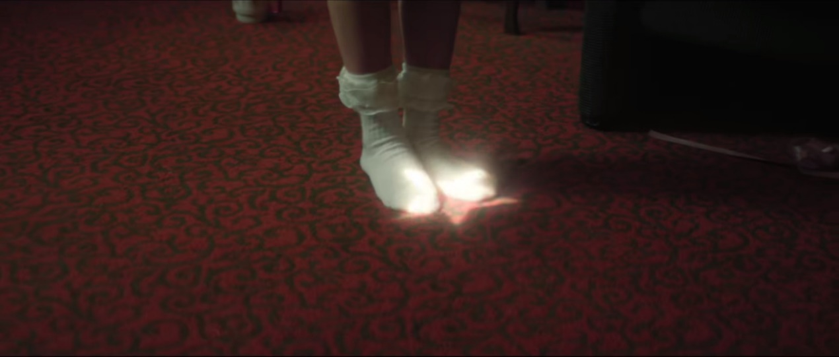
Several females in the video wore outfits that appeared childlike yet accentuated their body curves with hints of sexual innuendo. There are two close-ups of white lace socks and white over-the-knee socks. The camera contrasts the shattered porcelain plate fragments with the foot of a young girl completely covered in white socks, and the shadows on the red and black ground with a beam of light on the white socks. This creates a stark contrast against the dark background, guiding the viewer's gaze to the girl's white socks, curled toes, and bare legs against the dark background.
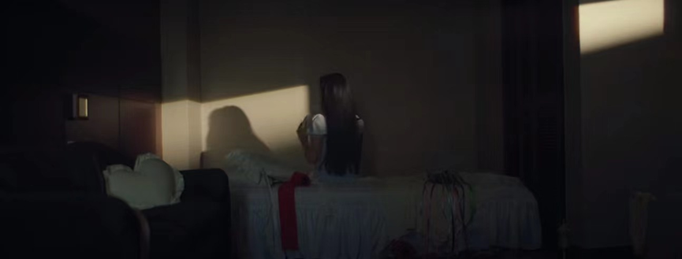
The scene depicts a young girl in pajamas within the intimate chaos of a bedroom. By framing her from behind and using dim lighting. It is barely illuminated by the natural light from the window which creates a private and sexually sensitive image. The voyeur in the music video is the viewer outside the screen.

References
Mulvey, Laura (Autumn 1975). "Visual pleasure and narrative cinema". Screen. 16 (3): 6–18.

Smelik, Anneke (1995), "What Meets the Eye: Feminist Film Studies" in Buikema, Rosemarie (ed.), Women's Studies and Culture. A Feminist Introduction to the Humanities, pp. 66–81.

