- Theory
In the era of classical Hollywood cinema, viewers were encouraged to identify with the protagonists, who were and still are overwhelmingly male. Meanwhile, Hollywood women characters of the 1950s and 1960s were, according to Mulvey, coded with "to-be-looked-at-ness" while the camera positioning and the male viewer constituted the "bearer of the look". Mulvey suggests two distinct modes of the male gaze of this era: "voyeuristic" (i.e., seeing woman as image "to be looked at") and "fetishistic" (i.e., seeing woman as a substitute for "the lack", the underlying psychoanalytic fear of castration).
在经典好莱坞电影时代，观众被鼓励去认同主角，而这些主角在过去乃至现在，绝大多数都是男性。同时，根据穆尔维的观点，20世纪50至60年代的好莱坞女性角色被赋予了“待审视性”，而摄像机的机位和男性观众则构成了“凝视的承担者”。穆尔维提出，这一时代的男性凝视有两种不同模式：“窥淫式”（即，将女性视为“待审视”的影像）和“恋物式”（即，将女性视为“缺失”的替代品，这种“缺失”源于精神分析学中对阉割的潜在恐惧）。

Different filming techniques are at the service of making voyeurism into an essentially male prerogative, that is, voyeuristic pleasure is exclusively male. As regards camera work, the camera films from the optical as well as libidinal point of view of the male character, contributing to the spectator’s identification with the male look. Furthermore, Mulvey argues that cinematic identifications are gendered, structured along sexual difference. The representation of powerful male characters is opposite to the representation of powerless female characters. Hence, the spectator readily identifies with the male characters. The representation of powerless female characters can be achieved through camera angle. The camera films women from above, at a high camera angle, thus portraying women as defenseless. Camera movement, editing and lighting are used in this respect as well.
不同的拍摄技巧都服务于将窥淫癖塑造成本质上的男性特权，也就是说，窥淫的快感是男性独有的。就摄影工作而言，摄像机从男性角色的视觉以及力比多视角进行拍摄，这有助于观众认同男性的凝视。此外，穆尔维认为，电影中的认同具有性别特征，是沿着性差异构建的。强大男性角色的呈现与无力女性角色的呈现形成对比。因此，观众很容易认同男性角色。无力女性角色的呈现可以通过拍摄角度来实现。摄像机从上方、以高角度拍摄女性，从而将女性描绘成毫无防备的样子。在这方面，摄像机运动、剪辑和灯光也会被用到。

- Why feel uncomfortable
The music video “Magnetic” uses numerous photographic compositions and light-dark contrasts, along with the unique first-person perspective of cinematography, to create the illusion that the viewer is the lecherous voyeur in the girls' dormitory. One could say this approach aims to delight viewers with a voyeuristic perspective, only for them to realize they are the voyeurs themselves—thus triggering moral condemnation and psychological discomfort.
音乐视频《Magnetic》运用了大量的摄影构图和明暗对比，再加上独特的第一人称摄影视角，营造出一种观众仿佛是女生宿舍里那个好色偷窥者的错觉。可以说，这种手法旨在用偷窥的视角取悦观众，却又让他们意识到自己就是那个偷窥者——从而引发道德谴责和心理不适。

Additionally, the film repeatedly features scenes and action sequences where the girls, upon being spotted by the camera, dash away in the opposite direction. In the dark, corridor-like setting of a shabby residential building, the girls are filmed from a surveillance camera's overhead perspective as they dash through the space. In an empty restaurant-café scene, the girls are seen chatting cheerfully one frame before suddenly scattering in panic upon noticing the camera the next. Within a luxurious golden building, girls in white dresses sprint desperately away from the camera's distant gaze. This kind of camera chase, the imagery of girls running away, places the camera—which empowers the viewer—in opposition to the girls, further reinforcing the act of voyeurism against underage girls. It even leads voyeurism toward more criminal aspects like imprisonment, control, tailing, and violence, thereby further intensifying the viewer's guilt and the anger of being labeled a voyeur, which causes the girls to run away.
此外，这部电影多次出现这样的场景和动作片段：女孩们一旦被镜头捕捉到，就会朝着相反的方向飞奔而去。在昏暗、类似走廊的破旧居民楼场景中，镜头以监控摄像头的俯视角度拍摄女孩们冲过这个空间的画面。在一个空荡荡的餐厅兼咖啡馆场景里，前一帧女孩们还在愉快地聊天，下一帧她们注意到镜头后就突然惊慌地四散开来。在一座豪华的金色建筑内，身着白色连衣裙的女孩们拼命地逃离远处镜头的注视。这种镜头的追逐、女孩们奔跑逃离的画面，将赋予观众权力的镜头置于与女孩们对立的位置，进一步强化了对未成年女孩的偷窥行为。它甚至将偷窥引向更具犯罪性质的层面，如监禁、控制、跟踪和暴力，从而进一步加剧了观众的罪恶感，以及因被贴上偷窥者标签而产生的愤怒——正是这种标签导致女孩们纷纷逃离。

On the other hand, according to Mulvey's theory, the minor girl whose privacy is invaded on screen is mistakenly identified as the female viewer. The widespread feminist discourse in contemporary society has significantly reduced women's “compliance” with the gaze. Some active female groups have recognized the “voyeurism” constructed by the screen lens within the system under this patriarchal order, naturally sparking dissatisfaction and anger among female viewers. Furthermore, the camera’s pursuit of the girl and her subsequent escape evoke a sense of personal dread in women who identify with the girl in the video.
另一方面，根据马尔维的理论，屏幕上隐私受到侵犯的未成年女孩被错误地等同于女性观众。当代社会中广泛存在的女性主义话语极大地降低了女性对这种凝视的“顺从性”。一些积极的女性群体已经认识到，在这种父权秩序下，系统内部的屏幕镜头构建了“窥淫癖”，这自然引发了女性观众的不满和愤怒。此外，镜头对女孩的追踪以及她随后的逃跑，会让那些在视频中与女孩产生共鸣的女性产生一种个人化的恐惧感。

- Two Examples to Reference
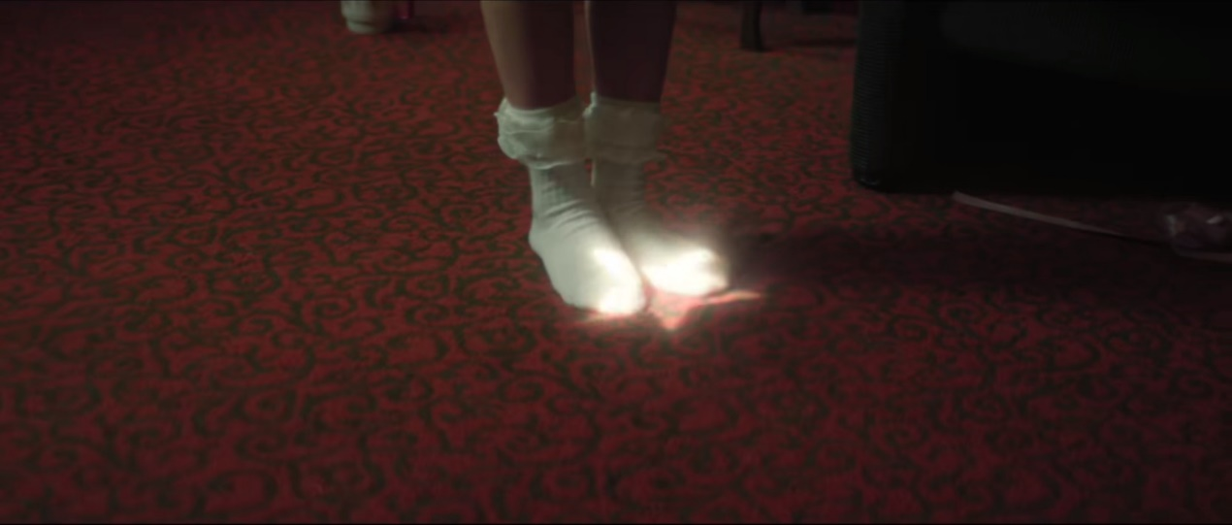
Several females in the video wore outfits that appeared childlike yet accentuated their body curves with hints of sexual innuendo. There are two close-ups of white lace socks and white over-the-knee socks. The camera contrasts the shattered porcelain plate fragments with the foot of a young girl completely covered in white socks, and the shadows on the red and black ground with a beam of light on the white socks. This creates a stark contrast against the dark background, guiding the viewer's gaze to the girl's white socks, curled toes, and bare legs against the dark background.
视频中的几位女性穿着看似孩童般的服装，却又凸显出她们的身体曲线，还带有一丝性暗示。视频中有两个特写镜头，分别是白色蕾丝袜和白色过膝袜。镜头将破碎的瓷盘碎片与一只完全被白袜子包裹的年轻女孩的脚进行对比，还将红黑地面上的阴影与照在白袜子上的一束光进行对比。这在深色背景下形成了鲜明的反差，引导观众的目光投向女孩的白袜子、蜷缩的脚趾以及在深色背景衬托下的裸露腿部。
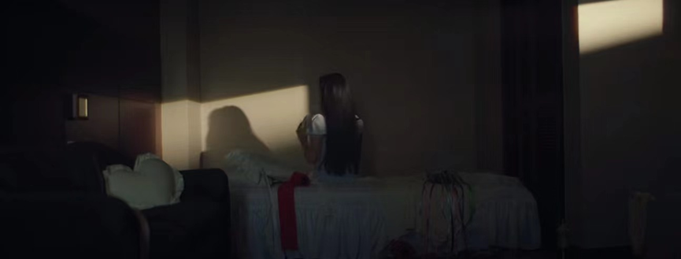
The scene depicts a young girl in pajamas within the intimate chaos of a bedroom. By framing her from behind and using dim lighting. It is barely illuminated by the natural light from the window which creates a private and sexually sensitive image. The voyeur in the music video is the viewer outside the screen.
这一场景描绘了一个穿着睡衣的年轻女孩身处杂乱却私密的卧室中。通过从她身后取景并运用昏暗的光线——房间仅靠窗外的自然光勉强照亮，营造出一种私密且带有性暗示的画面。音乐视频中的偷窥者，正是屏幕外的观众。

References
Mulvey, Laura (Autumn 1975). "Visual pleasure and narrative cinema". Screen. 16 (3): 6–18.

Smelik, Anneke (1995), "What Meets the Eye: Feminist Film Studies" in Buikema, Rosemarie (ed.), Women's Studies and Culture. A Feminist Introduction to the Humanities, pp. 66–81.

