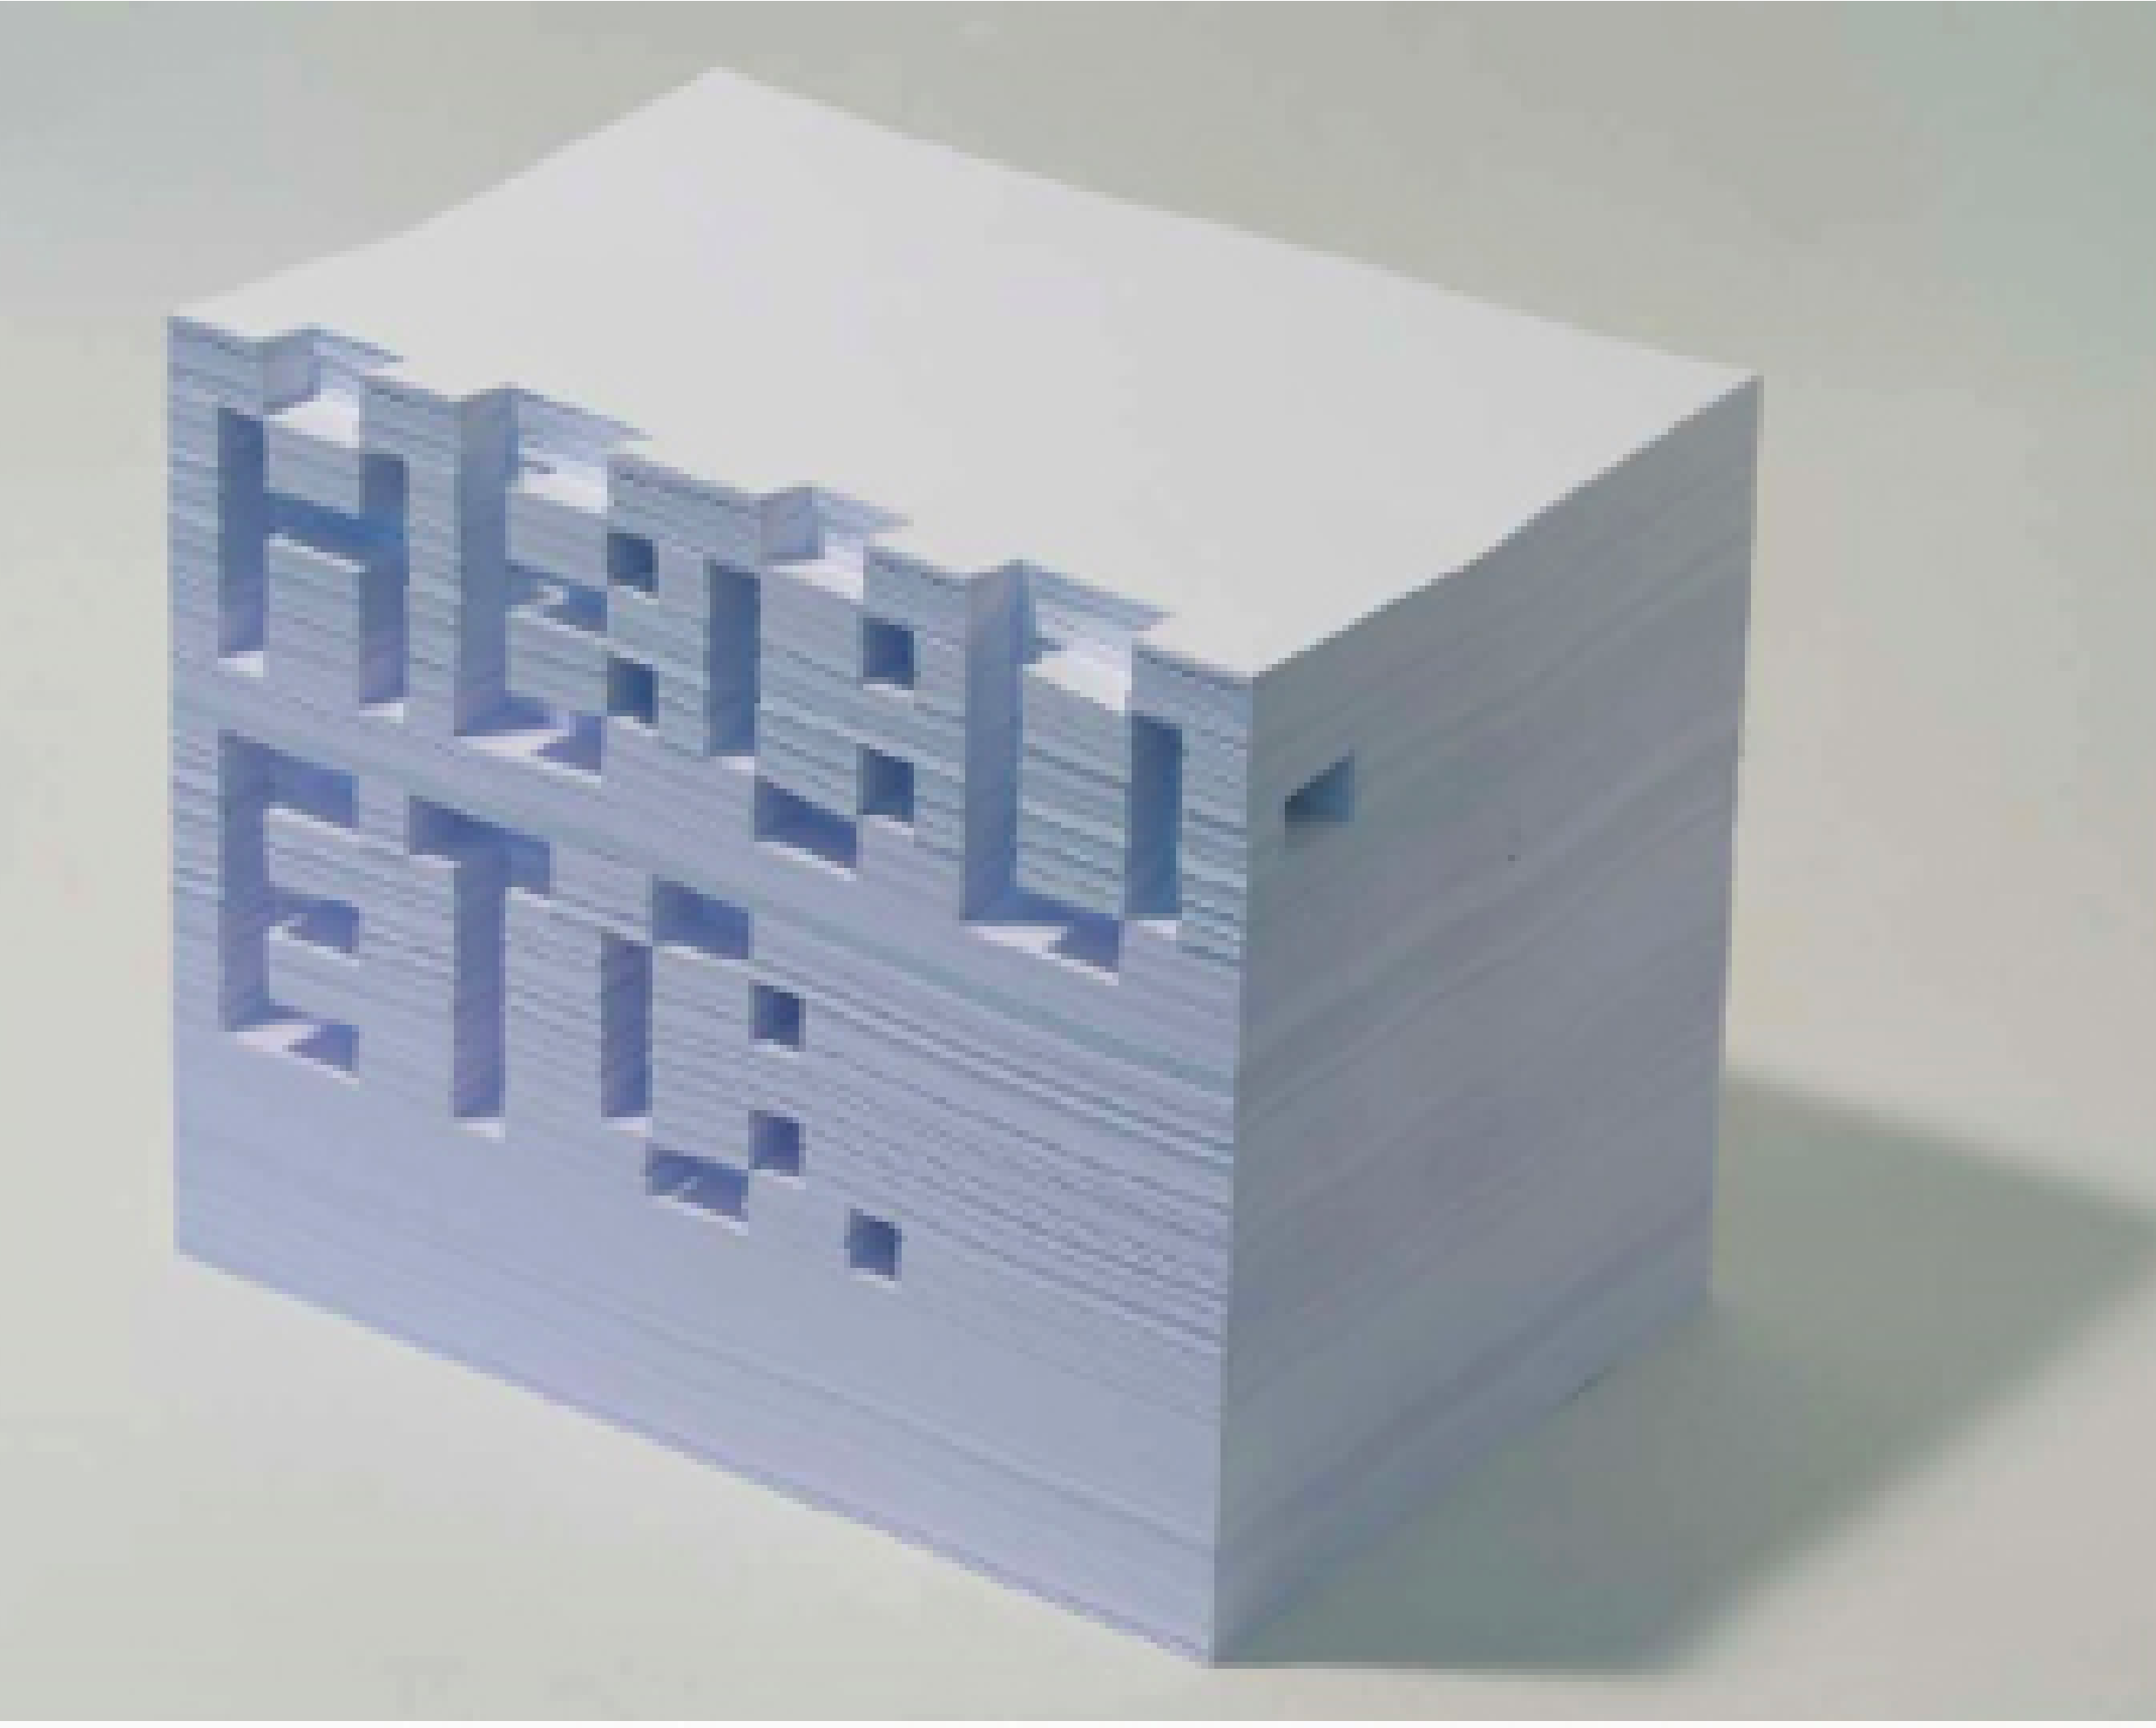
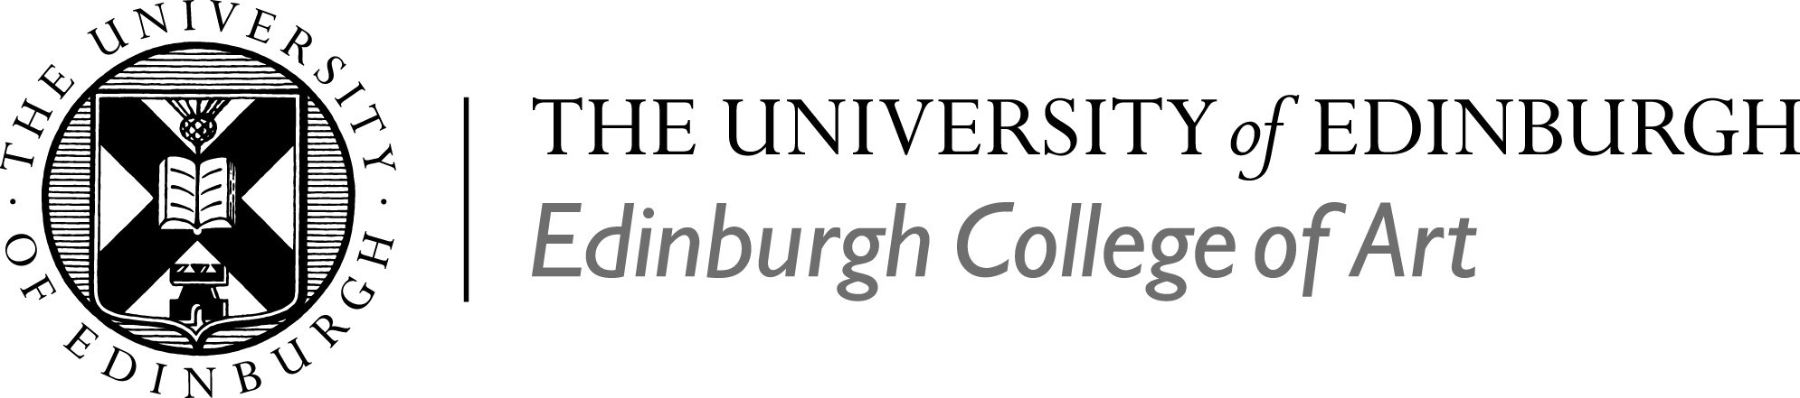
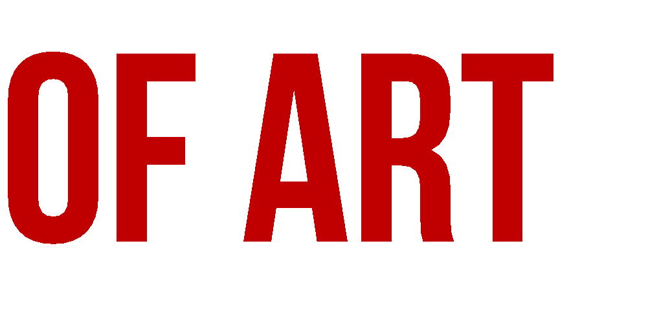
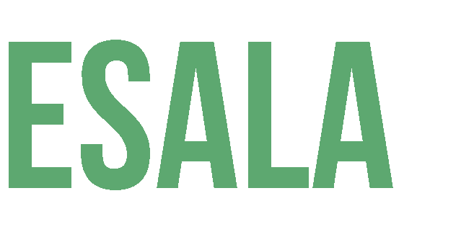
MA Contemporary Art Theory
Programme Handbook

202
1
/
22
Image:
Contemporary Art
Theory
(M
A
)
Neil Mulholland

Disability Statement
A copy of this document can be made available in alternative formats (Braille, large print, electronic, audiotape), on request from the Student Administration and Support Services Team.
Anyone requiring additional support relating to disability, i.e. note-taking, proof reading, etc., should make a first approach to their Programme Director and/or the Student Disability Service.

Contact the Student Disability Service:
Email disability.service@ed.ac.uk

Further information can be found at:
https://www.ed.ac.uk/student-disability-service

Welcome to the Contemporary Art Theory Programme Handbook, to the School of Art, and to Edinburgh College of Art.

This Programme Handbook contains lots of important information about the aims and academic content of your programme. It also explains the way that your programme is structured, and outlines the key administrative details around how degree progression and eventual award are determined.

The programme-specific information contained in this Programme Handbook is designed to work together with the wide range of further supporting information provided through the online ECA Handbook (https://edin.ac/eca-handbook).

The ECA Handbook contains information on many topics of relevance to your day-to-day activities as a student in ECA, including:

- Buildings, spaces, and technology (including details on how to access the physical campus)
- Computing, software, and equipment (including details of how to access software packages provided as part of your studies at ECA)
- Workshops, technical facilities, and materials (including how to book and use them via ECA’s BookIT system)
- Learning and teaching, including assessment and feedback
- Coursework extensions and special circumstances
- The Personal Tutor system
- Student support and representation
- Health, safety, and wellbeing

Hosting the ECA Handbook as an online platform means that it can be updated throughout the year with the most up to date information.

Contents
Section A: Your programme 5
Introduction to the School of Art 5
Programme Information 9
Key Contacts 9
Programme Structure 10
Educational aims of programme 12
Programme outcomes: Knowledge and understanding 12
Programme Assessment 13
The Purpose of Assessment 13
What is a Learning Outcome? 13
The Process of Assessment 14
Formative Assessment 14
Summative Assessment 15
Professional Development Opportunities 15
Professional Bodies 15
Work Placements 16
Section B: 16
General Assessment Information 16
Extended Common Marking Scheme 16
Progression and Award Information 19
Examination Diets 25
Board of Examiners 25
External Examiners 25
Academic Appeals 26

Contemporary Art Theory (MA) Handbook

Section A: Your programme

Introduction to the School of Art

Our Philosophy and Approach
A defining aspect of the MA Contemporary Art Theory is the emphasis it places upon speculative scepticism - not proceeding from the position of knowing what art is; rather, being motivated by speculation on what it might be. The curriculum generates an atmosphere that supports mutual co-operation, a dynamic, intellectually ambitious environment in which staff and students can learn together. To ensure that what we are learning is new to all (staff included), we embark on new educational journeys each semester, finding new ways to support each other’s personal goals.

The MA CAT is a post-studio programme. Art education is still predicated on the assumption that the ‘studio’ is the normative site of learning. Post Studio art (Baldessari 1970-) has challenged this assumption. The studio is a relatively recent invention (as is art) and is, by no means, the sole locus of artistic learning or production. Post-studio art education recognizes some of the more problematic and undesirable consequences of studio-centric art education and actively attempts to instill a broader understanding of what artistic production entails in non-studio sites.

So, what is post-studio practice? Here are a few sceptical speculations that we will update, amend and co-investigate during the programme:

‘After’ | Post-studio is central to foundational and emerging theories of contemporary art, but it is not synonymous with “contemporary art”. Nor is post-studio synonymous with anti-studio. Post-studio signifies what comes after the invention of the studio in the Renaissance; we cannot un-invent the studio and post-studio art does not seek to do so. Rather post-studio might be more concerned with how art is made in non-studio environments.
Open | Post-studio practitioners explore the wider world around them. Since post-studio work looks outwards rather than inwards; might it offer a support system for Open Learning?
Partnership | Post-studio practices are often produced in partnership, by a meshwork of contributors. Partners can be individuals, organisations, objects, machines… What are the implications of working in partnership?
Placement | Post-studio practices are implaced. The sites in which post-studio practices are implaced are myriad and need not be confined to the dependencies of the artworld.
Realist | Since they are implaced and often produced in partnership, post-studio practices are concerned with intersubjective reality. What forms does intersubjective working take?
Collaborative Enquiries | Post-studio practices often pursed a form of collaborative enquiry, working with others towards a common creative focus. In what ways can peers develop collaborative enquiry?
Logic of Scenes | Post-studio practices make their own scenes. These (art) scenes develop their own logic; this underwrites the development of the practices they host. How are scene and what is seen co-constructed?
Multi-hyphenate | Post-studio practice resists identarian thinking – it resists identification with a singular role or media. What are the implications for personhood?
Extradisciplinary | Post-studio practice tends to draw other disciplines into its orbit. In this sense it is extra-disciplinary (rather than interdisciplinary or transdisciplinary).
Organisational | Post-studio practice is frequently organisational in its orientation. It traverses and incorporates curating and arts production rather than consigning these roles to specialists. What are the implications of envisaging artistic knowledges and practices as ‘organisational’ in character? Might it divest power from artists, studios and galleries towards others who want to engage with art?
Inhabited Practices | Post-studio practice is inhabited, not inherent. (Following Dark Organisational Theory) a post-studio practice is positively parasitic in that it must find a host habitat in order to exist. How might practices become implaced, and how do we inhabit these practices?
‘Techniques of the Body’ | If ‘tacit’ forms of knowledge associated with the technical arts are ‘immanent in practice’ (Bourdieu 1977: 27), and habitus reproduces social structures by socialising habits then the reproduction of artisanal learning or academic rituals (habitus) need not rely on the continued maintenance of a specific learning environment (habitat). Practice will change over time, and with it, learning environments will be changed. How do our ‘techniques of the body’ co-create our post-studio environments?
Paragogic | Since it is extra-disciplinary, post-studio practice is a form of paragogy (peer-to-peer learning) rather than disciplina (instruction). Peers find common foci and learn together from each other. How might post-studio education adapt or replace art’s normative ‘teaching’ techniques (the crit, the tutorial)?
Meta practice | ‘Practice’ remains sacrosanct in art education. Post-studio art education remains open regarding the value and importance of practice vis a vis art. It seeks to understand some of the critiques of practice that have emerged from Practice Theory in philosophy and the social sciences and to understand how/if we might develop a more critical, or meta, understanding of what we mean by “practice”.

Our Art School

The School of Art is based in Edinburgh College of Art’s historic Main Building. Edinburgh College of Art’s specialist Library, the University Main Library and the National Library of Scotland (a full copyright library) are close by. We are just ten minutes’ walk from Edinburgh’s major public centres for contemporary art: National Galleries, Talbot Rice, Edinburgh Printmakers, FruitMarket Gallery and Collective. While l ECAlies in the heart of the Old Town in the shadow of Edinburgh Castle; our canvas is the whole world. We attract students from all over the world with very different backgrounds and experiences.

Our Students & Staff

With a shared passion for making interesting things happen, and an eagerness to participate, staff, students and our alumni are the School of Art’s greatest resources. On the MA Contemporary Art Theory (MA CAT) you will be taught by a mixture of practicing artists, critics, visual culture scholars, anthropologists and curators. Many of your tutors combine two or more of these roles bringing an exceptional diversity of expertise and experience to the MA CAT.

Our Networked Learning Community

While most of our grad students and staff are resident on-campus in Edinburgh, some remain resident for part of the academic year in their home countries or are in-residence at an arts venue elsewhere. The MA CAT uses blended learning to ensure that the whole cohort and staff remain in close dialogue not matter where we are in the world. Students are encouraged to undertake placements and fieldwork while on the programme since this enriches all of us. When some of our students are resident in different locations, we, as a programmme, have access to a more diverse range of live/authentic resources (artists, galleries, educational programmes, etc.) Equally, our internationally distributed peer-group can create and disseminate the programme’s artistic activities across multiple global time-zones. The programme is designed to enable us to connect our resources (our Personal Learning Networks), creating a conduit for pooling and sharing what we would struggle to access individually. In this, we all learn how to engage with a range of markedly diverse art scenes and their different host cultures. This ensures that we engage with an ever more diverse range of epistemologies and practices.

Our Partners

As paragogues (peer-to-peer learners), our graduate students quickly build a supportive and tight-knit community, one grounded in the rigorous and experimental combination of artistic research and post-studio practices. As a team, the MA CAT contribute directly to Edinburgh’s contemporary art sector. Graduate students benefit directly from our partners’ teaching and research input into their work, as well as from the considerable resources and experience they offer. Postgraduates will work with a range of Edinburgh College of Art’s external partners, including the Embassy Gallery, Rhubaba, Edinburgh Sculpture Workshop, Edinburgh Printmakers and other adjacent art venues in Scotland and the North of England.

Our Guests

The School invites prominent artists, critics and curators to deliver our Friday Talks.

Visitors also run workshops for our Masters students. Students make regular applications for funding and exhibition opportunities as part of their studies. Many have been selected for major residencies, exhibitions and prizes such as Bloomberg New Contemporaries, Glasgow International Film Festival and Curator Lab.

Our Fabrication Facilities

The programme makes direct use of ECA’s extensive facilities, software and online support for working with sound, digital imaging, web design and video editing.

While they are not essential to your studies, graduate students at ECA also book access to workshop facilities, with specialist technical support. Students also borrow photographic equipment as use the Digital print facilities.

Programme Information

This programme encourages a creative, holistic and practical knowledge of the increasingly expanded field of contemporary art, grounding practical schooling in its sub-disciplines of artistic research, post-studio practice, art criticism, art writing and curating, in addition to knowledge of key histories and theories of contemporary art. The MA CAT programme addresses issues raised by the field of contemporary art as a means of encouraging you to contribute both critically and practically.

MA CAT students think and act. Being contemporary means engaging with multiple perspectives and different ways of learning. MA CATs conduct research in relation to a broad range of creative, cultural and historical contexts in ways that are speculative, writerly, philosophical, organisational, social and economic.

You will apply aesthetics, art theory and criticism, art historiography, anthropology, and critical theory to engage with contemporary art’s variety of media, technologies, images, artefacts, tactics, texts, cultural contexts and professional practices.

At the beginning of each course you will be taken through a VLE (virtual learning environment) containing all briefs and submission deadlines, including how, when and where to submit your work for assessment. You will usually be required to submit written work directly to a VLE.
Learning and continuous assessment takes place through the VLE, in group workshops, in crits, and tutorials through short assignments wherein you are encouraged to exchange ideas relating to your artistic research methods.

Key Contacts

Programme Director

The Programme Director is responsible for the smooth running of the programme, including coordination of teaching and assessment, and programme evaluation. The Programme Director aims to facilitate your orientation and smooth progression through the programme, from initial induction through to the project/dissertation stage, and final completion. The Programme Director also undertakes the function of your Personal Tutor (Director of Studies).

Programme Director: | Professor Neil Mulholland, Chair of Contemporary Art Practice & Theory

n.mulholland@ed.ac.uk

Head of Subject Area, Art: | Dr Linda O’Keefe

Linda.OKeeffe@ed.ac.uk

PG Taught Director, Art: | John Beagles

j.beagles@ed.ac.uk

You can find out more about the postgraduate Art staff via the following link:
https://www.eca.ed.ac.uk/study/postgraduate/contemporary-art-theory-ma

Student Administration and Support Services
Programme Secretary: | Éadaoín Lynch
Email: | art.admin@ed.ac.uk

Programme Structure

MA Contemporary Art Theory
180 SCQF Credits/90 ECTS | The MA Theory programme is one year full-time or two years part-time.

Full-Time: http://www.drps.ed.ac.uk/21-22/dpt/ptmartcont1f.htm
Part-Time: http://www.drps.ed.ac.uk/21-22/dpt/ptmartcont1p.htm

The School of Art’s contemporary art theory programme encourages post-studio practices that are speculative and reflective, engaging in new research practices within the field of contemporary art. It is a team-taught programme, with art staff delivering five courses focussing on current developments in contemporary art theory and practice. The Theory MA supports an applied knowledge of art now, grounding schooling in post-studio practices, curating, arts education, anthropology, artwriting, artistic research and related extra-disciplinary approaches to the arts. The programme supports artistic research methods that are experiential, embodied through and understood by the acquisition of a practice. You will originate new ways of contributing to contemporary art’s expanding field by drawing on related fields, specifically the latest theories and methods in visual, materialist and sensual research, research design, organisational studies, arts education and anthropology.

MA theory students are encouraged and supported to develop a distinctive and ambitious artistic research practice by learning from and working as part of, a local learning community. The curriculum is based on a unique blend of short projects and peer-to-peer learning (‘paragogy’). We place a strong emphasis on learning through doing and you will be involved in developing curatorial and educational projects with Scottish art institutions. For assessment, you will submit project-work that utilises a variety of media, technologies, images, artefacts, tactics, texts, cultural contexts and professional practices.

A defining aspect of our Masters Theory programme is that it places emphasis upon questioning accepted notions of artistic production as a means of encouraging you to develop a highly ambitious research-practice. To this end, we seek to provide specialist support for students wishing to pursue research on and in established fields of contemporary art practices, art theory, artwriting and curating while fully engaging with the ever changing context of emerging media and innovative forms of critical and organisational praxis. In this, the programme is aimed both at aspiring art professionals (curators and critics) and artists who want to develop an artistic research-based practice by extending their practical, theoretical, organisational and economic engagement with contemporary art. It develops from a broad to a specialist understanding of the technical resources and validating contexts in which artists work today, drawing inspiration and nourishment from the experience of our international student cohort.

The MA CAT programme concludes with a major artistic research project that can take either a more practical or theoretical direction. Students on the Theory programme have access to a wide range of studio equipment, technicians and resources, including printmaking, metal, wood, casting, painting, photography, reprographic and digital facilities. As well as being able to work on your preferred media and approaches, you will collaborate with your fellow MA CATs on critical, creative and curatorial projects.

Educational aims of programme

The programme aims to provide you with both an overall level of expertise in recent developments in art practices and related cultural theories and research methods, and a high degree of specialisation within this field, culminating in an original Artistic Research Project.

This programme has the following specific aims:

- To undertake an examination of some key emerging international art practices.
- To analyse the major themes within art theory and curatorial studies that are currently informing these art practices, institutions and related cultural ecologies.
- To explore some of the principal critical, methodological and theoretical positions from other disciplines informing the current production and interpretation of contemporary art and its organisational contexts.
- To provide you with a set of research methods and critical tools necessary for the advanced analysis and creative organisation of your own artistic research.
- To provide you with a set of competencies, skills and understanding that will enable you either to undertake further academic research or to pursue a range of creative careers.
- To explore some of the principal critical and theoretical positions informing the interpretation of your artistic research and its organisational contexts.
- To provide you with a set of competencies, skills and understanding that will enable you to pursue a rewarding life as an artist, writer, curator or arts professional.

Programme outcomes: Knowledge and understanding

By engaging with and completing the Contemporary Art Theory (MA) degree, graduates will have
- Knowledge that covers and integrates most, if not all, of the main areas of the field of contemporary art including its features, boundaries, terminology and conventions.
- A critical understanding of the principal theories, concepts and principles of current art.
- A critical understanding of a range of specialised theories, concepts and principles of contemporary art.
- Extensive, detailed and critical knowledge and understanding in contemporary art and related educational, visual, materialist, sensual and anthropological specialisms, much of which is at, or informed by, developments at the forefront.
- A critical awareness of current issues in contemporary art and in at least one related educational, visual, materialist, sensual or anthropological specialism.

Programme Assessment

The Purpose of Assessment

Assessment has four distinct aims:

1. To promote your learning by providing feedback to improve performance.

2. To evaluate your knowledge.

3. To provide a grade that enables your progress to be established transparently against that of your postgraduate peers in Edinburgh College of Art, the University of Edinburgh, Scotland and internationally.

4. To enable the public (including employers) to apprehend that you have reached an internationally validated and externally assessed level of academic standard.

Throughout your programme you will be required to submit for various forms of assessment. The principal purpose of assessment is to enable you to demonstrate formally the extent to which you have met the objectives of your study.
These are referred to as ‘Learning Outcomes.’ You will demonstrate your achievement of these in other ways, too, including participation in group discussions. Since the programme adopts a peer-support approach to learning (paragogy), all aspects of your participation in this programme formally assessed.

What is a Learning Outcome?

A Learning Outcome is simply a short description of what your assessors hope you will learn by completing the assessment task they set you.

You can learn in many different things in many different ways. Learning Outcomes are intended to be the clear articulation of what you are expected to understand and be able to do in order to successfully complete a defined period of learning such as a specific project or brief. They will be articulated at different levels of generality and specificity depending on the level at which they are aimed.
As a learner in an art college, you construct your learning through relevant learning activities (researching, making, writing, talking, etc.)

Your tutor’s role is to support and maintain a learning environment that relates to and supports the learning outcomes they have designed for you.

The Process of Assessment
The grade you are awarded will correspond to a degree of learning achievement.

At the beginning of each course you will be taken through a Learn page containing all briefs and submission deadlines, including how, when and where to submit your work for assessment. You will usually be required to submit written work directly to Learn or present the work in your studio space, but you should always consult the course Learn page to ensure that you have the correct information on this.
Progression is dependent on the accumulation of credits. Each individual course comprises a programme of study with a specific set of learning outcomes, which also function as assessment criteria.

All learning outcomes of study are assessed and given one indicative grade:
A1 A2 A3 B C D E F (Fail) NS (Non-submission)

All courses have between 3 and 5 learning outcomes, all of which you are expected to be able to demonstrate in the work you submit for assessment. For example:

Learning Outcome 1 (LO1)
You will learn how to research the life and times of Joe Bloggs.

Learning Outcome 2 (LO2)
You will learn to analyse your research on the life and times of Joe Bloggs.

Learning Outcome 3 (LO3)
You will learn to clearly communicate what you have learned about the life and times of Joe Bloggs.

Formative Assessment

This is any form of spoken, as well as written, feedback given during the programme. While this may, as much as possible, relate to the stated outcomes of the course you are working on and inform you whether or not you are meeting the required standards it is not recorded formally. If you are given a letter grade for any work assessed on a formative basis then the letter grade only indicates your performance to date; it may go up or down at the point when you are finally summatively assessed at the end of each semester. Formal summative assessment only takes place at the course completion.

Summative Assessment

Takes place immediately at the end of each course. In this case your assessors will give you an indicative grade to intimate how well you have done in achieving the learning expected. For example:

LO1: A3
LO2: C
LO3: D

The grade itself, you should notice, doesn’t signify anything on its own. It’s just an abstract value that is indicative or symbolic of your performance. Focusing on the
letter grades themselves will not help you to learn, you need to listen to and read your assessment feedback very carefully. So, on completion of a course, this indicative grade will be accompanied by written feedback clearly explaining how well you meet that particular learning outcome and what you need to do to improve your learning process. This should explain why you have earned the grade you have been awarded for the Learning Outcome. For example:

LO1: A3
You have an outstanding understanding of how to research Joe Bloggs, and have used this methodology to unearth some very promising material, such as, etc.

LO2: C
Your analysis of the research you have produced on Joe Bloggs is good but there is room for improvement, e.g. …

LO3: D
You show an acceptable ability to communicate your ideas here, but there is much that you need to do to improve. Here are some examples of how you might do so…

Professional Development Opportunities

Professional Bodies

Students are strongly advised to join all artist-led organisations in Scotland, including:

- Embassy Gallery (Edinburgh)
- Generator (Dundee)
- Transmission (Glasgow)
- The Scottish Artists Union

You are also encouraged to join the student section of the College Art Association (CAA, New York) and the International Association of Art Critics (AICA, Paris).

Work Placements

Placements may be arranged for students who are undertaking their research project in collaboration with Edinburgh arts organisations. Other field-work placements are possible by arrangement with the Programme Director.

Section B:

General Assessment Information

Extended Common Marking Scheme
Extended Common Marking Schemes are used to mark and/or grade all of the assessments which make up your programme.
The University operates the following Extended Common Marking Schemes:
CMS1: | Undergraduate degree assessment (except BVM&S and MBChB)
CMS2: | Bachelor of Veterinary Medicine and Surgery (BVM&S)
CMS3: | Bachelor of Medicine and Bachelor of Surgery (MBChB)
CMS4: | Postgraduate Assessment Mark
The Extended Common Marking Scheme which is used is CMS4.
For further information on the University’s Extended Common Marking Schemes, including a breakdown of the marking criteria, please see the below link:
https://www.ed.ac.uk/timetabling-examinations/exams/regulations/common-marking-scheme

The final mark, grade, result, award and classification decision must be expressed using the relevant Common Marking Scheme, which for postgraduate courses in Edinburgh College of Art is CMS4.
CMS4 Assessment Grade Scheme:
Grade | Mark (%) | Description
A1 | 90-100 | An excellent performance, satisfactory for a distinction.
A2 | 80-89 | An excellent performance, satisfactory for a distinction.
A3 | 70-79 | An excellent performance, satisfactory for a distinction.
B | 60-69 | A very good performance.
C | 50-59 | A good performance, satisfactory for a Master’s degree.
D | 40-49 | A satisfactory performance for the diploma and certificate, but inadequate for a Master’s degree.
E | 30-39 | Marginal Fail.
F | 20-29 | Clear Fail.
G | 10-19 | Bad Fail.
H | 0-9 | Bad Fail.

Coursework on this programme will be marked according to the following grade descriptors:
Grade: A1 (95%)
In addition to the attainment at A3, below, the student has made an original contribution to the discipline, by questioning or challenging prevailing paradigms.
Grade: A2 (85%)
In addition to the attainment at A3, below, the student has made a significant contribution to the discipline within the limits of established paradigms.
Grade: A3 (75%)
The student has theorised, generalised and hypothesised in the context of their discipline and its relationship with other disciplines in ways appropriate to the problem, situation or theme of enquiry. Connections have been made both within and beyond the brief. Learning can be applied to unfamiliar situations or problems and may extend current theory. It is questioning, speculative and reflective.
Grade: B (65%)
The student has analysed, evaluated and /or applied a range of concepts and theories to familiar, and a few unfamiliar situations, problems or themes of enquiry. Resolutions and conclusions are mainly complex, and result from understanding in depth. Learning demonstrates a fully integrated and /or contextualised knowledge structure.
Grade: C (55%)
The student has demonstrated an ability to visualise, describe and /or combine established concepts and theories. Learning makes several varying relationships and connections. A few resolutions and conclusions may be complex and original, and result from understanding in depth. However, learning does not demonstrate a fully integrated and /or contextualised knowledge structure.
Grade: D (45%)
The student has demonstrated that the intended learning outcomes have been acquired at a threshold level. However, only a few simple relationships and connections have been made. A deeper theoretical understanding or contextual awareness does not support learning. Unless otherwise specified, this grade is satisfactory performance for the diploma and certificate, but inadequate for a Master’s degree.
Grades E, F G and H are all fail grades:
Grade: E (35%)
The student has acquired some disconnected fragments of learning, which make little structural sense. In this state, they do not overall address the problem, situation or theme of enquiry. They therefore do not demonstrate that the intended learning outcomes have been acquired.
Grade: F (25%)
The student has not addressed the problem, situation or theme of enquiry and therefore, has not acquired the intended learning outcomes.
Grade: G (15%)
Bad fail.
Grade: H (5%)
Bad fail.

Progression and Award Information

Progression
The majority of Master’s degrees at the University of Edinburgh are comprised of 180 credits of study, at least 150 credits of which are at designated at SCQF Level 11. All such 180 credit Master’s degrees in ECA are broadly constructed from a “taught component” comprising 120 credits of taught courses, and a “research component” comprising 60 credits of research-led study. Different programmes refer to this “research component” in different ways – e.g. “Dissertation”, “Master’s Project”, “Final Project”. In this handbook, and in line with the University’s Taught Assessment Regulations, we will refer to all such examples of the “research component” as simply the “Final Project”.
The progression point for a full time 180 credit Master’s degree is at the end of the taught component of the degree, which is usually at the end of Semester 2 of the programme in May/June, and once the 120 SCQF credits of taught courses have been taken. At this point the taught component of the programme is complete. Once the course marks from Semesters 1 and 2 have been confirmed, the Board of Examiners will consider each student’s academic profile in order to determine if they have achieved the necessary criteria in order to progress to the Final Project (i.e. to the research component) of the Master’s degree.
To progress to the Final Project phase of the Master’s degree a student must:
- Pass at least 80 credits at SCQF Level 11 with a mark of at least 50% in each of the courses which make up these credits; and
- Attain an average of at least 50% for the 120 credits of study examined at the point of decision for progression.

Credit on Aggregate
Credit on aggregate can be awarded for up to 40 credits worth of failed courses when:

- A student has achieved PASS marks in at least 80 credits; and
- A student has achieved an overall credit-weighted course mark average of 40% or more for the 120 credits of the taught component of their degree.
Note that the award of credit on aggregate is a separate matter to the specific requirements for Master’s progression, as outlined above. It simply provides a mechanism through which “credit” can be provided for up to 40 credits of failed courses (since, for example, in Scotland a Master’s degree usually requires 180 credits in order to be awarded) as long as the overall credit-weighted taught course mark average, including those failed credits, meets specific conditions (as outlined above).

Resits
Postgraduate degrees do not generally offer resit opportunities for failed taught courses, except where specifically required for reasons of external accreditation (as per the University’s Taught Assessment Regulations).

Borderline Criteria for Progression
Where a student is borderline for progression, the case will be considered by the Board of Examiners. The decision as to whether or not to allow progression in such cases is at the discretion of the Board of Examiners.

Borderline marks are defined as marks from two percentage points below the boundary for progression, up to the boundary itself, e.g. 48.00% to 49.99%.

Where applicable, factors taken into account in such cases will be:

- Any special circumstances, such as illness or other adverse personal circumstances, which have been brought to the attention of the Board of Examiners;
- Credit weighting of individual courses;
- The overall range of course marks;
- Marks awarded against particular learning outcomes.

Special Circumstances
Students may be permitted to resubmit the Master’s Final Project and/or course(s) from the taught component of the Master’s degree in line with the provisions of the University’s Special Circumstances Policy, where a student’s performance in assessment has been affected by illness, accident, or other circumstances beyond their control.

Criteria for Award of a Master’s Degree
In order to be awarded a Master’s degree a student must:
- Have satisfied any requirements for progression, as set out above; and
- Attain an additional 60 credits at SCQF Level 11 for the research-led Final Project component, achieving a mark of at least 50% in these credits;
- Satisfy any other specific requirements for the Master’s degree programme that are clearly stated in the respective programme handbook.

Degree Award Calculation and Classification
The relevant Board of Examiners has the responsibility to decide which students can be awarded a Master’s degree.
Master’s degrees may be awarded in the following classification bands: Pass, Merit, and Distinction. Please see the table below for a summary of the criteria required for each classification band.
Credits Studied for award | 80 credits or more at 50% or over in taught courses | Overall average of taught courses | Final Project Mark | Classification
180 |  | 50 – 59 | 50 – 59 | PASS
180 |  | 60 – 69 | 60 – 69 | MERIT
180 |  | 70 or above | 70 or above | DISTINCTION
Both the overall credit-weighted taught course mark average (i.e. the average mark for the taught component of the degree) and the Final Project mark must be in the same classification band in order to qualify for that classification. If either the overall average of the taught courses, or the Final Project mark, is in the category below, the degree will be awarded in the lower category (borderline criteria do apply, though, as outlined below).
Borderline Criteria for Award – including Distinction and Merit
Where a student is borderline for award, including award with Distinction and award with Merit, the case will be considered by the Board of Examiners. The decision regarding classification of degree in such cases is at the discretion of the Board of Examiners.

Borderline marks are defined as marks from two percentage points below the boundary for award, up to the boundary itself, e.g. 48.00% to 49.99% (Award), 58.00% to 59.99%

Where applicable, factors taken into account in such cases will be:
- any special circumstances, such as illness or other adverse personal circumstances, which have been brought to the attention of the Board of Examiners;
- performance in Final Project;
- credit weighting of individual courses;
- the overall range of course marks, including the Final Project;
- marks and letter grades awarded to learning outcomes.
In line with the University’s Taught Assessment Regulations, borderline rules are applicable to both the overall taught course mark average, and to the Final Project.

Example degree award classification calculation – PASS:
Taught course 1, 40 credits = 55%
Taught course 2, 20 credits = 62%
Taught course 3, 40 credits = 52%
Taught course 4, 20 credits = 50%
Credit weighted average of taught component = 54.33%
Final Project, 60 credits = 62%
Degree award classification: Award Master’s PASS

Example degree award classification calculation – MERIT:
Taught course 1, 40 credits = 68%
Taught course 2, 20 credits = 62%
Taught course 3, 40 credits = 58%
Taught course 4, 20 credits = 60%
Credit weighted average of taught component = 62.33%
Final Project, 60 credits = 65%
Degree award classification: Award Master’s MERIT

Example degree award classification calculation – DISTINCTION:
Taught course 1, 40 credits = 72%
Taught course 2, 20 credits = 68%
Taught course 3, 40 credits = 78%
Taught course 4, 20 credits = 82%
Credit weighted average of taught component = 75%
Final Project, 60 credits = 76%
Degree award classification: Award Master’s DISTINCTION

Please note that any optional courses at SCQF level 9 or below (of which up to 30 credits are normally permitted within a 180 credit Master’s programme) will be disregarded when calculating averages for progression and award purposes, in line with the University’s Taught Assessment Regulation 57.2.

Re-submission of Postgraduate Final Project
Students who are awarded a mark of between 45% – 49% for their 60 credit Final Project, at the first attempt, are entitled to one opportunity to resubmit the Final Project in order to achieve a mark of 50 or over, and hence receive a Master’s award.

Please note, however, that should the re-submitted Final Project meet the requirement of a pass at Master’s level (i.e. a mark of 50% or more) the revised mark will be capped at 50%.

Students who are granted the opportunity to resubmit their Final Project will not be eligible to graduate in November. Graduations for students who accept the opportunity to resubmit will be included in the ceremony the following summer.

For further details on resubmission of Postgraduate Final Projects/Dissertations, please see Taught Assessment regulation 58 (link below).

Exit Awards
If you do not qualify for the Master’s degree it is possible you could exit with a Postgraduate Certificate or a Postgraduate Diploma. The Board of Examiners has the responsibility to decide which students can be awarded the Certificate or the Diploma. Details on the criteria for these exit awards is available via the University’s Taught Assessment Regulations.

Regulations
This Master’s degree programme follows the University’s Taught Assessment Regulations.
http://www.ed.ac.uk/academic-services/policies-regulations/regulations/assessment
You can access the full Taught Assessment Regulations here:
https://www.ed.ac.uk/files/atoms/files/2021_taught.pdf
Please refer, in particular, to the following regulations:
- Regulation 44 Borderlines
- Regulation 56 Postgraduate assessment progression
- Regulation 57 Postgraduate degree, diploma and certificate award
- Regulation 58 Resubmission of postgraduate Final Project or research projects
- Regulation 59 Award of postgraduate merit
- Regulation 60 Award of postgraduate distinction
You will be informed of your Progression decision and your award classification on EUCLID, accessible via your MyEd channel. We are unable to provide results verbally, over the phone or by email.

Examination Diets

The University has various examination diets (December/January and May/June) and a resit diet in August for Undergraduates. Postgraduate degrees are ratified at Exam Boards that take place in October.
Further details on exam diets and information about centrally-arranged examinations is available from Student Administration:
http://www.ed.ac.uk/student-administration/exams

Board of Examiners
A Board of Examiners is a body with membership approved by the College of Arts Humanities and Social Sciences.
The role of the Board of Examiners is to take an overview of each student’s academic performance on a relevant course or programme based primarily on assessment results, and to make a final academic judgement on the appropriate outcome.
Board of Examiners meetings are held two to four times per academic year depending on the programme.
All marks and grades are provisional until their ratification during the above Boards.
Further information on the policies and principles of the Board of Examiners can be found in the below handbook:
http://www.ed.ac.uk/files/atoms/files/boe_handbook.pdf

External Examiners
The Board of Examiners includes an External Examiner, whose role is to assure standards of assessment and to provide a further source of advice on the Programme. Students are sometimes invited to an informal meeting with the External Examiner in December/January May/June.
The External Examiner system forms a key part of the University’s quality assurance and enhancement mechanisms. External Examiners help to ensure that degrees awarded by the University are comparable in standard to those awarded at other Universities, although their content may differ. They also ensure that the assessment system is operated equitably and fairly in respect of the treatment and classification of students and that the University’s regulations are consistently applied.
Further guidance on the role of the external examiner and associated regulations can be found here:
http://www.ed.ac.uk/academic-services/quality/external-examining
The External Examiner appointed for this programme is:

Programme(s) | External Examiner | Institution
Contemporary Art Theory MA | Jason Bowman | University of Gothenburg
Please note: **Students must not make direct contact with External Examiners**

Academic Appeals
An academic appeal is a request for a decision made by a Board of Examiners to be reconsidered in relation to:
- Grades/marks
- Progression
- Degree classification
- Degree award
If you are considering lodging an appeal, it is important that you act promptly. It is important to note that the appeal process cannot be used to challenge academic judgment. That is, a student cannot submit an appeal simply because they believe that they deserve a better mark.
There are specific and fairly narrow grounds under which an academic appeal may be submitted. Further information about appeals can be found on the Academic Services website:
http://www.ed.ac.uk/academic-services/students/appeals

Please note that during the Covid-19 pandemic, access to our our fabrication workshops and Digital Suites are subject to Scottish Government rules. The legal framework is subject to change without notice in response to outbreaks of Covid-19 and this may mean that our physical campus has to close.
For more details on the Scottish Credit and Qualifications Framework (SCQF) see: https://scqf.org.uk/
More information about credit on aggregate can be found in the University’s Taught Assessment Regulations: https://www.ed.ac.uk/files/atoms/files/2021_taught.pdf
More information on Special Circumstances can be found via the ECA Handbook (https://edin.ac/eca-handbook) and via https://www.ed.ac.uk/student-administration/extensions-special-circumstances
University Taught Assessment Regulations: https://www.ed.ac.uk/files/atoms/files/2021_taught.pdf
University Taught Assessment Regulations: https://www.ed.ac.uk/files/atoms/files/2021_taught.pdf

