Piazza Integration With Learn
Below is a brief guide on how to setup a Piazza Class through Learn.
Table of Contents
Enable Piazza 2
Create link to Piazza 2
First time user access 3
Setup Piazza Room (Instructor) 3
School information 3
Create your class on Piazza 3
Already have a class on Piazza/Want to join classes together? 4
Configuring your class 4
Basic class information 4
Enrolments 4
Points of note 5

Enable Piazza
Piazza is switched off by default. But to turn it on, click on Customisation > Tool Availability on the Course Management Menu.
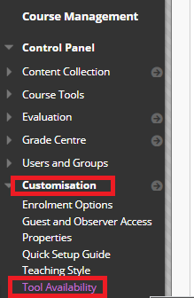
On the next page, select the tickbox for Piazza then click on submit.

Create link to Piazza
In the course content area click on Tools > More > Piazza
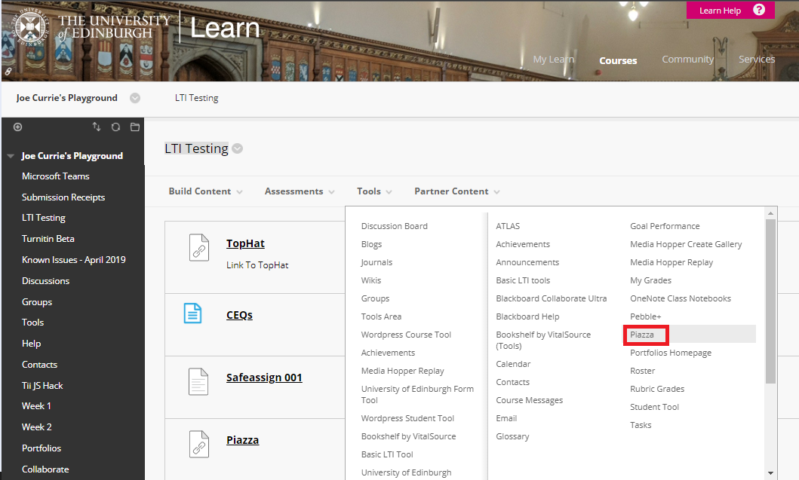
Links can also be added in the course menu by clicking on the plus icon and selecting Tool Link. You will find Piazza in the drop down menu.

First time user access
When any user clicks on the Piazza link, but do not have an associated email address they are taken to the below page:
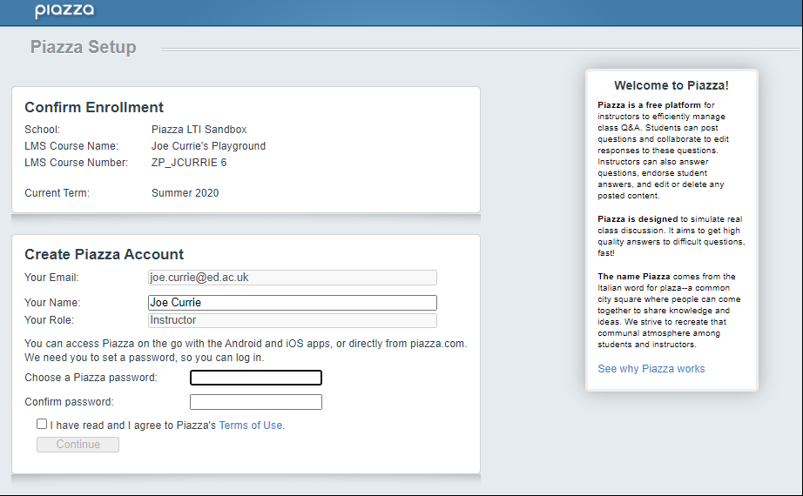
- Email address: Auto-populated from LTI (non-editable)
- Name: Auto-populated from LTI (editable)
- Role: Auto-populated from LTI (non-editable)
Email confirmation with a code is sent automatically. The code must be entered in the next screen. (screenshot required).

Setup Piazza Room (Instructor)
Either click on the link within a course or “Create link to Piazza”.

School information
This is automatically populated and non-editable
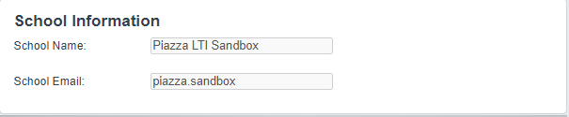

Create your class on Piazza
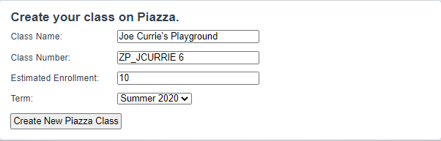
- Class name: Auto-populated with Course name from LTI (editable)
- Class number: Auto-populated with Course ID from LTI (editable)
- Estimated Enrolment: Must be set by instructor
- Term: Values in dropdown menu are auto-populated by Piazza

Already have a class on Piazza/Want to join classes together?
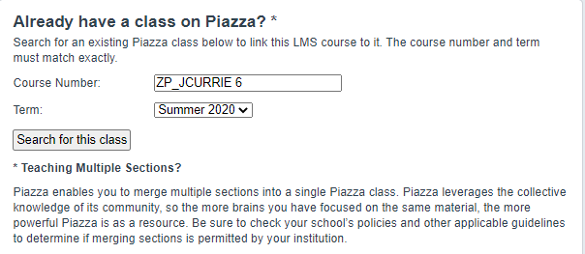
- Course Number: auto-populated with Course ID from LTI (editable)

Configuring your class

Basic class information
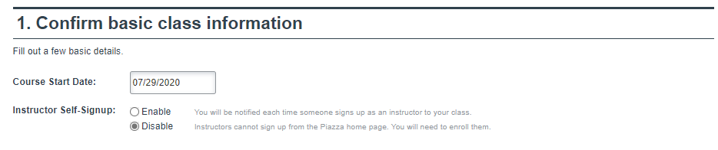
- Course start date: automatically set to same day as link created
- Instructor Self-signup: Should be left as Disabled

Enrolments
There are different ways to enrol users into a Piazza class; however, we recommend only adding users by getting them to click through the link in Learn.
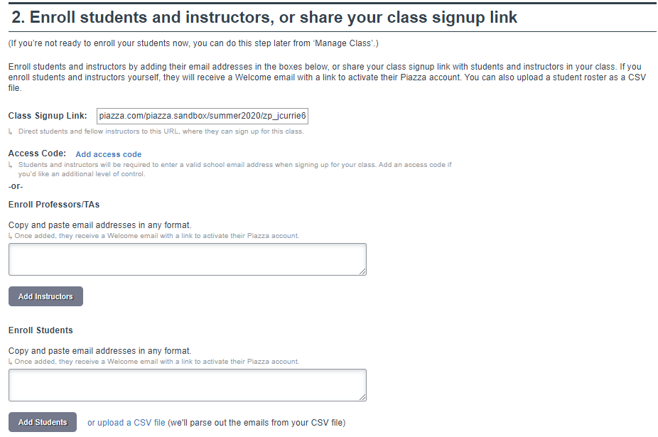

Points of note
Below are a few points that we should be aware of:
- Class rosters are not synced through the integration
  - Users are added when they click on the course link or added using Piazza interface
  - Users will not be removed automatically if they leave the course
- There is no integration with UoE Logins
  - Users need a Piazza account – Setting up of which is streamlined through the integration
  - If a user already has a Piazza account with a different email address, they two accounts can be merged by following the instructions at: https://edin.ac/2EkqJ8J
- If a Teaching Assistant (TA) tries to access the link, an email is sent to all instructors on the course asking to be provided access. Once this is granted, they are given TA access to Piazza

