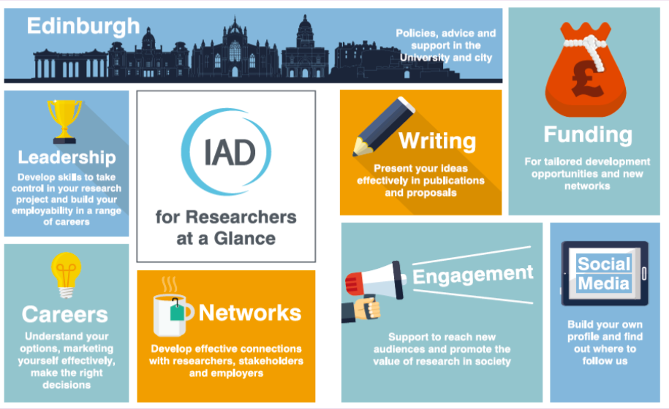

Career Choices

Exploring Options



What’s my appetite for change?

Section 01



I don’t want to use my research skills

I want new experiences before changing career

I’ll retrain in my own time before changing

I’ll move anywhere for my next job

I want to work outside academia

I’m only interested in a University job

I’ll retrain after starting a new job

I don’t want to leave Edinburgh

I don’t want to gain new experience

I only want to use my research skills



01 What is affecting your career choice?

My experience from 1:1 careers appointments is that people react to alternative career options in different ways. Some are happy to consider retraining, comfortable leaving their research experience and skills behind and are able to relocate.

Others dismiss all alternatives as second-class options, because they are still coming to terms with the reality of leaving academic research.

Before you start to look into alternatives, take a moment to gauge your attitudes to change. It’s probably helpful to think in terms of “ideal” and “acceptable” parameters as you answer and to remember the two sides are extremes - you’re probably somewhere between these pairs of statements.

# Factors that affect career choice and openness to options

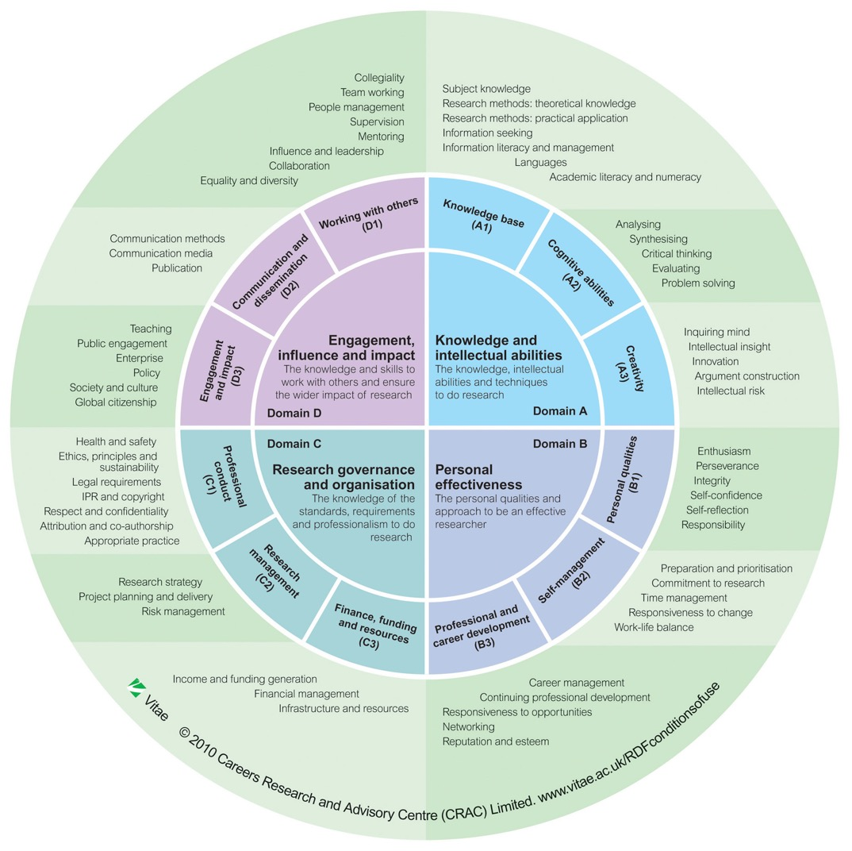



01 Appetite for Change

Resources to help you audit your skills

The IAD Skills Audit for Research Staff:

<https://www.ed.ac.uk/institute-academic-development/research-roles/research-only-staff/career-management/skills-audit>

The National Researcher Development Framework:

<https://www.vitae.ac.uk/researchers-professional-development/about-the-vitae-researcher-development-framework/developing-the-vitae-researcher-development-framework>

Being a researcher requires lots of skills. Some will be specific technical skills which you may not be able to apply in new roles, but many are transferable and marketable.

# Thinking about your skills



What are the options?

Section 02

If you want to use aspects of your experience and knowledge, but not focus on research, related roles might appeal



If you’ve enjoyed the autonomy and independence of research, perhaps working for yourself is the right choice

If you love being part of the research environment, there are options in universities, funders & professional bodies

If you aren’t sure research was ever right for you, or feel it isn’t now, you can move into something very different

If you want to use aspects of your experience and knowledge, but don’t want to focus on research, related roles might appeal

If this is all you want to do, look into the academic opportunities, but be aware that it’s difficult to progress as a postdoc

If you enjoy research, and want to keep using your skills and knowledge, doing research in another sector might be a good fit

Research in academia

Research elsewhere

Related professional area - *depending on your research area could include engineering, museums, IT, archives, finance*

Alternative roles in research environment

New career directions

Self-employment



02 What are the options?

# The Broad Overview



These are general groupings - many research fields and industry sectors go across our College structure so don’t view this as restrictive - rather a starting point for your thinking.



02 Research Outside Academia

CMVM

CSE

CAHSS

Biotechnology Companies

Finance/Investment/Insurance

Government (local/central)

Charities

Museums/Galleries

Consumer Research

Think Tanks

Contract Research Organisations

Clinical Science Services (NHS)

Manufacturing and Engineering

IT Sector

Scientific Civil Service

Pharmaceutical Sector

Management Consultancy

Consumer Products Companies

Food and Agriculture Sector

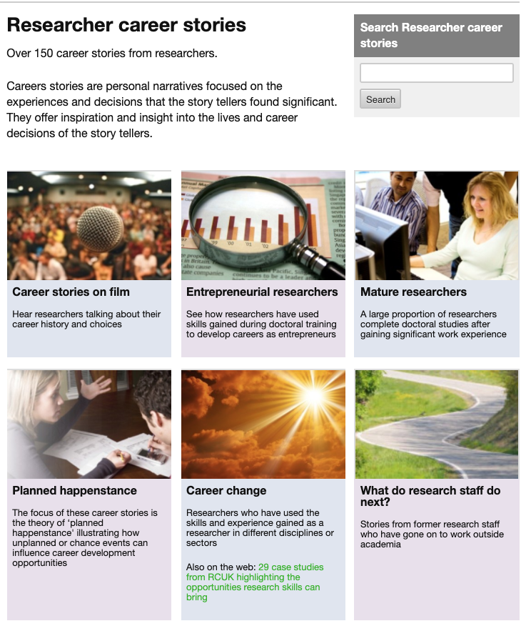

Vitae’s Researcher Career Stories database



02 Exploring Options Outside Academia

The University’s Careers Service has many resources for PhD students which are also useful for research staff considering options:

<https://www.ed.ac.uk/careers/postgrad/phd/options>

<https://www.ed.ac.uk/careers/postgrad/phd/options/non-academic-research>

Vitae, the national researcher development organisation has a section for research staff and students with destination reports, resources and career stories

<https://www.vitae.ac.uk/researcher-careers>

An archived version of the RCUK case studies on researcher career options is available:

<https://webarchive.nationalarchives.gov.uk/20140508193229/http://www.rcuk.ac.uk/skills/percase/>

SULSA have a set of life sciences post-academic career case studies

<https://www.sulsa.ac.uk/careers/>

# Resources to help you look at other sectors





01 Career Options inside Research Environments

Student Welfare

Research Support and Administration

Recruitment and Admissions

Strategic Planning and Policy

Commercialisation

Researcher Development

Public and Community Engagement

Communications and Marketing

School and College Management

Internationalisation

# Universities are often one of the biggest employers in a city. Did you know 15,000 people work at The University of Edinburgh?



Governance and Strategic Planning

Edinburgh Research Office

Institute for Academic Development

Edinburgh Innovations

School and College Research Offices

Academic Services

Discipline Teaching Organisations

Edinburgh Global

Edinburgh Local

Health and Safety

Research Support Services (Library)

# Former researchers now work across the University in interesting and important roles.





01 Career Options inside Research Environments



Programme Managers in funding bodies

Education programmes in Learned Societies

Communication and Engagement for funders and charities

Policy work in funders or learned societies

IT, Data Analysis, Market Research

Example employers: UKRI, Universities UK, Scottish Funding Council, Institute of Physics, Society of Edinburgh, Royal Society of Chemistry, Cancer Research UK, Society of Chemical Industry

# Research is a multi-billion pound activity. Many people work in roles which support this huge effort.



How will you generate and explore your own ideas?

Section 03





03 Generating Ideas

In addition to all the sites introduced in the last section:

Look at resources for undergraduates and PhDs to give you a sense of the SECTORS available and to improve your labour market knowledge (i.e. getting a sense of entry level job titles and responsibilities so you can explore career paths and work out your entry point)

Look at the website of your professional body - many have careers information, some have careers staff for 1:1 help

You might be a little hesitant about talking openly with people about your decision to look for a new career. We’ll start the exploration of options with “invisible” approaches. These are web-based and will help you identify options to explore in more detail.

# What will help you discover new options?



Image by [StockSnap](https://pixabay.com/users/StockSnap-894430/?utm_source=link-attribution&utm_medium=referral&utm_campaign=image&utm_content=2562138) from [Pixabay](https://pixabay.com/?utm_source=link-attribution&utm_medium=referral&utm_campaign=image&utm_content=2562138)





03 Generating Ideas

Your initial ideas about career options need to match the timescale of your transition into a new role and the availability of suitable vacancies.

Look at the jobs that are currently being advertised and build your awareness of what employers are looking for. It’s ok if the details in job descriptions lead you to think again - it’s all helping you to fine tune your options!

# What does the labour market look like at the moment?

Some suggested starting points from the Careers Service

Careers sites / occupational databases

*www.ed.ac.uk/careers > exploring jobs and careers*

*www.prospects.ac.uk > jobs and work exp. > job profiles*

https://targetjobs.co.uk/career-sectors

Industry sector / professional association sites

*e.g. Assn of British Pharmaceutical Industry, Management Consultancy Association, Institution of Analysts and Programmers, Market Research Society*

Local vacancies

www.talentscotland.com – focus on science, technology and engineering

www.s1jobs.com – general Scotland wide vacancies

www.ed.ac.uk/careers/looking-for-work/graduate-jobs/specific-locations

Career guides and job search outside the UK

https://online.goinglobal.com/

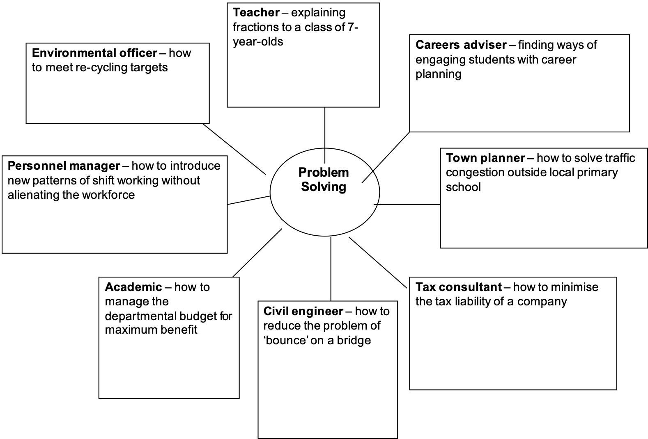

This is an example of how to link occupations to a preferred skill. If there’s something you particularly enjoy, you can be on the look out for reference to it in job descriptions, career profiles and as part of information interviews (see the next section).



03 Generating Ideas - from skills

*Although aimed at graduate occupations, you can use the Prospects Planner to match your preferred skills with occupations*

[*https://www.prospects.ac.uk/planner*](https://www.prospects.ac.uk/planner)







03 Generating Ideas - from skills



Sharing plans, asking for help, getting feedback

Section 04



People can help your career transition by:

* giving you insights into their career paths
* introducing you to people who have relevant experience
* telling you how jobs in their field are advertised
* telling you how they got their job
* giving you feedback on your CV
* sharing new career ideas which they think might suit you



04 Sharing Plans

As your confidence about career change grows, you should start to share your plans. Other people, particularly those with relevant knowledge, can help to make your career transition much easier.

# Who could enrich your career planning?



Image by [Gerd Altmann](https://pixabay.com/users/geralt-9301/?utm_source=link-attribution&utm_medium=referral&utm_campaign=image&utm_content=2212771) from [Pixabay](https://pixabay.com/?utm_source=link-attribution&utm_medium=referral&utm_campaign=image&utm_content=2212771)





05 Information Interviewing

Realities of the Job - the day to day tasks and skills needed, progression prospects

How to get a job - recruitment processes, competition,

Organisational Culture - how people are treated, rewarded and what’s important to the organisation

All images by [Gerd Altmann](https://pixabay.com/users/geralt-9301/?utm_source=link-attribution&utm_medium=referral&utm_campaign=image&utm_content=2212771) from [Pixabay](https://pixabay.com/?utm_source=link-attribution&utm_medium=referral&utm_campaign=image&utm_content=2212771)





05 Some Information Interviewing Ideas

The role

What are the typical activities in your role?

What do you enjoy most about it?

What are the less appealing elements?

Which skills are most valuable?

Where do you see your job going in the next few years?

The organisation

What do you like about working here?

Is there anything you would change?

Are there opportunities to work part time?

What would a new starter in this position expect to earn?

What are the challenges facing the organisation in the next few years

Getting in

What did you do before joining the company/ moving into this role?

What helped you to secure the job?

What do you tend to look for?

How do you recruit?

Who should I talk to if I wanted to apply here?

What kind of experience would help someone get a job in this area?

What do you think I should do to make myself more employable?

Moving ahead

How long do people tend to stay here?

What are the criteria for promotion?

Are there regular opportunities for promotion?

Further information

Where else could I look for jobs in this area?

Is there anyone else you think I should be talking to?

Would it be possible to use your name when I contact them?

# Adapt and add to this list - remember what’s important to you in a career





05 Making Best Use of Your Networks

**Talk to people**

Use Online networkslike LinkedIn and Twitter - ask people for introductions to people in their networks

Look at career paths in people’s profiles - have they made interesting moves you could learn from?

Follow or search companies and organisations

Prepare your questions in advance to respect their time - focus on what only they can tell you

Image by [Gerd Altmann](https://pixabay.com/users/geralt-9301/?utm_source=link-attribution&utm_medium=referral&utm_campaign=image&utm_content=2212771) from [Pixabay](https://pixabay.com/?utm_source=link-attribution&utm_medium=referral&utm_campaign=image&utm_content=2212771)

After you’ve been in touch with anyone…

Reflect on the information that you’ve gained  
and the questions that you’ve asked – what gaps remain in your understanding?

Write and thank the person you saw. Explain how meeting them has helped you and let them know what you plan to do next.



Narrowing Options, Making Decisions

Section 06



*Once you’ve narrowed down your options, you can start to think about how to adapt your CV, develop skills, seek experience, ask for recommendations and opportunities.*



06 Narrowing Options, Making Decisions

If these exercises have left you with a list of more than 3-4 occupational areas to explore, you should start to prioritise which you are going to investigate in more detail. You can always come back to the “long list’ but the next stage of option analysis involves a greater investment of your time and that of others.

It might be helpful to go back to workbook 1 “Where Do I Start?” to remember the key skills, values and motivations you identified.

# Deeper Research

|  | Directly help people | Use scientific and research background in new way | Information analysis |
| --- | --- | --- | --- |
| Careers Adviser | Yes, face to face and training. Very people focused | Slightly, if can focus on research students | Yes, identifying labour market trends, linking interests to career options |
| Public Engagement Manager | Yes, both audiences and working with researchers to develop strategies and activities | Yes, definitely, although will be working with diverse research fields | Some, but mostly about presenting |
| Policy Adviser | Not directly, but work could have wider influence | Not really | Lots, but might not be the kids of information I’m used to |
| Education Officer | Yes, developing resources for teachers and students | Yes, but at lower level and more broadly | Yes - need to be aware of sector, needs of students and teachers, working out how to present, |





06 Getting your own insights

Internship / secondment /industry placement

You’ll be working on a discrete project but viewed as someone being trained or developing skills

Work shadowing

You will be observing the workplace and able to talk to people rather than gaining direct experience.

Consultancy

You’ll be working on a project as an expert and bringing skills into a new setting. You will be expected to deliver results, rather than be learning or training.

Image by [Ricarda Mölck](https://pixabay.com/users/Ricinator-3282802/?utm_source=link-attribution&utm_medium=referral&utm_campaign=image&utm_content=1962592) from [Pixabay](https://pixabay.com/?utm_source=link-attribution&utm_medium=referral&utm_campaign=image&utm_content=1962592)

Image by [Manfred Steger](https://pixabay.com/users/manfredsteger-1848497/?utm_source=link-attribution&utm_medium=referral&utm_campaign=image&utm_content=3704046) from [Pixabay](https://pixabay.com/?utm_source=link-attribution&utm_medium=referral&utm_campaign=image&utm_content=3704046)

Image by [Mariana Anatoneag](https://pixabay.com/users/mary1826-3583171/?utm_source=link-attribution&utm_medium=referral&utm_campaign=image&utm_content=2247538) from [Pixabay](https://pixabay.com/?utm_source=link-attribution&utm_medium=referral&utm_campaign=image&utm_content=2247538)



Supporting Your Next Steps

Section 07





07 Supporting Your Next Steps

Edinburgh Innovations

*(Will help commercialise*   
*your research and find consultancy opportunities)*

https://edinburgh-innovations.ed.ac.uk/

Edinburgh Entrepreneurship Club

*(Networking events and support, including links to competitions and fellowships)*

<https://eclub.business-school.ed.ac.uk/>

# Self Employment



All our career linked resources are available on our website

<https://www.ed.ac.uk/institute-academic-development/research-roles/research-only-staff/career-management>

Including details of how to book a 1:1 appointment with our Careers Consultant

<https://www.ed.ac.uk/institute-academic-development/research-roles/research-only-staff/career-management/career-consultation>

# Careers Support in IAD



This workbook was written by Dr Sara Shinton, Head of Researcher Development based on materials from Peter Fantom and Steve Norman, Careers Consultants.



08 Acknowledgements and Licence Information

This work is licensed under a CC BY-NC-ND licence.

To view a copy of this licence, visit:

https://creativecommons.org/licenses/by-nc-nd/4.0/

