1. HAILI WU

Democratising The Future of Access-based Consumption Through Participatory Approach

The sharing of physical goods has been viewed as a promising direction to reduce our environmental impact and optimise available resources, which aligns with the goals of the Circular Economic Framework (CE) and Sustainable human-computer interaction (SCHI) [1], [2], [3], [4]. These object-sharing experiences are usually framed as Access-Based Consumption (ABC) or Sharing Economy (SE), which refers to the experience of instead buying and owning everyday goods, such as a drill, individuals can now share temporary access to an item without legal ownership [5].

Today, many shared resources are available for individuals, from transportation, such as through the Enterprise Car Club[1], to everyday objects, for example, through a range of Libraries of Things (LoTs) [2].

There is an ongoing interest in the HCI and design community to explore how to encourage people to participate in ABC (e.g. [7], [8], [9]). While some studies highlight the need to develop self-borrowing, maintaining and cataloguing systems for tangible things and easy access instructions for the users (e.g.[8], [9]), some studies explored how to promote the longevity of the shared objects through designing objects that respond to user’s emotional needs, such as the Psychological Ownership (e.g. [4], [10]). Psychological Ownership refers to what people feel a sense of ownership over but do not necessarily legally own; studies suggested providing PO in object sharing experience could enable users to feel a stronger sense of responsibility over the shared object, extending the lifespan of shared objects [11].

However, an increasing amount of studies suggested that the entanglement and misalignment of interests and motivations between different stakeholders in ABC could be a bigger problem for the development of ABC. The ABC is based on a participatory culture that relies on public engagement [12]. In which different stakeholders often do not think with one mind. This means it is hard to identify an effective way to make the experience of object sharing more desirable [13], [14]. For instance, while some users might suggest object sharing experience should offer a sense of PO, some users claim that PO is not what they are looking for in the sharing experience [5], making it difficult for researchers and designers hard to identify a practical solution that responds to different people’s needs.

My research argues that in order to promote the longevity of shared objects, develop new technologies to improve the sharing experience, and bring ABC to a preferable state for various stakeholders in the future, it is necessary to incorporate the concerns, vision, and goals of different stakeholders. My research is based on a design and participatory approach involving a series of future-oriented co-design workshops. These workshops will use design and making to uncover stakeholders' concerns and intentions regarding ABC's future. Inspiring designers and researchers to identify a practical approach to make object sharing more desirable and sustainable.

[1] E. Blevis, ‘Sustainable interaction design: Invention & disposal, renewal & reuse’, Conf. Hum. Factors Comput. Syst. - Proc., pp. 503–512, 2007, doi: 10.1145/1240624.1240705.

[2] A. Dabbous and A. Tarhini, ‘Does sharing economy promote sustainable economic development and energy efficiency? Evidence from OECD countries, J. Innov. Knowl., vol. 6, no. 1, pp. 58–68, Jan. 2021, doi: 10.1016/j.jik.2020.11.001.

[3] M. Hossain, ‘Sharing economy: A comprehensive literature review’, Int. J. Hosp. Manag., vol. 87, p. 102470, May 2020, doi: 10.1016/j.ijhm.2020.102470.

[4] P. Rogers, ‘Rented But MINE! Application of Psychological Ownership Theory to Access-Based Consumption and the Circular Economy’, Circ. Econ. Sustain., vol. 1, no. 2, pp. 719–744, Sep. 2021, doi: 10.1007/s43615-021-00041-0.

[5] F. Bardhi and G. M. Eckhardt, ‘Access-Based Consumption: The Case of Car Sharing’, J. Consum. Res., vol. 39, no. 4, pp. 881–898, Dec. 2012, doi: 10.1086/666376.

[6] S. Hamilton, ‘What’s Mine Is Yours: The History of U.S. Tool-Lending Libraries’, Sch. Inf. Stud. Res. J., vol. 11, no. 1, May 2021, doi: 10.31979/2575-2499.110104.

[7] T. R. Dillahunt, X. Wang, E. Wheeler, H. F. Cheng, B. Hecht, and H. Zhu, ‘The Sharing Economy in Computing: A Systematic Literature Review’, Proc. ACM Hum.-Comput. Interact., vol. 1, no. CSCW, p. 38:1-38:26, Dec. 2017, doi: 10.1145/3134673.

[8] L. Jones, A. Nousir, T. Everrett, and S. Nabil, ‘Libraries of Things: Understanding the Challenges of Sharing Tangible Collections and the Opportunities for HCI’, in Proceedings of the 2023 CHI Conference on Human Factors in Computing Systems, in CHI ’23. New York, NY, USA: Association for Computing Machinery, Apr. 2023, pp. 1–18. doi: 10.1145/3544548.3581094.

[9] A. M. I. Lampinen, ‘Account sharing in the context of networked hospitality exchange’, in Proceedings of the 17th ACM conference on Computer supported cooperative work & social computing, in CSCW ’14. New York, NY, USA: Association for Computing Machinery, Feb. 2014, pp. 499–504. doi: 10.1145/2531602.2531665.

[10] R. Garg, ‘Supporting the Design of Smart Speakers to Foster a Sense of Ownership in Asian Indian Families’, in Proceedings of the 2022 CHI Conference on Human Factors in Computing Systems, in CHI ’22. New York, NY, USA: Association for Computing Machinery, Apr. 2022, pp. 1–15. doi: 10.1145/3491102.3517680.

[11] J. L. Pierce, T. Kostova, and K. T. Dirks, ‘The State of Psychological Ownership: Integrating and Extending a Century of Research’, Rev. Gen. Psychol., vol. 7, no. 1, pp. 84–107, Mar. 2003, doi: 10.1037/1089-2680.7.1.84.

[12] T. Smith, ‘The Disturbing Colonial History of Pumpkin Spice’, Medium. Accessed: Sep. 20, 2023. [Online]. Available: https://tomsmith585.medium.com/the-disturbing-colonial-history-of-pumpkin-spice-fbe62b7e213a

[13] J. Arekrans, L. Sopjani, R. Laurenti, and S. Ritzén, ‘Barriers to access-based consumption in the circular transition: A systematic review’, Resour. Conserv. Recycl., vol. 184, p. 106364, Sep. 2022, doi: 10.1016/j.resconrec.2022.106364.

[14] D. Buhalis, L. Andreu, and J. Gnoth, ‘The dark side of the sharing economy: Balancing value co-creation and value co-destruction’, Psychol. Mark., vol. 37, no. 5, pp. 689–704, 2020, doi: 10.1002/mar.21344.

1. Sebastian Prost and Henry Collingham.

Probing the Internet of (Small) Farm Things

Sebastian Prost

Northumbria University, sebastian.prost@northumbria.ac.uk

Henry Collingham

Northumbria University, henry.w.r.collingham@northumbria.ac.uk

1 INTRODUCTION & BACKGROUND

IoT devices are key components in future visions of data-driven farming. Connected sensors provide real-time data from the environment, soil, plants, and animals to enable precision farming through drones, robots, and tractors, promising to improve productivity and sustainability [1, 5]. However, many such technologies continue and greenwash the industrial unsustainable model of agriculture. Smallholder farmers, who typically already practice sustainable forms of agriculture, are further marginalised and economically disadvantaged [2–4].

In this research, we ask what an Internet of Farm things might look like that is socially responsible, sustainable, and appropriate for smallholder farms. We conducted farm visits and interviews on 10 such farms in Northern England. The data highlighted several tensions around the use of IoT and digital technology more broadly on farms. Building on these tensions, we developed 8 speculative design probes. The probes are intended to challenge conceptions of IoT, question material and aesthetic qualities of IoT, and point to opportunities for responsible IoT on farms. Deliberately unfinished, speculative, playful, or even silly, they come in the form of ‘seed packets’ (see Figure 1), seeding ideas that we hope to grow with our participants in future co-design activities. Each seed packet presents a futuristic technology and includes a small task to complete. We present 3 of these probes below.

2 THE PAPER MILL

The Paper Mill challenges assumptions that technology necessarily automate and replace manual labour. Instead, the Paper

Mill is an AI device that does all the boring chores that our participants do not like doing – paperwork. The probe (see Figure 1) consists of an illustration and description of the technology and a simple card sorting activity, in which participants are asked to decide if they want a particular data task (e.g., tax return, invoice, grant application, customer

order, social media post etc.) to be handled by the AI or by a human and give reasons for this choice.

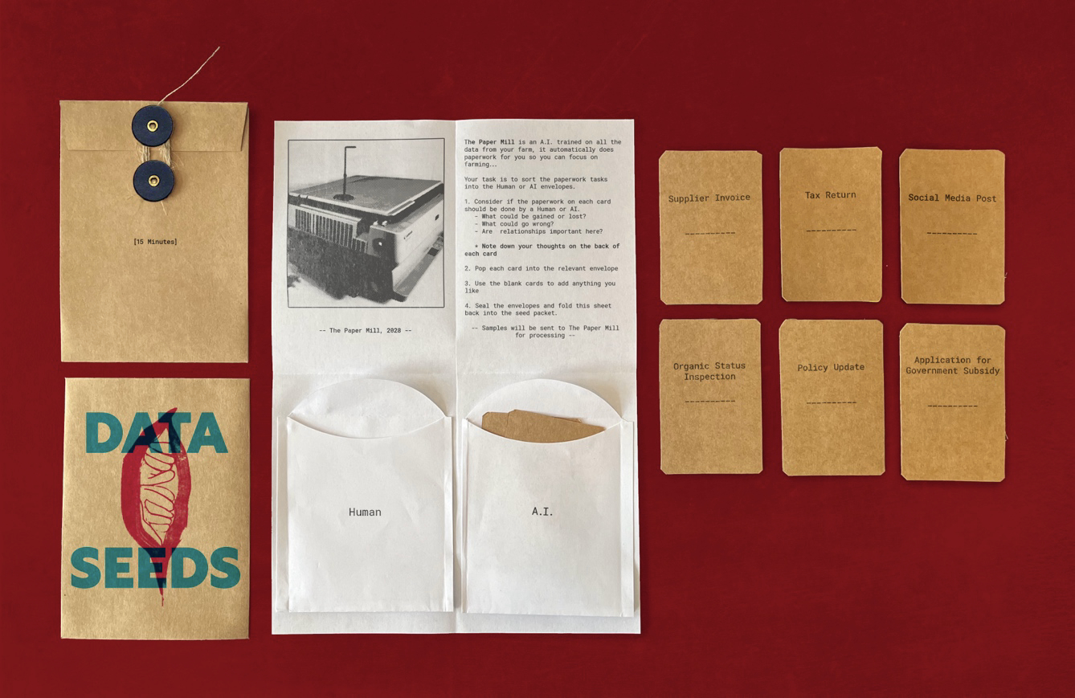

Figure 1: The Paper Mill (full probe pack)

3 SOIL STORY TELLER

The soil story teller pushes back on assumptions what sensor data could look like. Participants preferred their own senses to know how their produce is doing, but they also needed to communicate the benefits of their farming methods, e.g. for

biodiversity or nutrition, to others. The Soil Story Teller is a device you can stick in the ground, and it turns sensor data into stories about soil as a living organism (Figure 2).

You can set the target audience, e.g. “children” and mood, “e.g.

comedy” and the device tells the story via a speaker, for example while sitting in a field, or it can share them with others, for example on social media. The probe asks participants to take a soil “sample” using a double-sided sticky tape attached

a postcard and write a title, target audience, and the mood they want the story to have next to it.



Figure 2: The Soil Story Teller (illustration)

4 THE ROBOT COMMENTATOR

The Robot Commentator questions what robotic labour on a farm might include. Our participants valued manual labour

and being outdoors. However, many of them could do with more workers on the land. So instead of automating physical labour, the Robot Commentator follows the farmer doing everyday farm work and learns from them to then recruit and

instructs customers and volunteers (Figure 3). The probe asks participants to role play the robot watching the farmer and audio record their observations and commentary.

Figure 3: The Robot Commentator (illustration)

5 AT THE WORKSHOP

We are happy to share more some of our probes and our thinking behind them at the workshop and look forward to exciting

discussions about sustainable future for the Internet of Things.

REFERENCES

[1] Biggs, H., Joshi, T., Murphy, R., Bardzell, J. and Bardzell, S. 2021. Alternatives to Agrilogistics: Designing for Ecological Thinking. Proceedings of

the ACM on Human-Computer Interaction. 5, CSCW2 (2021), 1–31. DOI:https://doi.org/10.1145/3479557.

[2] Chandra, R. and Collis, S. 2021. Digital agriculture for small-scale producers. Communications of the ACM. 64, 12 (Dec. 2021), 75–84.

DOI:https://doi.org/10.1145/3454008.

[3] Hanrahan, B. V, Maitland, C., Brown, T., Chen, A., Kagame, F. and Birir, B. 2021. Agency and Extraction in Emerging Industrial Drone Applications.

Proceedings of the ACM on Human-Computer Interaction. 4, CSCW3 (Jan. 2021), 1–21. DOI:https://doi.org/10.1145/3432932.

[4] Liu, J. and Sengers, P. 2021. Legibility and the Legacy of Racialized Dispossession in Digital Agriculture. Proceedings of the ACM on Human-

Computer Interaction. 5, CSCW2 (Oct. 2021), 26. DOI:https://doi.org/10.1145/3479867.

[5] Steup, R., Dombrowski, L. and Su, N.M. 2019. Feeding the World with Data: Visions of Data-Driven Farming. Proceedings of the 2019 on Designing

Interactive Systems Conference (New York, NY, USA, Jun. 2019), 1503–1515.

1. Michela Musto

**Smart Couture: Enhancing Human Capabilities and Promoting Long-lasting, Sustainable Fashion**

Michela MUSTO

Università degli Studi della Campania “Luigi Vanvitelli”

Fashion, traditionally perceived as an expression of individual identity and creativity, can be transformed into a dynamic technological enclave capable of interacting with both the wearer and the environment. The integration of Internet of Things (IoT) technologies into garments represents a promising avenue for enhancing human capabilities while addressing critical sustainability challenges within the industry. This abstract explores the potential for augmenting human functionality through IoT-enabled garments and advocates for the development of durable, long-lasting fashion that counters the prevalent fast-consuming system.

The current fashion industry is marked by rapid trend turnover, leading to excessive consumption and significant environmental impacts (Niinimäki et al., 2020; Fletcher, 2014). By integrating IoT technologies, we can transition towards a model of long-lasting fashion that emphasizes durability, reusability, and adaptability (Bauer & Jones, 2022). IoT-embedded clothing can offer customizable functionalities such as health monitoring, environmental sensing, adaptive aesthetics, and personal comfort adjustments (Choi & Lee, 2020; Kwon & Kim, 2017; Stoppa & Chiolerio, 2014). These innovations not only enhance the human experience but also provide a platform for continuous interaction and personalization, promoting a sustainable consumption pattern that reduces waste and extends the lifecycle of garments (Bocken et al., 2016; Niinimäki & Hassi, 2011). IoT-enabled clothing can indeed be updated with new functionalities over time, thereby eliminating the need for frequent replacements and fostering a deeper connection between consumers and their clothing (Choi & Lee, 2020; Ryan, 2014). Research within the Waste and Resources Action Program (WRAP) context indicates that the average lifespan of garment utilization in the UK is approximately three years (Maddox, 2018). Globally, between 2014 and 2020, the frequency of garment use before disposal has halved. This demonstrates the urgent need for a shift towards durable, reusable, and adaptable fashion facilitated by IoT technologies. Hyper-customized fashion, achieved through personalized functionalities embedded in clothing, can mitigate the disposal of unused or prematurely discarded garments. This stands in direct contrast to the fast fashion culture that encourages frequent purchasing and disposal (Fletcher, 2014).

Hyper-customized garments can be produced more resource-efficiently, reducing the need for mass production and inventory surplus. Advanced on-demand manufacturing technologies can create garments that precisely meet customer specifications, minimizing material and energy waste (Bocken et al., 2016). These garments can be designed to adapt to various contexts and needs through integrated functionalities that can be updated or modified over time, enhancing both the user experience and the garment's utility (Stoppa & Chiolerio, 2014; Choi & Lee, 2020). The integration of IoT technologies in fashion enables an unprecedented level of customization, fostering a paradigm able to catalyze a virtuous demand that advocates for less, but better, or as described by the fashion designer Vivienne Westwood in an interview of 2014 for The Guardians "Buy less. Choose well. Make it last." (Battel, 2022). By enabling garments to evolve with changing needs and preferences, the fashion industry can move towards a more sustainable and responsible future.

**References**

Battel, V. (2022). Buy less, choose well, make it lasts! Il motto di Vivienne Westwood per la sostenibilità. Available via Fashion Journal https://www.ffri.it/fashion-journal/corsi/moda-sostenibile/vivienne-westwood-sostenibilita/. Accessed 02 Feb 2024

Bauer, R. A., & Jones, M. L. (2012). Satisfaction and Continuance Intention in Consumer IoT: An Integrated Model. Journal of Interactive Marketing, 26(1), 33-43.

Bocken, N. M. P., de Pauw, I., Bakker, C., & van der Grinten, B. (2016). Product design and business model strategies for a circular economy. Journal of Industrial and Production Engineering, 33(5), 308-320.

Choi, J., & Lee, H. (2020). Fashioning the Internet of Things (IoT): Technology and Fashion in the Age of the Internet. Fashion and Textiles, 7(1), 1-17.

Fletcher, K. (2014). Sustainable Fashion and Textiles: Design Journeys. Routledge.

Kwon, S., & Kim, Y. (2017). E-textiles for Wearable Applications: Review and Research Directions. Sensors, 17(5), 1-27.

Maddox, P. (2018). Garment lifespan: Insights from the UK. Waste and Resources Action Program (WRAP).

Niinimäki, K., & Hassi, L. (2011). Emerging design strategies in sustainable production and consumption of textiles and clothing. Journal of Cleaner Production, 19(16), 1876-1883.

Niinimäki, K., Peters, G., Dahlbo, H., Perry, P., Rissanen, T., & Gwilt, A. (2020). The environmental price of fast fashion. Nature Reviews Earth & Environment, 1(4), 189-200.

Ryan, M. (2014). The Future of Wearable Technology and Ethics. IEEE Technology and Society Magazine, 33(4), 29-36.

Stoppa, M., & Chiolerio, A. (2014). Wearable Electronics and Smart Textiles: A Critical Review. Sensors, 14(7), 11957-11992.

Weber, R. H. (2015). Internet of Things – New security and privacy challenges. Computer Law & Security Review, 26(1), 23-30.

1. Jia Wang

Reconceptualizing the interface of copyright and design rights for 3D printing

Jia Wang

Associate Professor in Intellectual Property Law

Durham University

Building the Internet of Things (IoT) requires data obtained from 3D scanning of objects from the real world and producing things from 3D designs to physical objects. 3D printing technologies and platforms are becoming more prominent, faster and more ubiquitous, and they have significantly challenged the modular intellectual property (IP) system. An unclear interface between different types of IP rights has led to the overprotection of design files. Moreover, despite the significant growth of designs in China, the current debate on cumulative design protection is more focused on UK and European law. This article investigates the current interface between copyright and design rights for 3D printing design files. To fill the gap in the literature, a comparative approach is taken to compare the laws between Europe, at the European Union and national levels, and China. This article views the road ahead for developing the IP legal system from three aspects: the identification of disclosure, the criteria to establish copyright originality and design novelty and the limitations and exceptions for using designs. In terms of practical significance, this article helps designers better understand the legal landscape when dealing with designs that are easily transmitted and traded across borders. It gives law and policymakers a more robust understanding of how IP rights operate in industrial contexts.

1. https://www.enterprisecarclub.co.uk/gb/en/home.html
2. LoTs refer to “borrowable collections of tangible objects, which enable individuals to access items other than books from the library [6]