Monday 25 March @ 6:00 - 7:30 pm
Violet Laidlaw Room, School of Social and Political Science, Chrystal Macmillan Building 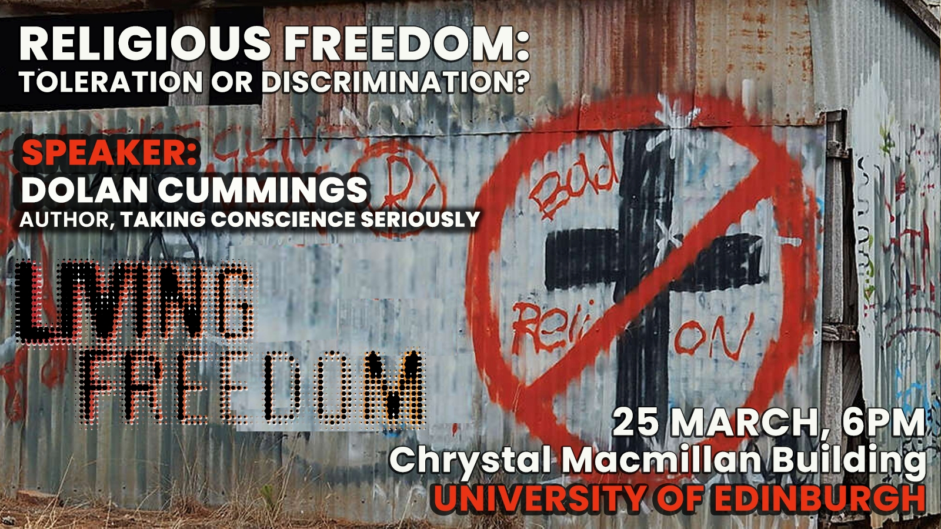
TALK AND DISCUSSION
Defending expression and practice of religious beliefs throws up many tricky questions in relation to preserving freedom and equality for all.
In pluralistic societies, how do we reconcile the right of faith communities to exercise their beliefs with our established wider freedoms? Are street preaching or prayers in school rights we should all enjoy? Should holy books be protected by law? Is firing a midwife who refuses to perform abortions an act of justice or discrimination? Where practical conflicts arise, for example, with anti-discrimination equality laws or medical service provision, how should we respond?
SPEAKER: Dolan Cummings
Author, Taking Conscience Seriously
ALL WELCOME. FOR MORE INFORMATION AND TO RERSERVE A TICKET

