Adult Colouring Book Workshop v5

Participant’s handbook

This handbook is part of a collaborative workshop designed to create a new adult colouring book inspired by over 40,000 images published by the University's Centre for Research Collections (CRC) under a Creative Commons Attribution licence (CC BY).

Combining both analogue and digital processes participants will learn key skills to transform photographs from the collection into new artworks.

For more information please contact the Interactive Content team:

- Service website – https://www.ed.ac.uk/is/interactive-content
- Service email – interactive-content@ed.ac.uk
- Team blog – https://interactive-content.is.ed.ac.uk
- Team Twitter – https://twitter.com/tweelearning
- Team Facebook – https://www.facebook.com/IC.UoE
- Team Instagram – https://www.instagram.com/interactivecontent

Licence and copyright

Copyright © Jackie Aim and Stewart Lamb Cromar, The University of Edinburgh 2019 CC BY

This work is licensed under a Creative Commons Attribution 4.0 International License:
http://creativecommons.org/licenses/by/4.0/

Table of contents

Participant’s handbook 1
Licence and copyright 1
Table of contents 2
Workshop guidelines 3
Image repositories 3
Choosing your image 3
Option A - Drawing digitally (with a mouse) 5
Step 1 - What is Sketchpad Online? 5
Step 2 - Preparing your canvas 5
Step 3 - Tracing your image 7
Step 4 - Paths and lines 8
Step 5 - Shapes 10
Step 6 - Editing 11
Step 7 - Layers 11
Step 8 - History/undo/redo 12
Step 9 - Zoom in/out 12
Step 10 - Saving/exporting your image 13
Step 11 - Voting (friendly competition) 14
Step 12 - Printing and colouring in 14
Option B - Drawing traditionally (with pencils/pens) 15
Top tips 15
Things you will need 15
Key steps 15

Workshop guidelines

- Please be respectful to the original artist and their creations
- Be mindful of any potential sensitives regarding certain religious and cultural artworks
- If in doubt, we suggest choosing an image from our approved shortlist
- Historical context for some of the shortlisted images will be provided by our invited guests from the Main Library
- Double-check the copyright of your orginal image before publishing photos on social media

Image repositories

All images shortlisted by the workshop facilitators are selected from the Centre for Research Collections, The University of Edinburgh’s Image Collection and have a Creative Commons Attribution licence (CC BY):

- http://images.is.ed.ac.uk/

Choosing your image

To choose your image please go to this Padlet page:

- https://padlet.com/interactive_content/colouring_download

Tap the image to view a larger version and download the file to your desktop.

Some suggestions:

- Take at least five minutes to decide which image you want to transform
- Think about how you want to approach this challenge, be creative
- Consider how detailed you want the final artwork to be
- Be realistic about the time available
- What about adding a background to your creation such as we did with Ada Lovelace and Mary Sommerville
- Similarly, you may want to set your image in a frame or window, think if it would look good in a round, rectangular or square shape

See an example below of a digital version:

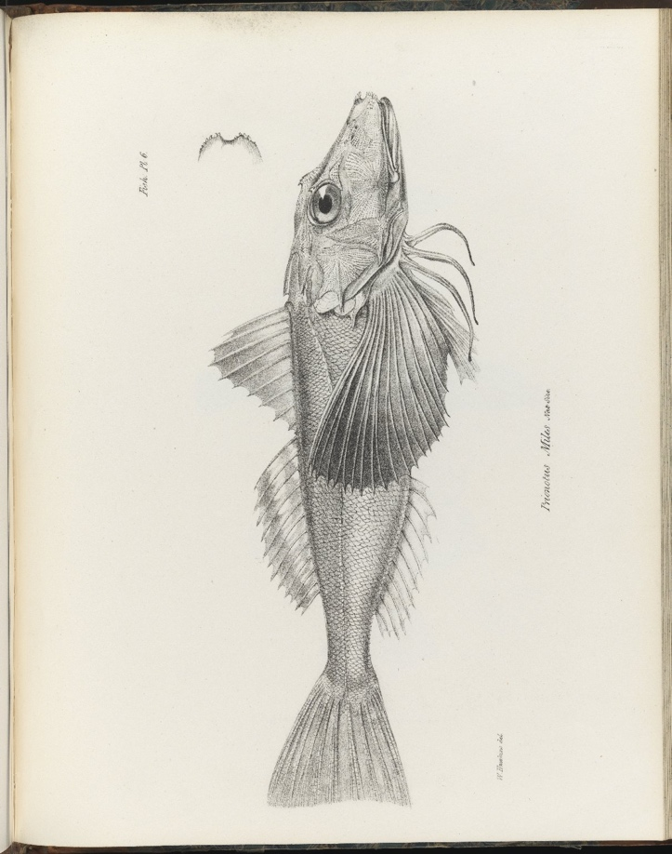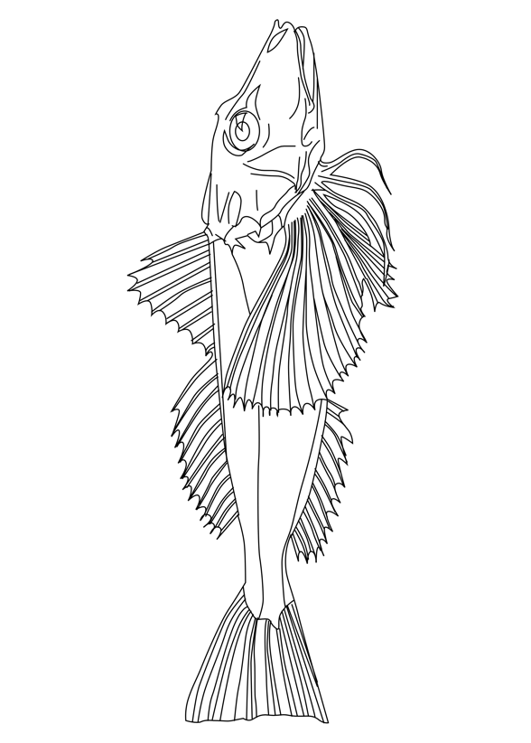
© University of Edinburgh CC BY

We could add scales on the fish and a themed background, but it also looks quite good without and there are still plenty of areas to colour in.

Option A - Drawing digitally (with a mouse)

Step 1 - What is Sketchpad Online?

Sketchpad is a free browser-based illustration app with a wide range of drawing tools. It is quite similar to Adobe Illustrator and provides a useful starting point for people learning to create vector-based artwork.

N.B. There is a paid desktop version that works offline, but we will only be using the online version in this workshop.

Step 2 - Preparing your canvas

- In your browser window go to – https://sketch.io/sketchpad/
- Close the “Hello!” pop-up dialogue window
- To ensure we have the correct ratio for our final A5 sized document please use the ‘Crop and resize’ tool
- Use the arrow up/down keys next to the numbers and specify:
  - Width: 148mm or 15cm (approx.)
  - Height: 210mm or 21cm (approx.)
- Save by selecting ‘Apply crop’ (this can be found at bottom left of your browser window)

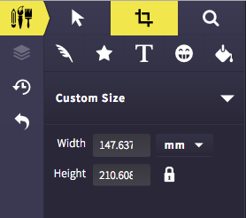

- Select the ‘Clipart’ button (looks like a smiley face) then ‘Load Your Own Image’. Select your image. It will automatically load on to your canvas.

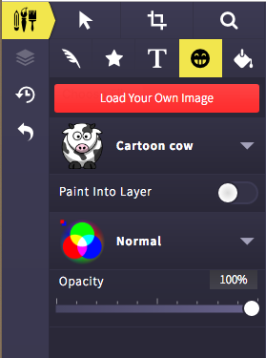

- The image loads into the centre of the canvas and scales to fit. To adjust the image select it then you can rescale/rotate/move it using the handles to get it how you like or the part if you are just doing a section.

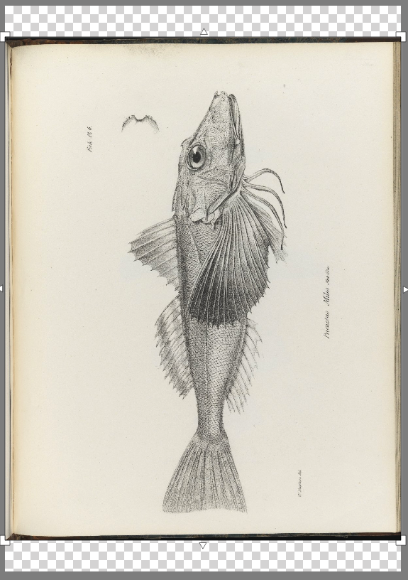

- You might want to reduce the opacity of your background image (e.g. 75%) to make the tracing process slightly easier.
- N.B. SketchPad autosaves your image in the browser as you draw.

Step 3 - Tracing your image

In an attempt to keep things relatively consistent between different artists we will be limiting ourselves to only three primary tools:

- Line - for straight
- Path - for curves
- Shapes - for angular/geometrical

Step 4 - Paths and lines

To select paths or lines:

- Select the feather icon
- In the dropdown next to Calligraphy choose the Path or Line icon

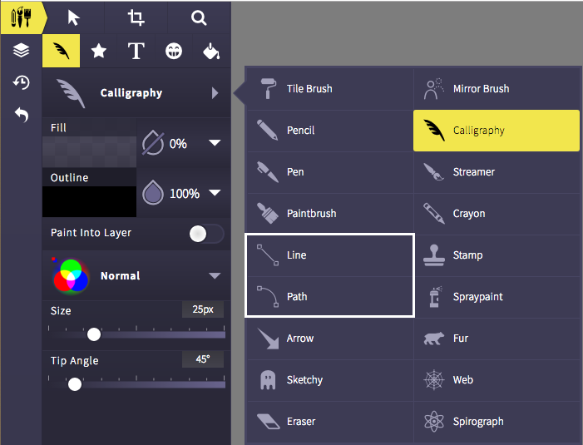

- Make your Fill opacity 0%, the Outline colour 100% black and the Size 1px
  - N.B. You may want to choose a different colour from black to assist with contrast, this can be changed back at the very end
- You can also tap the droplet shape next to Fill and Outline to turn the opacity on/off

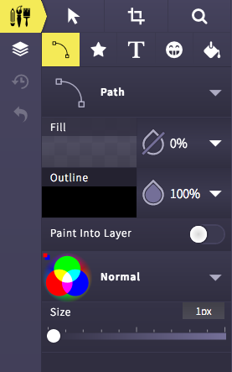
To start drawing your paths:

- Click and drag on the canvas to start building your paths
- The paths create Bezier curves and have handles which you can use to adjust them
- To end the path you just double-click. There are also red buttons in the bottom left of your browser window ‘Finish editing’ and ‘Close path’
- Continue until you have the main outlines of your image, then begin adding the details

Step 5 - Shapes

- You can find a number of useful shapes listed underneath the star-shaped icon

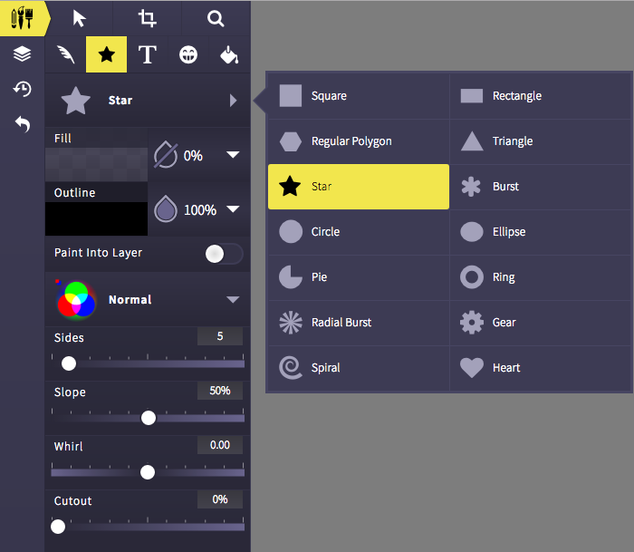

- In the fish drawing below two ellipses were used to represent the eye

Step 6 - Editing

- If your shape/path doesn’t land quite where you want it, select the arrow icon and click on the canvas to move/scale/rotate/delete it
- You can also change the line size, colour and fill

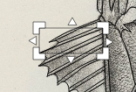

Step 7 - Layers

- Everything you add to the canvas is listed here
- Layers can be useful if you want to re-order, copy, delete or just turn off the visibility of a path/shape

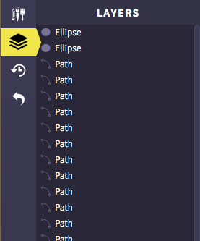

Step 8 - History/undo/redo

In case of any wee accidents these three handy tools are situated just below layers.

Step 9 - Zoom in/out

It may prove useful to zoom into your image. Tap the magnifying glass icon and a new menu will appear in the top-right of your browser window:

- +/- zoom in and out
- x zoom to actual size
- [ ] zoom to fit

Handy hint: when using the zoom tool you can freely scroll around the entire canvas without the risk of accidentally moving your background image.

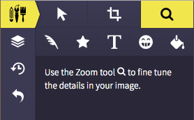

Step 10 - Saving/exporting your image

Before saving/exporting your image, please ensure:

- The layer with the original image has the visibility turned off (the eye with a line through it)
- Your line and path sizes are all set to 1px
- Your line and path colours are only black
  - N.B. You can select all layers via keyboard shortcuts:
    - PC: Ctrl A
    - Mac: Cmd A
- There are no fills (exception of white)

When you are ready to export:

- Tap the export icon (bottom-left of your browser):

- Then select the “Save .Sketchpad” option:

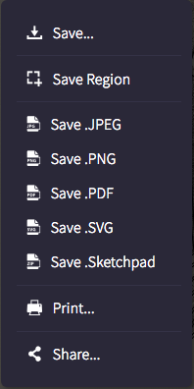

- Please email your Sketchpad file to us at interactive-content@ed.ac.uk.

Step 11 - Voting (friendly competition)

- Vote for your favourite image ​
  - https://padlet.com/interactive_content/colouring_vote
  - Post your name as a comment underneath your favourite image
  - One vote only (not your own image)

Step 12 - Printing and colouring in

If you wish to print a copy of your finished image for yourself:

- Tap export again
- Then select the “Save…” option at the very top
- Select .PNG, 300 DPI, Scale and 1.0x
- Finally tap Download

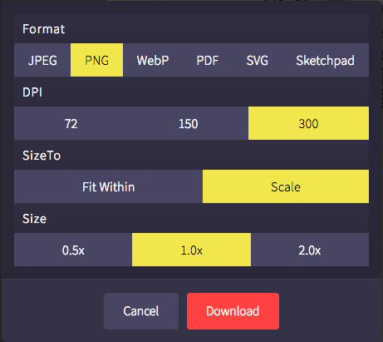

- We have a colour printer available, so please email us your PNG file or put it on one of the USB sticks provided
  - interactive-content@ed.ac.uk
- Happy colouring!

Option B - Drawing traditionally (with pencils/pens)

Top tips

- Don’t select too dark an image as we will be tracing the main areas.

Things you will need

- A4 printout of your selected image
- Tracing paper
- Masking tape
- Pencils HB, 2B, 3B and 4B
- Sharpener
- Eraser
- Fineline pen
- Scrap paper
- A4 smooth paper

Key steps

- Tape the tracing paper to the image and using the HB pencil draw the main areas of your image. If you are struggling to see, tape the image to the window.
- With a plain piece of paper underneath turn the tracing paper over and with the 4B pencil roughly trace your traced lines.
- Get your final piece of paper and turn your tracing paper back to the correct side up, tape and trace carefully again and with your HB pencil over your previous lines.
- You should have a lightly traced image on your final sheet. Now you can go over it again with the HB pencil (not too hard) and start adding details. If you are confident you can go straight to the pen at this point to get your black outlines.
- Use the pen to go over your pencil lines.
- Once the ink is dry erase your trace marks.
- You can touch up or add more details with the pen.

