Consent Form
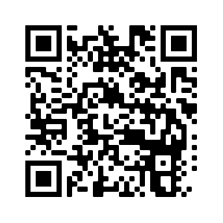
Title of Project: Deaf Education and the British Sign Language (Scotland) Act 2015: comparisons with the Welsh approach
Name of Researcher: Dr Rob Wilks
Please (initial) all boxes

- I confirm that I have read and understand the information sheet dated 17 January 2022 (version 1) for the above study. I have had the opportunity to consider the information, ask questions and have had these answered satisfactorily.
- I understand that my participation is voluntary and that I am free to withdraw at any time without giving any reason, without any consequence to myself.
- I agree to my participation being audio and video recorded and it’s been explained how this data will be stored, destroyed, anonymised. Who will have access to it, and how long it will be kept.
- I give permission for my data to be stored and processed in accordance with the GDPR (2018)
- I agree to my anonymised data being used in study specific reports and subsequent articles that will appear in academic journals as part of this study.
- I agree to take part in the above study.
Name of participant | Date | Signature
Name of researcher taking consent | Date | Signature

