Wes Streeting orders inquiry into ‘unforgivable’ hearing test scandal
The health secretary fears lifelong damage for hundreds of children who were wrongly diagnosed as deaf or denied the help they needed
Shaun Lintern
, Health Editor
Saturday April 12 2025, 11.45pm, The Sunday Times

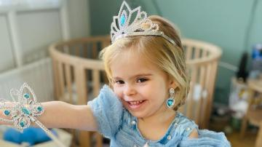
Luna Brewell, five, has fallen behind at school and struggles to speak
COURTESY OF THE FAMILY
Share
Wes Streeting has ordered an inquiry into how hundreds of children came to be misdiagnosed by NHS hearing test centres, leaving them with learning and communication problems. The health secretary condemned inaction by senior leaders at NHS England as “unforgivable”.
At least 775 children across England have been recalled by hospitals amid fears they have been misdiagnosed after having hearing tests between 2018 and 2023. Another 1,374 children need to be seen in the next two months. So far, 107 have been found to have suffered serious harm because of a botched diagnosis that saw many written off as deaf when they may have just needed hearing aids or cochlear implants.
Professor Sir Stephen Powis, NHS England’s medical director, admitted the problems could stretch back beyond 2018. NHS regions were due to complete their recalls by the end of last month but Powis said this was behind schedule and the southwest region had yet to even begin its recall.
Streeting said the failures could have “devastating and lifelong” consequences for the affected children.
They can suffer developmental delays in their language, learning and social skills and some can be wrongly labelled as having a learning disability. This can see them placed into a special needs school when all they needed was a correctly fitted hearing aid.
Dr Camilla Kingdon, a consultant neonatologist and former president of the Royal College of Paediatrics and Child Health, will head the investigation. She will report to Streeting on lessons for preventing similar service failures in future.
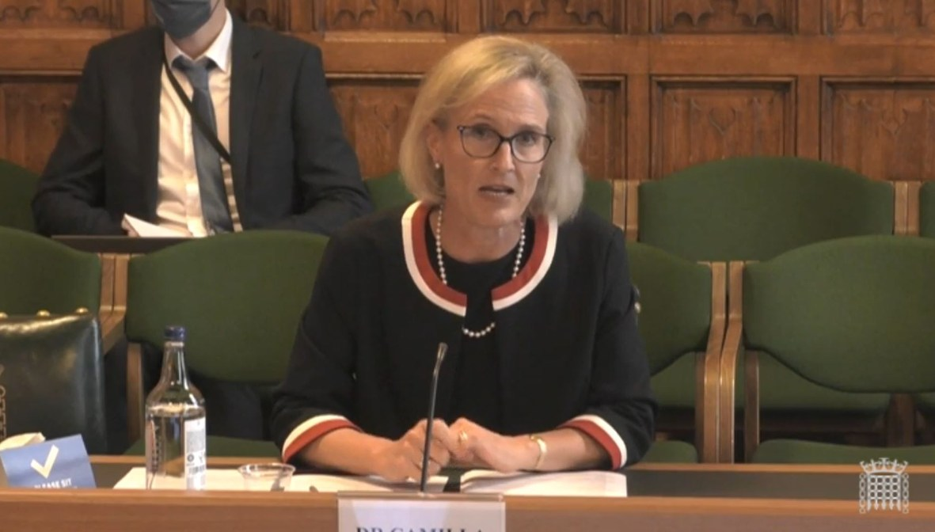
Dr Camilla Kingdon will lead the inquiry
PA
Streeting said he was shocked by the scale of the errors which he described as a “profound breach of trust” between families and the health service.
He added: “Early diagnosis of hearing issues is vital — the first few years are a crucial window for speech and language development that, once missed, cannot be fully recovered. And yet years passed without sufficient action being taken by senior leadership in either central government or NHS England. That is unforgivable.”
In 2013, when the NHS was last restructured and the screening programme put under the control of Public Health England, a decision was made by the government to scrap quality checks on hospital hearing services. Experts sent a letter to the chief scientific officer, Professor Dame Sue Hill, warning that the changes would affect care.
Concerns first emerged at the NHS Lothian health board in 2021. This prompted NHS England to review a handful of hospitals in England where the same systemic issues were found, leading to a wider review of all 142 centres across the country.
In June 2023, whistleblowers told The Sunday Times that poor-quality testing at paediatric audiology units had affected thousands of children across the country and NHS England was moving too slowly on the issue.
In September last year, a leaked internal report warned that as many as 1,500 children could have been misdiagnosed. Streeting was only briefed about the issue that month.
The problems have been caused by inadequate training and supervision of staff and a failure to follow clinical guidelines as well as incorrect interpretation of the auditory brainstem response (ABR) test results. These are used to assess the hearing level of babies who are referred after failing their newborn hearing test.
Now hospitals across England have been forced to declare incidents and trawl through records to double check if they have missed children in need of help.
The health secretary said the scandal was typical of an NHS “culture that buried problems rather than confronting them head-on”.
He said: “I’m determined that nothing of this kind is allowed to happen again. That’s why I’ve commissioned this independent review — to provide families with the answers they deserve, to identify clear lessons and ensure history does not repeat itself.”

‘Fantastic news’
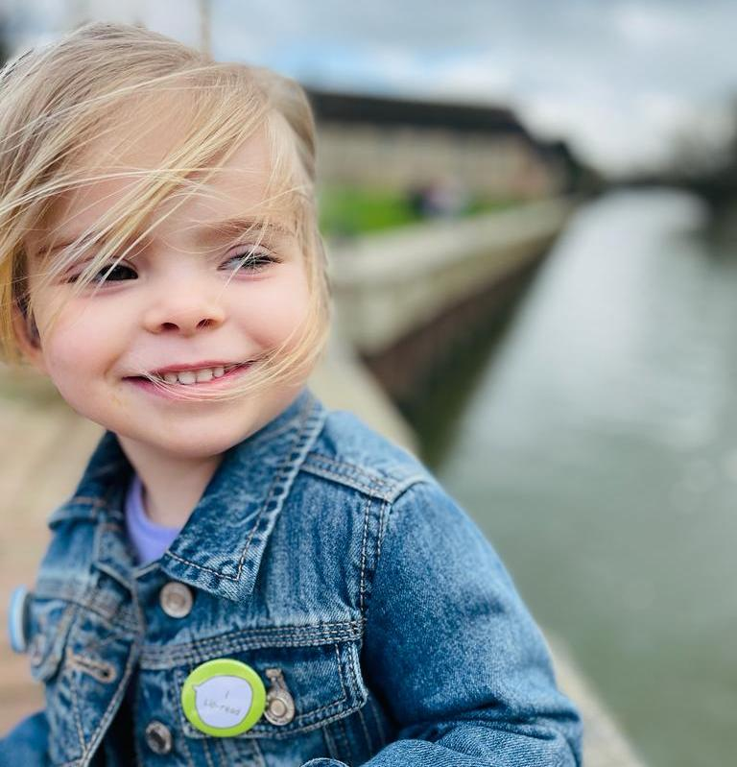
BREWELL FAMILY HANDOUT
One of those affected was five-year-old Luna Brewell, from St Ives in Cambridgeshire, who has been classed as suffering severe harm after her misdiagnosis. As a result of being deaf and without the hearing aids she needed, she has fallen behind at school and struggles to speak.
Her mother Natalie, 40, said an inquiry into what had happened was “fantastic news” and would hopefully bring answers to families about why the mistakes happened and became so widespread.
She said: “We as a family are struggling. It’s affected our life tenfold. We are very proud of Luna and being deaf is part of who she is and I wouldn’t change her, but it’s heartbreaking to think all these other children that have just been left are out there.
“They will have been struggling for years without hearing aids. People in the deaf community are just as important as people with other disabilities.”
Powis said: “We fully recognise the distress that this is causing to families. We have always recognised the need for speed in this programme because we know that these are potentially developmental issues for the children affected.
“We are moving at pace on this. But we have a limited number of expert audiologists who can do this work.”
He said it was now likely the number of children misdiagnosed would be in the hundreds although he cautioned the process has yet to finish.
Powis, who is stepping down from his role this summer, said he couldn’t comment on decisions made about audiology services a decade ago but accepted the problems could stretch back further than the five-year window NHS England was focused on.
“I think that it’s fair to say we should hold that concern,” he said. “We chose five years as the period that we needed to look at because that would have the most impact in terms of reviewing patients, but I think we need to keep it under review.

“There will always be areas, looking back, where we will identify that we could have done things faster. We are open to learning the lessons from this.”
He said it was likely some hearing test centres would have to close to concentrate expertise and ensure better quality of care for children in the future.

