

Final Report on the Student Email Consultation Project

18.05.2018

Contents

1. Background and Scope of the Consultation…………………………………...pp.3-4
2. Results of the Student Survey………………………………………………………pp.5-19
3. Results of the Student Focus Groups………………………………………….pp.20-22
4. Results of the Staff Survey………………………………………………………...pp.23-27
5. Format of Student Email Address Used in Other Universities………….pp.28
6. Summary of Key Findings…………………………………………………………..pp.29-30
7. Recommendations……………………………………………………………………………p.31
8. Background and Scope of the Consultation

In May 2017, the IT Committee approved changing the format of the student email address from the unfriendly student matriculation format to a friendly name approach that can last for the lifetime of the student. Changing the form of the student email address and the creation of a lifelong alumni email address are things which students themselves have asked for, and formed some of the manifestos of 2017/18 EUSA President, Patrick Kilduff.In deciding the exact format of the new email addresses, we wanted to consult directly with students and staff to involve them in the process and therefore ensure that the email address format we decide on will address the preferences of the majority of the student and staff body.

The consultation took place in two phases: the first phase was an online survey, one for students and one for staff. The second phase was focus groups, which further explored some of the results of the survey that were ambiguous or that we wanted to delve into further and established stakeholder preferences in more detail.

* 1. Student Survey

We sent out the survey on the format of the student email address to students on Friday 9th of March and it remained open until midnight on Monday 26th of March. The survey was created using the Bristol Survey Tool Online. We disseminated the survey by emailing school offices and asking them to forward a message to all of their students. We then put announcements on MyEd, tweeted about the survey and put up posters. We also emailed schools again one week before the closing date of the survey and asked them to circulate another message. Students were encouraged to participate in the survey by offering them a chance to enter a prize draw for an iPad.

In total we had **3,042 respondents**. The highest rate of responses were received in the first five days after opening the survey, suggesting that recipients were most likely to respond upon receiving the email from their school.

On Tuesday 20th March, the survey was amended to add two new questions about transitioning from the current format of the email address to a new format. The first phase of the survey (before these questions were added) received 2,343 responses. The second phase, after the survey results were added, received 699 responses. The tables in this report are drawn from the responses to the first phase of the survey but the graphs combine the results of both phases.

* 1. Student Focus Groups

Focus groups with students took place on the 18th and 20th of April. Four focus groups took place in total lasting 90 minutes each with 35 students participating altogether, from across year groups and disciplines. In the survey, we asked respondents to indicate if they would be interested in undertaking further consultation activities with us. 749 people said that they would be and it was from this pool that participants for the focus groups were drawn. In order to encourage students to take part we offered them 10 pounds catering credit for participating, as well as offering them tea, coffee and cake during the break. In general, the focus groups were very successful, with participants showing a high level of engagement with minimal encouragement required from the facilitator. In the feedback forms, 100% of the participants said that they enjoyed the focus group and would attend one again. Several commented in the free text section that they really appreciate the chance to give their opinions on this matter.

We also undertook a Skype focus group with distance learners in order to give them a chance to participate as many of them filled in the survey, suggesting that their university email address is important to them.

* 1. Staff Survey

The staff survey was open between 24th April and 7th May. The survey was sent out via email to contacts in Accommodation Services, the Career Service, the Advice Place, Student Counselling, Student Recruitment and Admissions, Registry, Alumni and Development, Information Services Helpline, Main Library Helpdesk, CRC Helpdesk and the School Offices. It was also advertised in the staff channel on MyEd.

In total, we had 171 responses to the survey. The responses to the staff survey were sufficiently detailed that we decided it was not necessary to carry out staff focus groups.

1.4 Formats of Email Addresses in Other Universities

We also researched into the format of email addresses in other universities of a similar size to get an idea of how they approach the issue and see what we could learn from this.

1. Results of the Student Survey

The results of the student survey are split into the following sections:

* Background of respondents
* Communicating with Email
* Email address format
* Method of Change and Choice of Different Formats for Email Address
* Lifelong email

Section 2.1: Background of Respondents

2.1.1 Subject of Study

We received responses from across all subject areas of the university. The graph below represents how many responses were received by college:

Graph 1: Number of Respondents by College

The spread of responses were therefore fairly even across all colleges – the lower response numbers from Medicine and Vet Medicine reflect the fact that it is the smallest college in terms of student numbers.

2.1.2 Year of Study

Graph 2: Year of Study of Respondents

52.23% of all survey respondents are undergraduates, fairly evenly divided between the different year groups, while 21.25% are Taught postgraduates and 26.53% are Research postgraduates. In terms of the overall size of the student body, this means we have proportionately a far greater response from postgraduates compared to undergraduates, suggesting that postgraduates are more invested in this issue.

There was a high level of engagement from taught postgraduate students in particular. Comments in the free-text answer boxes of the survey suggested that this was because they are at the stage of wanting to build a network in with contacts in other universities and therefore find it particularly awkward to use the student email address in its matriculation number format. Many postgraduate taught and research students commented that a name based email address looks ‘much more professional’ and is easier for those outside the university to remember.

Postgraduate students were also more likely than undergraduate students to think it was Very Important or Important to have a name based email address (see Table 1 below).

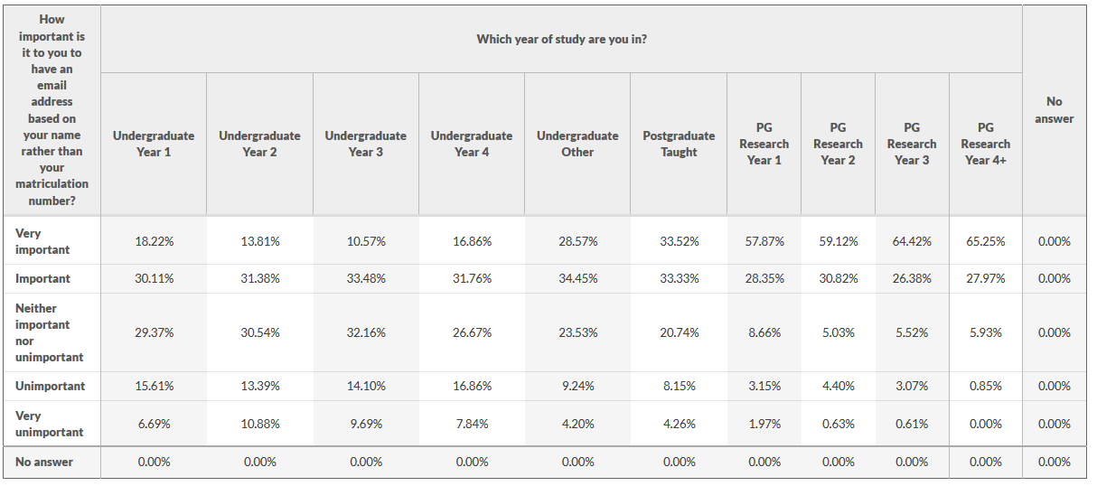Table 1: Cross-tabulation of year of study and importance of name based email address

Section 2.2 Communicating with Email

2.2.1 For what kind of correspondence do you use your university email address?

Graph 3: Form of Correspondence with Email Address

This question allowed respondents to choose multiple answers. Almost all respondents said they use their email address for official university correspondence (99.2%) while 20.4% also selected that they use it for personal correspondence. 24.4% said they use it for job applications.

11.05% selected other. Of those who selected other, the most frequently commented use for the university email address was to network with other academics, both within Edinburgh and more widely. Other reasons that appeared several times was:

* To organise work placements
* To recruit participants for research projects
* To create accounts relating to education (e.g. Mendeley)
* To get student discount
* Society correspondence
* Submitting abstracts to conferences
* Submitting articles for publication

One student who wrote in the ‘other’ free text box commented that they used their university email address whenever they ‘wanted to be recognised as a student of Edinburgh University’ which is a good way of summarising these various reasons above which people wrote in the ‘other’ box. One respondent also commented that, when trying to contact research participants etc., sometimes it was difficult because the email address format, with the matriculation number and the ‘sms’, did not appear like a real email address and more like spam.

2.2.2 How often do you contact other students using your university email address?

Graph 4: Use of Email Address to Contact Other Students

54.96% of students said that they contact other students either often or sometimes with their university email address.

In response to the question, why do they not use their university email address to contact students, the most frequently cited reason was that it is quicker, easier and faster to use social media (Facebook in particular was mentioned) to contact one another. They feel they are more likely to get a quick reply using social media and one respondent commented that they liked the feature of Facebook that allowed you to see if the message recipient had read them yet. Another often given reason was that using university email seems too official for contacting other students. Other reasons are:

* Prefer to use personal email account
* Prefer to use Google docs to collaborate with other students
* Not easy to remember student email addresses without the name
* No need to contact other students
* Students don’t check email too often
* University email is subject to freedom of information requests
* For online and distance learning students, they are recommended to use discussion boards
* University email is not permanent

Many students were also complaining that they receive too much ‘junk mail’ on a daily basis. One suggested all course related information should only be added through Learn.

When asked what they used instead of email to contact other students, the following all appeared frequently, with Facebook messenger being by far the most frequent:

* Facebook messenger
* Facebook group
* Text messages
* WeChat
* WhatsApp
* Personal email or Gmail

2.2.3 How do you find out the email addresses of others in the university when you want to contact them? Please select all that apply

Graph 5: Find Email Addresses for Contact

The most popular method for finding out the email addresses of others is through searching on the Office 365 address book (34.2% of total answers; selected by 55.03% of respondents). The majority of responses in the ‘other’ section, state that they ask someone for their email directly, most often in person but sometimes via Facebook.

Of those who use the address book on Office 365 or Outlook, the majority found it easy to use (Very easy 19.4%; Easy 36.6%; Neither easy nor difficult 35.6%; Difficult 7.3% and Very difficult 1%).

* 1. Email Address Format
     1. How important is it to you to have an email address based on your name rather than your matriculation number?

Graph 6: Importance of Email Address Based on Name

63.95% of respondents answered that it was very important or important for them to have an email address based on their name rather than their matriculation number, indicating that a clear majority want to have a name based email address. Reasons often given for this were:

* more professional
* easier to remember
* less likely to be mistaken for spam.
  + 1. How important to you is it to have an @ed.ac.uk email address rather than an @sms.ed.ac.uk email address?

Graph 7: Importance of an @ed.ac.uk email address

73.8% of survey respondents thought it was important or very important to have an @ed.ac.uk email address rather than an @sms.ed.ac.uk address. This means that this aspect of the email format is even more important to students than the use of their name. Reasons given for this were:

* Looks more professional
* Shows that students are thought to be part of university community
* Will remove confusion about when to use the ‘sms’ part of the email address and when not to (for example, when logging on to Office 365).

### 2.3.3 In a name based email address format, I would want my first name included e.g. joe.bloggs@ed.ac.uk.

### Graph 8: Inclusion of the first name in the email address

### 61.28% of respondents strongly agree or agree that they would want their first name included in a name based email address, again because it is more professional and easier to remember. Some respondents did raise concerns surrounding gender bias resulting from use of first names. Others pointed out that we would have to take into consideration the fact that international names do not always follow the same system as British ones – for examples, Spanish people have two surnames. Concerns were also raised about how to differentiate between people with the same name.

### 2.3.4. In a named based email address format, I would prefer to have my first initial included rather than my first name e.g. [j.bloggs@ed.ac.uk](mailto:j.bloggs@ed.ac.uk).

### Graph 9: Inclusion of the initial in the email address rather than the first name

### 43.6% of respondents agree or strongly agree that they would rather have their initial included instead of their first name. Although a couple of people noted in the comments that there could be a problem with unconscious bias relating to gender if the first name was included in the email address, if we look at the results divided by gender, we can see there was not a big difference between men and women agreeing or disagreeing on the inclusion of the first name vs. the inclusion of initial.

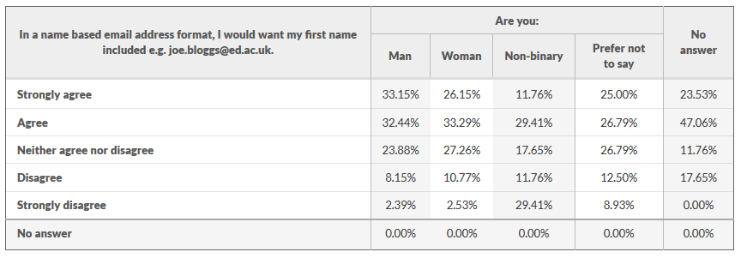

Table 2: Cross Tabulation of Gender and Inclusion of First Name

Table 3: Cross Tabulation of Gender and Inclusion of First Initial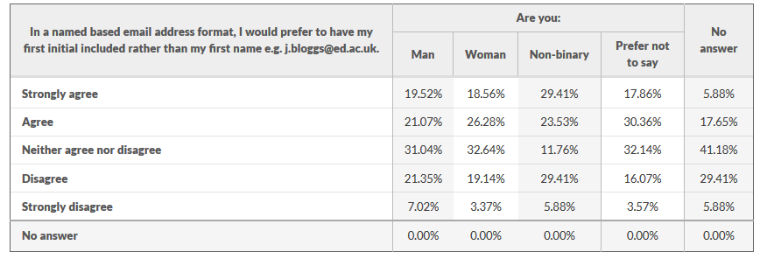

### 2.3.5. In a named based email address format, I don't mind having my year of entry included e.g. j.bloggs2018@ed.ac.uk or j.bloggs18@ed.ac.uk.

### Graph 10: Inclusion of the year of entry in the email address format

### 58.9% of respondents either disagree or strongly disagree that they want their year of entry included in the new email address format compared to 22.85% of respondents who agree or strongly agree. Therefore the majority of respondents do not want to have their year of entry included in their email address. In the comments, people expressed concern that this would give their age away to friends, colleagues or potential employers.

### First year undergraduates were the least likely to mind having their year of entry included, while fourth year PhD students or above were the most likely to mind having their year of entry included (see table below).

### 

### Table 4: Cross Tabulation of year of entry with inclusion of year of entry in the email address.

**2.4 Method of Change and Choice of Different Formats for Email Address**

### 2.4.1 What method of change for introducing the new email address would you prefer: opt-in or opt-out

### C:\Users\lbeattie\AppData\Local\Temp\student-email-address-survey-q17(hbar).pngGraph 11: Method of Change from old email format to new one

### There is a small preference (11.6%) for an opt-in default method of change, compared to an opt-out method of change. As this is not a clear-cut result, this is something that will be discussed further at the focus groups, to try to tease out a more definite choice.

### It was noticeable that the majority of people who entered the prize draw used their email address in the matriculation number format, suggesting that they are not aware that they can already use a name-based email alias. Therefore, using the opt-out by default method might mean that people remain unaware they can change to the new format.

### 2.4.2 How problematic do you think it might be for you, your contacts, or subscriptions, if we changed the email address which you use to send emails from your university account? NB. your current email address would continue to receive emails and you could still choose to go back to your current email address

### C:\Users\lbeattie\AppData\Local\Temp\student-email-address-survey-q11(hbar).png

### Graph 12: Whether changing the email address to a new format would be problematic or not

### Only 17.4% of respondents thought it would be problematic or very problematic for them, their contacts and their subscriptions if we changed the format of the email address. Of those who commented further, it seemed as if they did not understand the fact that mail sent to their old email address would be forwarded to their new email address.

### 2.4.3 How important is it to you to have the option to change your email address during your studies?

### Graph 13: Importance of having the option to change email address

### The response to having an option to change email address during studies is more ambivalent with 41.49% citing it as important or very important.

### Graph 14: Importance of having different email formats to choose from

### Similarly, the response to having a choice of different email address formats was also ambivalent, with 46.32% of respondents saying they strongly agree or agree that they want to have a choice of email address formats to choose from.

In the comments section, respondents indicated that they were strongly in favour of one uniform email format for everyone as this would make it easier to be able to guess what people’s email address is and to know if you are using the right format. They indicated that it would be too confusing to have different formats.

As the response to these questions about different formats of email addresses are somewhat ambivalent, we will discuss this further in the focus groups.

**Section 2.5 Lifelong Email**

2.5.1 How important is it to you to have an email address for life?

Graph 15: Importance of email address for life

A total of 80.12% of respondents think it is very important or important to have an email address for life which makes it the most decisive result to come out of the survey. The comments from respondents indicated that having a life long email address would mean students were more likely to use their university email address as their main one rather than their personal one as they know that it is not going to be deleted in future. Many respondents commented that having a lifelong email address would allow them to maintain a connection to the university after they have graduated.

Section 3: Summary of Results from Student Focus Groups

* 1. Deleting the ‘sms’

All participants from all groups strongly agreed that the ‘sms’ should be gotten rid of. There was a lot of confusion around when you have to include the ‘sms’ in the address and when you don’t, with participants saying that many people they know are confused by this. One suggested that even before the format of the email address is updated, communications should be sent out to all students to clarify when they have to use the ‘sms’ and when they don’t.

* 1. Formats of email address

I asked participants to suggest formats for the email address. They suggested the following:

* [Firstname.lastname@ed.ac.uk](mailto:Firstname.lastname@ed.ac.uk)
* [Initial.lastname@ed.ac.uk](mailto:Initial.lastname@ed.ac.uk)
* initialsNNN[last three numbers of matriculation no]@ed.ac.uk
* [Initial.lastnameNN@ed.ac.uk](mailto:Initial.lastnameNN@ed.ac.uk)
* Initial + first two letters of last name + [NN@ed.ac.uk](mailto:NN@ed.ac.uk)
* [Firstname.surname@department.ed.ac.uk](mailto:Firstname.surname@department.ed.ac.uk)
* [Firstname.surname.department@ed.ac.uk](mailto:Firstname.surname.department@ed.ac.uk)
* Initial.surname.s[firstthreenumbers]@ed.ac.uk
* [matriculationno@ed.ac.uk](mailto:matriculationno@ed.ac.uk)
* Initials + surname + matriculation [year@ed.ac.uk](mailto:year@ed.ac.uk)
* Firstname + [shortenedlastname@ed.ac.uk](mailto:shortenedlastname@ed.ac.uk)

When asked to rank the various formats suggested, the format that most often came out on top was [initial.lastname@ed.ac.uk](mailto:initial.lastname@ed.ac.uk) and [firstname.surname@ed.ac.uk](mailto:firstname.surname@ed.ac.uk). The third most popular format was these two choices but with the last three digits of the matriculation number appended in order to differentiate between people of the same name. A couple of people said they preferred the current matriculation number format as their first choice, but without the sms.

* 1. The ‘uniqueness’ problem of the name-based email address

All the participants recognised that with name-based email addresses there is a problem of potential conflicts with the same name. Several suggestions were discussed about how to get around this. One was including the matriculation year in the email address. While some people didn’t mind this, others were not keen, reflecting the results of the survey. Similarly, although some people didn’t mind having a randomly assigned number, others preferred that the number was assigned on a more logical basis.

Another suggestion given was that we could include the last three digits of the matriculation number after initial.surname or firstname.surname. This seemed to be the most popular choice, as the number has a logical reason for being there and should help to effectively distinguish between people of the same name.

Another advantage of including a number/part of the matriculation number in the email address format is that it will help users to distinguish between staff addresses and student addresses.

Participants in several of the focus groups suggested using the department in the email address i.e. [first.name@department.ed.ac.uk](mailto:first.name@department.ed.ac.uk), however others also pointed out difficulties of this approach, in terms of people who are members of two departments or who change departments part way through their studies.

A further suggestion given for a name-based email address format was to use shortened versions of names – this could be particularly useful in cases where students have long names.

In one focus group, participants suggested that we should keep a mail alias to the UNN permanently for use internally or in cases where it is better to maintain a sense of anonymity.

* 1. Opt-in vs Opt-out

Participants in the focus groups agreed almost unanimously that an automatic opt-in approach is the best option. Their reasons for this choice were that it would be too confusing to have some people opting-in or opting-out and that some people, were they given the choice, might not realise that they could change the format of their email address if they wanted to.

In terms of when is best for the transition to take place, many participants mentioned that it makes the most sense for the transition to take place at the start of the new academic year. They also said that they would like to be warned at least a few months in advance of the change taking place.

There was also a question about how long the old email address format should be able to forward to the new one. One postgraduate student raised the example of having recently submitted an article to a journal which has an average turnaround time of eighteen months, therefore they would need their old email address set up for forwarding for at least this amount of time. This, however, could be a special case where they could get in touch with IS to set this up.

Participants also suggested that, in advance of the transition to the new email format taking place, all students should be alerted to how their new email address will look and given a chance to raise concerns in advance.

* 1. Choice of email address formats

When asked about choice of email address formats, many people were not keen on this, suggesting that we should offer two different formats at most, otherwise this could get too confusing. As in the survey, the participants emphasised the importance of a unified and consistent approach to the email address format, so that it is more intuitive when it comes to trying to guess what people’s email address might be.

* 1. Alumni email address

There was general agreement that an alumni email address is desirable, although some students did state that they would rather just give their personal email address to the alumni and development team. It was suggested that it would therefore make sense to have the alumni email address be an opt-in process, so that resources are not getting wasted on people who won’t make use of them.

Several participants also suggested that provision of the email address alone is not enough – there would have to be ‘value added’ in the form of regular newsletters/updates from the university or more specifically from their department.

Some postgraduate students mentioned that the provision of a life-long email address is particularly important for them, especially if they want to follow an academic career path, because it shows their connection to the university.

Other participants suggested that it would be nice to add ‘pay monthly’ options, where students would pay a small flat fee to have access to journal articles.

* 1. Other

Some of the other issues that come up during the focus groups was that one group suggested it would be nice to have a standardised format for society email addresses to make them easier to contact. At the moment many of them use non-university email addresses.

Another group mentioned that they feel it is important to clarify how the ‘preferred name’ field is used, with participants saying that they didn’t realise this name would be used on all records. When giving the students the option to enter their preferred name it would be a good idea to give a sample of how the email address will appear with the preferred name included.

In the survey, several respondents indicated that they had a problem with the way that someone’s names shows up in Outlook as SURNAME Firstname as this can be confusing for recipients. On the whole, the focus group participants did not have a strong opinion about this although one participant gave an example of when they arranged to meet up with someone via email and the person then addressed them by their surname, thinking it was their first name.

Section 4: Results of the Staff Survey

Results of the staff survey are split into the following sections:

* Background of Respondents
* Communicating with Students
* Format of the Email Address
* Lifelong Email

4.1 Background of Respondents

4.1.1 Which department of the university do you belong to?

We received responses to the survey from across many different departments of the university who have regular contact with students.

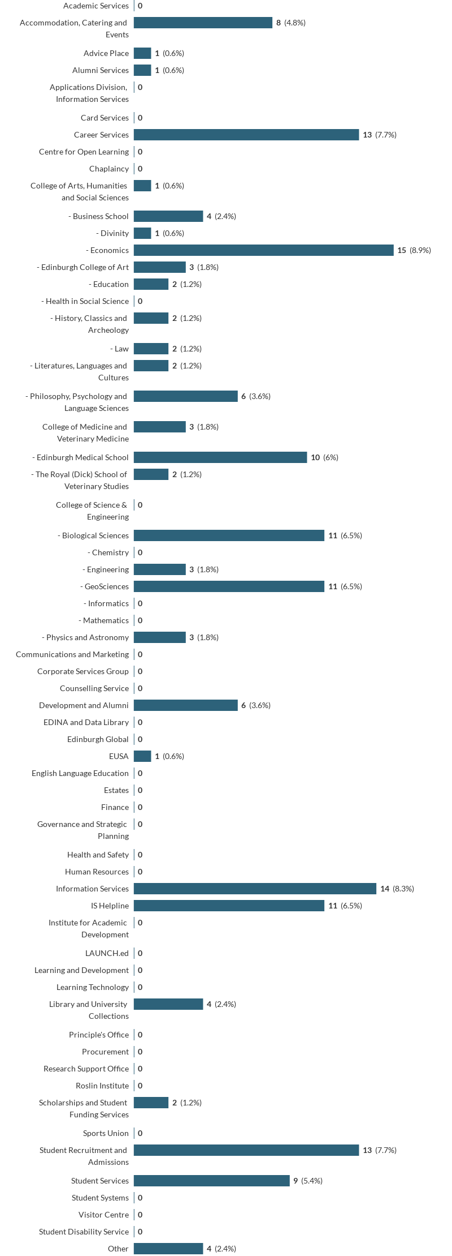

4.2 Communicating with Students

4.2.1 Time spent emailing students

The amount of time staff responding to the survey spend communicating with students via email ranges from 10-25%, to 75 to 100%.

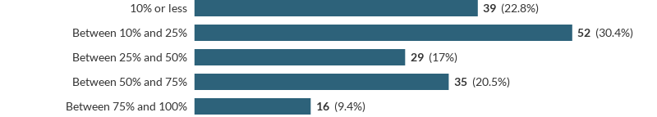

4.2.2 Finding students email address

Staff were asked ‘when you have to email students for the first time, how do you find their email address? Please select all that apply’.

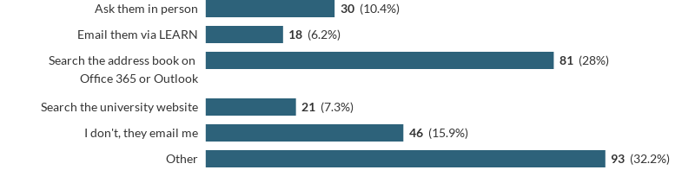

The majority of the responses in the ‘other’ section stated that they use student matriculation numbers, which they either already have or find out in EUCLID, and add @sms.ed.ac.uk to it.

IS Helpline staff said that they use the caller IDs in Unidesk while Main Library Helpdesk staff, search ALMA, their library database. Widening Participation use a software called BI Suite.

One recurrent theme in these answers was that ‘I never email a student by name, only by matric number’, as one respondent put it.

4.2.3 Using the Address Book to find Students email addresses

If you use the address book on Office 365 or Outlook, how easy is it to find a student by name?

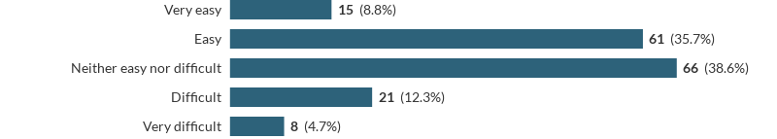

When asked to comment on what would make it easier to use, staff responded that it is difficult if their name is really common or if they have double barrelled surnames. Some also commented that it would be easier if the address book displayed their full name rather than their preferred name and if their name on EUCLID exactly matched those in the address book, which is not always the case. They also commented that it can be difficult to know when you have the right student.

4.2.4 Students using personal email addresses

When you are corresponding with students, how often do they respond from a personal email address, rather than a university one?

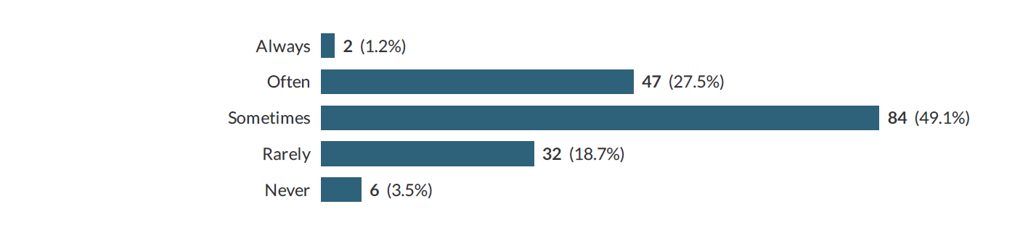

We then asked: does it cause difficulties for you when students respond from their personal email address rather than their university one?



35.1% of respondents said that students using their personal email addresses causes problems for them, 36.8% said it sometimes causes problems for them and 28.1% said it doesn’t cause problems for them.

The reasons given for the use of personal email addresses causing problems were that having an email from students’ university account acts as proof of ID and if they do not use it they need to ask additional security questions for proof of ID or look up their student number in EUCLID. There were also concerns around data protection because you can’t always know that you are emailing the right person with personal email addresses.

Another reason given was that personal email accounts are not as reliable as university email accounts because the students could change accounts without telling the uni i.e. from gmail to Hotmail.

4.3 Format of the Email Address

4.3.1 Importance of having a difference between staff and student email address

How important is it to you, in terms of ease and convenience, that the format of the student email address is different from the format of the staff email address?

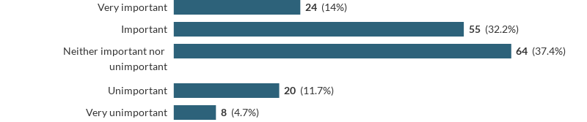

In the comments, respondents wrote that it would be good to have a difference between staff and student email addresses, suggesting retaining the ‘sms’ or using @student.ed.ac.uk. One respondent also wrote that at Aberdeen University, they use ‘@abdn.ac.uk’ for staff and ‘@aberdeen.ac.uk’ for students.

4.3.2 Change to name-based format will make it easier to email students

We asked staff if ‘Changing the format of the student email address to a name based format will make it easier to email students’.

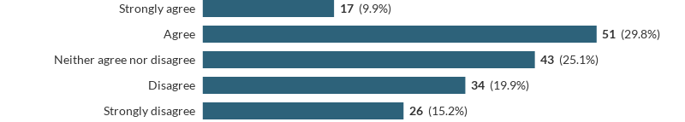

The most commonly given reason for disagreeing that it would be easier is to do with the way that people usually generate student email addresses, by adding @sms.ed.ac.uk to the end of the matriculation number.

For example, one respondent wrote:

This change would be very time consuming. In almost everything we do within student administration, we use spreadsheets using matric numbers that can then be very simply converted to an e-mail address. Changing to name based e-mails will add significant workload and could take a simple task from seconds to hours. I cannot think of how this would be made easier. Name based e-mails will also be more open to errors & students may miss out on important information sent to them.

Another respondent suggested to keep showing the matriculation number in Outlook so there is a way of double checking that they have the right student.

Someone else also commented:

I think it would be great if there was a way to download email addresses of students depending on the programme and year they belong to either from EUCLID or through Outlook.

**This is an important issue in terms of internal communications and we will have further discussions with staff surrounding this issue in particular.**

4.4 Lifelong Email

4.4.1 Distinguishing alumni email addresses

Alumni email addresses should be distinguished from current student email addresses.

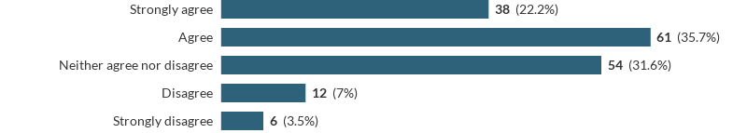

The response to students having life long email addresses was received very positively, with most people in the comments writing that they think it is a very good idea. Several people wrote that they think students should just keep the same email address after they have graduated. However, some respondents also wrote that if students keep the same email address forever it might make it more difficult to email current students.

Section 5: Format of Student Email Address Used in Other Universities

In order to help us determine the format of the student email address, it is useful to look at what other UK universities of a similar size to Edinburgh do for staff and student email addresses.

|  |  |  |
| --- | --- | --- |
| **University** | **Format of Student Email Address** | **Format of Staff Email Address** |
| Aberdeen | name(or initial).surname.matriculation year(last two digits)@aberdeen.ac.uk | name.surname@abdn.ac.uk |
| Strathclyde | initialsmatricNN@uni.strath.ac.uk | Firstname.surname@strath.ac.uk |
| St Andrews | [Initials.NNN@st-andrews.ac.uk](mailto:Initials.NNN@st-andrews.ac.uk) | Initials.NNN@st-andrews.ac.uk |
| Stirling | [Username@students.stir.ac.uk](mailto:Username@students.stir.ac.uk) | [Firstname.surname@stir.ac.uk](mailto:Firstname.surname@stir.ac.uk)  Initial.surname@stir.ac.uk |
| Newcastle | Initials.surname@newcastle.ac.uk | Firstname.surname@newcastle.ac.uk |

Out of the universities looked at, 4 out of 5 use different formats for staff and for students, either by including ‘students’ or retaining the firstname.surname format for staff only. The exception to this is St Andrews, which uses the same format for all.

Most other universities use a combination of initials and numbers for student email addresses. From looking at how other universities approach this issue, it is clear that there is no easy answer on how to do it as universities all differ in their approach. Therefore it is a matter of taking the approach that works best for our students.

Section 6: Summary of Key Findings

Section 6.1 Summary of Key Findings of Student Consultation

1. **Format of the email address**

The majority of respondents (64%) agreed that it was important to them to have a name-based university email address. The most commonly given reason for this was that it is more personal and professional.

1. **The ‘uniqueness’ problem of the name based email address**

One of the issues raised in both the survey and the focus groups was the fact that, although a name-based email address is desirable, it could cause problems with distinguishing between people of the same name. One potential way to solve this would be including the year of matriculation in the email address. However, this approach was not popular among respondents to the survey as 58.9% of respondents disagree or strongly disagreed that the year of entry should be included in the new email address format.

In the focus groups, we discussed in more detail the different options available for making name-based email addresses unique. One of these options was including randomly assigned numbers in the email address. While some participants were in favour of this, others argued that it might be better if numbers were more logically assigned i.e. the last three numbers of the matriculation number could be appended. This was thought by most participants of the focus groups to be a favourable solution.

Another suggestion given was to use the format @department.ed.ac.uk, however other participants thought that this would overcomplicate things, especially for students who are members of two departments.

1. **Omitting the sms**

One strong theme to emerge from both the survey and the focus groups was that students want the ‘sms’ to be deleted from the email address. In the survey, 73.8% of respondents said that they wanted to have an @ed.ac.uk email address rather than @sms.ed.ac.uk. In the focus groups, participants explained that they were still often confused about when it was necessary to include the ‘sms’ in the email address and when it was not.

1. **Provision of a life long email address (alumni email service)**

The clearest conclusion to come out of the survey is that the majority of students (80.12%) want to have an email address for life. The reasons given for this were varied: to communicate with peers, to keep in touch with staff at the university, to feel connected to the university. In the focus groups, participants stressed that while it would be nice to have an alumni email address, it would also be good if there was some sort of ‘added value’ to having an alumni email address i.e. alumni newsletters from the different departments, invitations to alumni events.

1. **Opt-in or opt-out**

In the survey, we asked respondents whether they prefer an opt-in by default method of change to a new format (i.e. everyone automatically gets moved over to the new form of address) or an opt-out by default method of change (i.e. everyone automatically keeps the old form and have to choose to switch to the new one). The answer from the survey was not clear-cut – there was a marginal preference (11.6%) for the opt-in by default method of change.

However, in the focus groups, there was a clear preference for the opt-in by default method of change, with participants stating that it would cause too much confusion to have some people remaining on the old format (potentially for years) with others changing to the new. It was suggested that the best time for the transition to happen would be in September at the start of the new academic year, with regular communications being sent out in the months before hand to warn students of the change.

1. **Choice of email address formats**

The response to the option of having a choice of email address formats in the survey was ambiguous, with only 46% of respondents saying that this was important to them. We discussed this issue further in the focus groups, where the majority of the participants stated that they would rather have a sense of uniformity among email address format. This sentiment was also strongly expressed in many of the free-text comments in the survey.

It was suggested in the focus groups that instead of offering a choice of email formats as such, we retain the matriculation number format of their email address as a mail alias so that they can still receive mail to it if they want to (i.e. in cases of concern about anonymity).

Section 6.2 Summary of Key Findings of Staff Consultation

1. **Retaining the matriculation number format as an alias**

Only a minority of staff (39.7%) agreed or strongly agreed that having a name-based email address would make it easier to email students. This is because many of them generate student email addresses simply by appending @sms.ed.ac.uk to their list of student matriculation numbers.

In many ways this is a separate issue form that of the email address format as such and more to do with having confidence in a reliable way to source student email addresses. This is an issue that we are keen to address and there is already a project underway that will consider this further.

1. **Concerns around Data Protection and Confidentiality**

Respondents to the staff survey made known their concern that with name-based email addresses, they might not necessarily know that they are emailing the right person which is particularly problematic in terms of confidential information and data protection laws. Hence it is important for us to include a mechanism in the email address, such as a number to make sure they are unique.

1. **Distinguishing between staff and student email addresses**

46.2% of staff thought it was important or very important to be able to distinguish between staff and student email addresses.

1. **Alumni email address**

Staff agree that having an alumni email address could be a positive thing with many commenting that it could help with alumni relations.

Section 7: Recommendations

1. The new format of the email address should be name-based but should include some mechanism for differentiating between people of the same name i.e. including the last three digits of the matriculation number. Taking into consideration all the results of the survey and the focus groups, it would seem the best format would be either:

**firstname.surname[last three digits of matric. no]@ed.ac.uk**

or

**initial.surname[last three digits of matric.no]@ed.ac.uk**

This looks professional and is unique to the individual. The use of the last three digits of the matriculation number would allow student email addresses to be distinguished from those of staff.

2. The new format of the email address should omit the ‘sms’ and be @ed.ac.uk.

3. An opt-in method of change should be used, with students being advised several months in advance when the change is going to happen.

4. Students should be given the option to have a lifelong email address.