Workflow 5:
Turnitin assignment, grading to multiple learning outcomes, single or multiple graders

Create assignment
Assessments>Turnitin Assignment

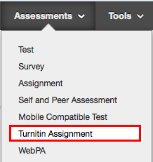

- If prompted, select Paper Assignment, then Next.
- Enter Assignment title
- Enter Point value (100)
- Allow only file types that Turnitin can check for originality
- Start date: date students can start to upload their assignments
- Due date: Deadline for submissions
- Post date: select the post date as 15 working days (ie 3 weeks) after the assignment deadline. Please don’t change the post date without speaking with a member of the learning technology team (Alex and Eli) first.
- Enter special instructions: you can include guidance for students here
- Allow submissions after the due date: YES
- Generate Originality Reports for submissions: YES
- Generate Originality Reports for student submissions: Immediately (can overwrite reports until due date)
- Exclude bibliographic materials…: YES
- Exclude quotes materials …: YES
- Exclude small matches: NO
- Allow students to see Originality reports? YES
- Reveal grades to students only on post date: YES
- Enable anonymous marking? YES
- Submit papers to: NO REPOSITORY
- Search options: SELECT ALL
- Attach a rubric/form to this assignment? Add appropriate rubric
- Enable grammar checking? NO
- Select Submit.

