Workflow 2:
Learn assignment, grading to multiple learning outcomes, single grader

Step 1: Create assignment
Assessments>Assignment

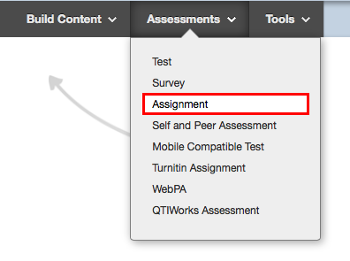

- Add assignment Name and Instructions
- Add Due Date (assignment deadline)
- Points possible – enter 100
- Add rubric. Ensure you are adding the correct rubric for this particular assignment (number and name of learning outcomes being assessed). Ensure ‘Show rubric to Students’ is set to NO.
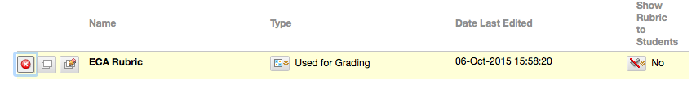

- Submission Details:
  - Individual / Group. Select whether this is an individual or group submission. If a group submission, ensure your groups have already been created and contain the correct members. Changing membership of a group at a later date can cause problems.
  - Number of Attempts: check with the CO but the default is Multiple Attempt with a maximum of 2. Score attempt using Last Graded Attempt.
- Grading options:
  - Enable Anonymous Marking if required.
  - Do not enable Delegated Marking.

- Display of grades:
  - choose Letter (Common Marking Scheme) if this is how the CO has asked for grades to be returned. Choose ‘percentage’ if the CO has asked for grades to be returned as a number. Select ‘none’ for secondary option. DO NOT SELECT LETTER – this is a default Blackboard grading scheme which will cause your students to see an incorrect grade.
  - Don’t include in calculations
  - Don’t show to students in My Grades
  - Don’t show statistics.

- Make assignment available.
- Select Submit.

